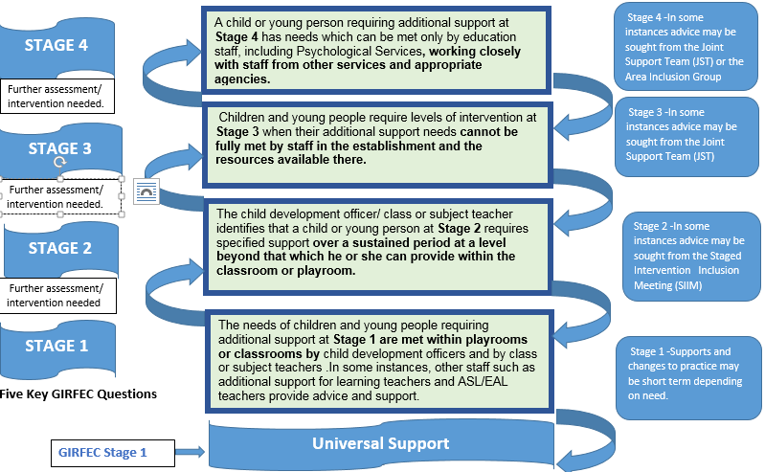

STAGE 1
Assessment |  | Plan/ Record | Review and Timescales | Points to consider
What is getting in the way of this child or young person's wellbeing?  - Do I have all the information I need to help this child or young person ? |  | What can I do now to help this child or young person?  - What can my agency do to help this child or young person? | What can my agency do to help this child or young person? | - What additional help, if any, may be needed from others?
- Classroom/ Playroom observations and assessments of the child/ young person determine his /her needs and identify intervention. .  - Assessment to support planning as appropriate to pupil need and educational provision in line in line with the National Practice Model. |  | - Forward plan for classroom/playroom may sit within forward planning.  - Record Stage 1 in SEEMIS ASN Data | - Ongoing monitoring of progress  - Minimum of an annual review.  - All necessary and proportionate information is shared with child/young person, family and relevant staff. | - Some adjustments to learning environment.  - Modified curriculum  - Differentiated planning of learning, teaching and assessment programmes.  - Consider use of digital and assistive technologies.  - In some instances teacher/ CDO may seek additional supports from other e.g, EAL , Nurture co-ordinator
W  H  O | Class /Subject teacher, CDO  CLOL, GDSS Ambassador  Nurture Teacher, EAL ,SALT | Class /Subject teacher, CDO,  Nurture Teacher, EAL  Parent/ carer, Pupil Voice | Class /Subject teacher, CDO,  Nurture Teacher, EAL Parent/ carer, Pupil Voice
 | ASL –Co-ordinator retains overall responsibility for Staged Intervention
All significant events, reviews, partner agency assessment and outcomes should be recorded as significant events within Pastoral Notes.

Additional assessment information indicates the need for more targeted intervention move to 2 or as appropriate.
Progress made move to class planning and universal supports.

STAGE 2
Assessment |  | Plan/ Record | Review and Timescales | Points to consider
What is getting in the way of this child or young person's wellbeing?  - Do I have all the information I need to help this child or young person? |  | What can I do now to help this child or young person?  - What can my agency do to help this child or young person | - What can my agency do to help this child or young person? | - What additional help, if any, may be needed from others?
- ASN coordinator, with support from other appropriate staff assess the child/young person, and their environment, to determine his/her support needs, and agree appropriate intervention to meet those needs.  - Assessment to support planning in line with the National Practice Model. |  | - Forward plan for class/playroom-Group plans may sit within forward planning  - Where child/young person requires a more tailored programme linked to the forward plan, staff should identify and plan individual short term outcomes as part of classroom/ playroom planning.  - Record ‘Stage 2’ in schools staged intervention overview. | - Minimum of an annual review.  - Keep progress under review and take action as required.  - All necessary and proportionate information is shared with child/young person, family and relevant staff.  - For cross-sectoral transitions Enhanced transitions arrangements should be considered no less than 12 months prior to the date of transition (no less than 6 months in Early years establishments) (ASL Act, 2009). | - Increasingly personalised approaches to learning, including specialised support.  - Modified curriculum  - Differentiated planning of learning, teaching and assessment programmes.  - Advice and consultation from Staged Intervention Inclusion Group(SIIM)  - Partnership working e.g ASL- Sector, 3rd sector organisations
W  H  O | Class/subject teacher, CDO, Nurture Staff  Advice and consultation may be sought from other relevant staff/partner agencies. This will now include support/ input from e.g EAL Service, GDSS, ASL – Technology
 | ASL –Co-ordinator retains overall responsibility for Staged Intervention
All reviews, partner agency assessment and outcomes should be recorded as significant events within Pastoral Notes.

Additional assessment information indicates the need for further intervention from within education move to Stage 3.
Progress made move to Stage 1/ Universal support and monitor progress

STAGE 3
What is getting in the way of this child or young person's wellbeing?  - Do I have all the information I need to help this child or young person? |  | What can I do now to help this child or young person?  - What can my agency do to help this child or young person? | - What can my agency do to help this child or young person? | - What additional help, if any, may be needed from others?
- ASN coordinator, with support from other appropriate staff, assess the child/young person, and their environment, to determine his/her support needs, and agree appropriate intervention to meet those needs.  - Assessment to support planning in line with the National Practice Model. |  | - Wellbeing Assessment Plan (WAP) created  - WAP will detail Outcomes and Interventions  - Parent/ carer, Pupil Voice recorded in plan.  - Plan will detail roles and responsibilities of all those involved in providing support.  - Record ‘Stage 3’ in schools staged intervention overview. | - Minimum of an annual review.  - Progress monitored through review of WAP.  - All necessary and proportionate information is shared with child/young person, family and relevant staff.  - For cross-sectoral transitions Enhanced transitions arrangements should be considered no less than 12 months prior to the date of transition (no less than 6 months in Early years establishments) (ASL Act, 2009). | - Increasingly personalised approaches to learning, including specialised support.  - Modified curriculum.  - Differentiated planning of learning, teaching and assessment programmes.  - Consider use of digital and assistive technologies.  - Advice and consultation from Staged Intervention Inclusion Group(SIIM).  - Advice and consultation from  Joint Support Team (JST).  - Partnership working e.g ASL- Sector, 3rd sector organisations.
W  H  O | Class/subject teacher, CDO.  Other relevant staff/partner agencies within education e.g GPS, Enhanced Nurture Provision, shared placements
 | ASL –Co-ordinator retains overall responsibility for Staged Intervention
All reviews and partner agency assessment and outcomes should be recorded as significant events within Pastoral Notes.

Additional assessment information indicates the need for further intervention from out with education move to stage 4.
Progress made move to Stage 2/1 and monitor progress.
STAGE 4
Assessment |  | Plan/ Record | Review and Timescales | Points to consider
What is getting in the way of this child or young person's wellbeing?  - Do I have all the information I need to help this child or young person? |  | What can I do now to help this child or young person?  - What can my agency do to help this child or young person? | - What can my agency do to help this child or young person? | - What additional help, if any, may be needed from others?
- ASN coordinator, with the support of multi-agency team (partners’ out with education) should consult on appropriate assessment for the child/young person, and their environment, to determine his/her support needs, and agree appropriate intervention to meet those needs.  - Assessment to support planning in line with the National Practice Model. |  | - Wellbeing Assessment Plan (WAP) created/continued.  - WAP will detail Outcomes and Interventions.  - Parent/ carer, Pupil Voice recorded in plan.  - Plan will detail roles and responsibilities of all those involved in providing support.  - Record ‘Stage 4’ in schools staged intervention overview.  - Where appropriate Social Work Care Plans and documents should be kept within Vulnerable/ CP Pupil Case Files. | - Minimum of Annual Review.  - Progress monitored through review of WAP.  - Bi –annual review for Looked After pupils.  - All necessary and proportionate information is shared with child/young person, family and relevant staff/ external agencies.  - For cross-sectoral transitions Enhanced transitions arrangements should be considered no less than 12 months prior to the date of transition (no less than 6 months in Early years establishments) (ASL Act, 2009). | - Increasingly personalised approaches to learning, including specialised support.  - Modified curriculum.  - Differentiated planning of learning, teaching and assessment programmes.  - Consider use of digital and assistive technologies.  - Advice and consultation from Staged Intervention Inclusion Group (SIIM).  - Advice and support from Joint Support Team (JST).  - Partnership working e.g ASL- Sector, 3rd sector organisations.  - Enhanced tracking arrangements  In place for vulnerable groups of learners to inform and support planning.
W  H  O | Class/subject teacher, CDO.  Other relevant staff/partner agencies within and outwith education e.g. Nurture Staff, GDSS, ASL Tech ,EAL, GPS, and outwith Education e.g. SW, SALT, Health
 | ASL –Co-ordinator retains overall responsibility for Staged Intervention Processes
http://www.goglasgow.org.uk/Pages/Show/757 - Care Experienced Support Documents
All reviews, partner agency assessment and outcomes and annual consideration of CSP should be recorded under Significant Event within Pastoral Notes. Annual consideration of CSP for all Looked After children as defined within Care Experienced documentation.
http://www.goglasgow.org.uk/Pages/Show/757

Progress made move to Stage 2/3 and continue to monitor progress.
Additional assessment information indicates the need for further intervention and co-ordinated support.

