Exploring the experience of children and young people during the coronavirus pandemic at key transition points
What did we ask?
We asked 25 children and young people about their experiences of transitioning to new primary or secondary schools during the COVID-19 pandemic.
This research aimed to gather the views of children and young people whose lived reality has been disrupted by the pandemic. We hoped to clarify what worked well at key transition points and to consider recommendations for the future. Finally, we hoped to contribute towards the evidence base for Nurture Principle 6 “Transitions are important in the lives of children”.

What did we do?
We asked P1 & P2 pupils from one primary school and S1 & S2 pupils from one secondary school to take part in focus groups. The pupils were asked questions about their experience of moving to a new primary or secondary school during the COVID-19 pandemic.
We acknowledged that pupils were asked to give their views on events which happened almost 18 months- 2 years ago. Therefore, this was likely to impact their ability to remember events accurately. To support their memories, we created a visual timeline (figure 1), highlighting which months nurseries/ schools were open and when home learning was in place, due to COVID-19 regulations. Primary school participants were also given mood cards (figure 2), to help them express how they felt at key transition points. We hoped that this information could support pupils to reflect on their transition to primary or secondary school.
With permission from parents, we scribed the focus group discussions to record data. The data was analysed using Braun and Clarke’s (2006) guide to thematic analysis, to identify themes which were generated from the focus group discussions.
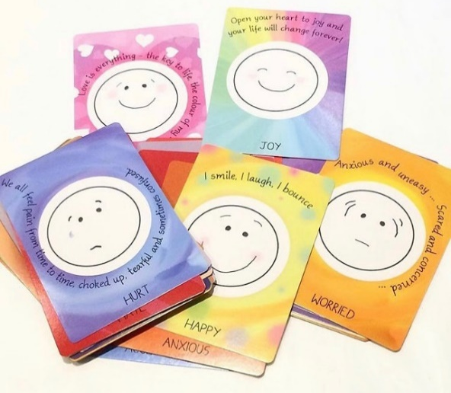
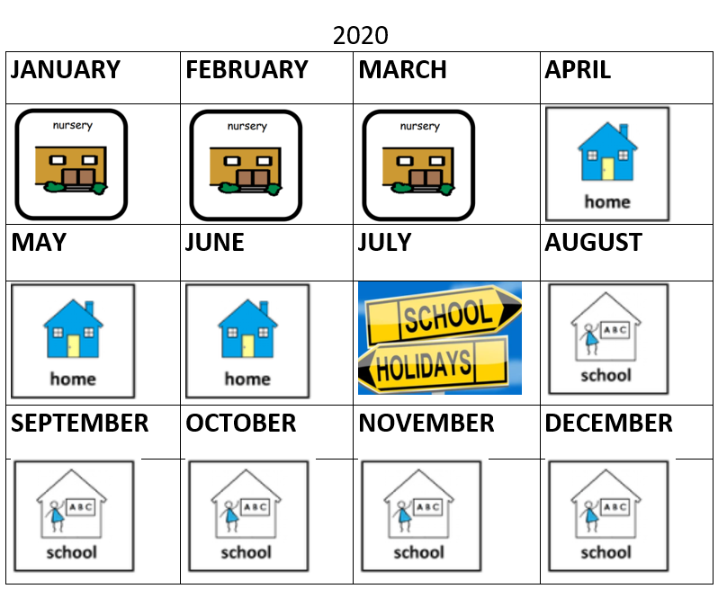
Figure 1. Example of visual timeline
Figure 2. Mood cards
What have we found?
The impact of COVID-19 on learners at key transition points.

Change | Social distancing | “I didn’t know why my nursery had shut down” [picked confused face].  “I didn’t get to come to visit the school in person, so didn’t know much about it and I felt quite nervous when I started first year”.
 | Home environment | “[Picked love card] I liked my Mum and staying with her”.
Loss | Learning | “I was annoyed because I was missing being in the nursery. Because all the fun times we had like roasting marshmallows” [picked annoyed card].
 | Nursery/ school experience | “I didn’t come to school half the time in S1”.
 | Celebrations | “Everything got cancelled. We were supposed to go on a P7 trip to an outdoor learning centre and we didn’t get to go”.
Relationships | Closure | “I got to say goodbye to my nursery teacher”.
 | Reconnection | “It was good having people I knew here, like my friends. That helped me to settle”.
 | Meeting new staff/ pupils | “I liked meeting the teachers and meeting other pupils”.
Transition | New learning environment | “I found it quite scary coming to secondary school, it’s a really big building, too big for me”.
 | Children and young people’s feelings about transition | “[Picked happy] After nursery I was excited about going to school”.
 | Family experiences of school shared | “I have a sister that comes to this school so she talked to me about it and told me what it was like”.
Transition Plans | Activities to support transition- school visits | “I thought my tour of the school was good. I felt like I knew where everything was when I joined the school”.  “I think it would have been good to have some videos of the school to see what it was like inside before we came. I think we missed out because we didn’t get many visits”.
 | Sharing school relevant information | “There was a video. Primary 7s showed us around”  “I had a map which was helpful for getting around the building and finding classes”.
 | Additional supports | [would have liked] “having a therapist or a school nurse. Someone we could talk to”.  “We had buddies that took us to our subjects, we also had the Welcome Room (nurture room) and the nurture teachers helped me to settle in”.

Summary of Findings
Transition to a new nursery or school environment is significant for children and young people. This change can be a loss experience in “non-COVID” circumstances, given the loss of connection with key adults, peers and loss of familiarity with the school environment. Within the context of the pandemic, this transition also involved loss of learning, loss of nursery or school experience and loss of celebrations such as school proms and nursery graduations. It is important that transitions are marked and that children are given time and space to process loss and change.
Relationships are essential to support children and young people at key transition points. Children and young people appreciated having the opportunity to say goodbye to their teachers before moving on to a new learning establishment. They reflected that their existing friendships supported them to manage their transition to primary or secondary school. Pupils also highlighted that having opportunities to meet with new staff and pupils prior to their school transition was helpful for them.
Pupils reflected on what supported them to adjust to their new learning environments. Having friends and family who attended the school and shared their experiences was helpful for some learners. Pupils felt a mixture of emotions ranging from nervous to excited, in relation to their school transition.
Activities, such as school visits in small groups, helped some pupils to familiarise themselves with their new environment. However, not all children and young people were able to visit the establishments, due to COVID-19 regulations. Some pupils accessed videos from their new schools, which facilitated them to meet some new teachers and see what the school was like inside.
Additional supports which assisted pupils included having “buddies” to show them around the school, and also access to nurture groups and support for learning departments. Pupils also highlighted that it was helpful to have relevant information such as a map of the school building, to help them navigate their new surroundings.

Recommendations
A child-centred approach, informed by nurture principles should be central to guiding transition planning and approaches. Transitions are “not a one size fits all”, so it is important to gather the views of children and young people and to be attuned to their individual needs.
Forming positive relationships with staff and peers is essential to a successful school transition. Having opportunities to meet with key staff prior to the transition allows children and young people to communicate and form connections with people from their new school community. Being able to say goodbye to peers and key adults from their existing school community also supports transitions by providing ways to mark the occasion and gain some closure.
The key principle of transition planning is to make the unfamiliar familiar, thereby reducing anxiety and confusion for learners. In-person school visits were most frequently identified as a helpful activity to support school transitions. Where in-person visits are being carefully managed due to COVID-19, small group, in-person visits were identified as helpful by learners who received enhanced transition support. Where learners are unable to visit their receiving school in-person, it is beneficial for learners to have access to videos or photographs of the school environment to help them to familiarise themselves with it.
Transitions should be carefully planned and prepared, with good information sharing between the existing and receiving establishments, learners and their families to ensure a level of consistency. Transition planning tools, such as pupil passports, can be utilised to support transitions and share relevant information that key adults should be aware of.
Lastly, future research projects consulting with children and young people may benefit from using a similar methodology, which involves developmentally appropriate methods to capture children’s views.

References
Braun, V, & Clarke, V. (2006). Using thematic analysis in psychology. Qualitative research in psychology, 3(2), 77-101.

March 2022.

