

# Best practice guidelines around gathering and taking account of the views of children and young people in a way that shapes case management; and supports the integrity and efficiency of the meeting management of the LC-JSTs.

Susan Clark, Vince McMahon, Kevin Williams, Vanessa Pignataro, Marie Kerr

(With the help of Craig Shields and Hilda Dalziel)

29th May 2019

## **Why do we consult with children and young people and gather their views?**

### **To find a solution**

Children are experts in their own lives. They are able to provide information that may lead to a solution or identify possible supports; or can exclude identified strategies which may not be likely to work for them.

### **It brings about benefits**

Gathering and taking account of children’s views in a meaningful way can benefit the child or young person (Kirby & Bryson, 2002). A few of the benefits include:

* increased confidence and self- esteem
* trust in adults and themselves
* social inclusion and a sense of belonging
* a sense of responsibility
* increased control over aspects of their lives
* understanding of decision-making processes

### **Legislation places a duty on us to gather children and young people’s views.**

**The Children (Scotland) Act 1995 & The Children and Young People Scotland Act (2014)**

These acts incorporate the UNCRC into Scottish legislation, making it necessary for all children and young people to be consulted over any important decisions and promoting an ethos of positive relationships where children are respected, listened to and supported to participate.

The **Standards in Scotland’s Schools etc. Act 2000** places a duty on the local authority to take account of the views of children and young people.

**Education (Additional Support for Learning) (Scotland) Act 2004 as amended and Supporting Children’s Learning, Statutory guidance (2017)**

This act puts an emphasis on children’s right to be **involved in decisions relating to their education** and emphasises the importance of consultation with children and young people needing to be set within an **ethos** of children’s views being valued. It states that some children will require **support to express a view through their preferred method of communication.** The statutory guidance also suggests **methods** which could be used and **considerations** which should be made when gathering the views of the child and young person – what was expressed and how it was interpreted.

**Every Child Included and Supported Policy (2016).** This provides a local authority context for supporting Glasgow’s children. It suggests two tools which can support gathering the views of children and young people - the Glasgow Motivation and Wellbeing Profile (GMWP) and Nurturing Me.

**United Nations Convention on the Rights of the Child (1989)**

**Article 12: Respect for the view of the child**

*“States Parties shall assure to the child who is capable of forming his or her own views the right to express those views freely in all matters affecting the child, the views of the child being given due weight in accordance with the age and maturity of the child. For this purpose, the child shall in particular be provided the opportunity to be heard in any judicial and administrative proceedings affecting the child, either directly, or through a representative or an appropriate body, in a manner consistent with the procedural rules of national law.”*

**Article 13: Right to Freedom of expression & information**

*“The child shall have the right to freedom of expression; this right shall include freedom to seek, receive and impart information and ideas of all kinds, regardless of frontiers, either orally, in writing or in print, in the form of art, or through any other media of the child’s choice”*

Figure 1. shows a model based on article 12 of the UNCRC. This model is set within other articles of the UNCRC including:

Article 2 – Non-discrimination

Article 3 – Best Interests

Article 5 – Right to guidance from adults

Article 13 – Right to information

Article 19 – Right to be safe

This can help guide our practice around how children’s views are gathered and taken account of.

**Voice**: Provide appropriate information and facilitate the expression of children’s views.

* Have children been given the information they need to form a view?
* Do children understand that they can choose to pause or stop the conversation?
* Have they been given a choice of options of how to express their view?

**Space**: Provide a safe and inclusive space for children to express their views

* Have children’s views been actively sought?
* Was there a safe space in which children can express themselves freely?



**Audience**: Ensure that children’s views are communicated to someone with the responsibility to listen.

* Do children know who their views are being communicated to?
* Does that person or body have the power to make decisions?

**Influence**: Ensure that children’s views are taken seriously and acted upon, where appropriate.

* Are there procedures in place that ensure that children’s views have been taken seriously?
* Have children and young people been provided with feedback explaining the reasons for the decision taken?

Figure 1. Lundy’s Model of participation and Voice-Model checklist. Adapted from “*Overview of the National Strategy on Children and Young People’s Participation in Decision-Making (2015-2020)”* by Department of Children and Youth Affairs, 2017, 8. Copyright by Department of Children and Youth Affairs.

**What do adults think is important when gathering the views of children and young people for LC-JSTs?**

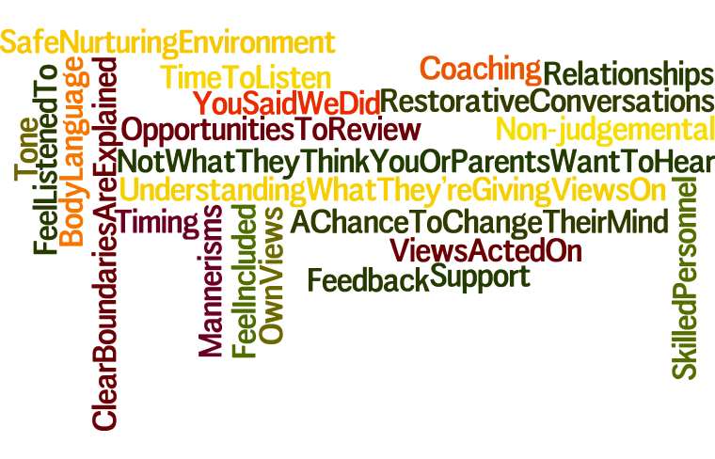

**What did children and young people we asked think is important when gathering their views for LC-JSTs?**

**Environment in which they share their views should be quiet, with art activities or the art room being considered a good option.**

The majority of children and young people would like to give views in person, one-to-one (or small groups where appropriate), this was preferred over electronic versions of sharing views.

Some views should be allowed to be expressed anonymously (for more general gathering of views – such as suggestion boxes)

Young people felt their additional support need should be taken into account, and in relation to this they expressed they would like the opportunity to think about it and come back.

**Sharing their views with a trusted adult was a very important theme that came up often. This was so that they could trust the adult to take account of their views and feedback to them; and be able to ask the adult questions following feedback too.**

**Ten steps to gathering and taking account of children and young people’s views**

1. Choose the right time and provide the right environment (Safe space, child friendly, quiet)
2. Identify the right person to gather the views of the child/young person

* Do they have a good relationship with the child?
* Consider giving the child or young person a choice of people with whom they can discuss the LC-JST process and their views.

1. Address power imbalances: Inform children they have the power to pause or stop the conversation. Consider using a visual tool such as a stop/pause sign for children to indicate their wish to pause/stop where appropriate.
2. Explain the process of a LC-JST, who attends and what things can happen from a LC-JST discussion with the help of a leaflet. Explain reasons for referral in an age and stage appropriate way.
3. Seek consent to discuss the case at the LC-JST from the child or young person. If child or young person does not give their consent it may be beneficial to discuss this with the parents and child at the same time.
4. Choose an appropriate method(s) to gather the child or young person’s view. (See pack of resources). Consider giving the child or young person a choice of methods.
   * GMWP (different versions)
   * Nurturing Me
   * Solution focussed questioning & art materials
   * Mosaic approach
   * Person-centred planning (PATH and MAPs)
   * Multi-Element Model pupil discussion
   * Direct work with children and parents
   * Social stories/comic strip conversations
   * Talking Mats
   * Interactive ‘My World Triangle’
5. Give the child or young person time to reflect on the information and to form a view where this is necessary. Check back with the child or young person to see if their view is still the same.
6. With the young person, discuss what they consider to be the most important points from the views gathered so that these can be included in the SOA grid. Inform them that you will share the original document capturing their views, if this has been completed, and ask if they are happy for this to be shared. When recording the most important points from the child/young person’s view in the SOA grid, you could consider representing their view by using a different colour of font.
7. Discuss case at LC-JST – ensure due consideration is given to the child or young person’s view.
8. Feed back the outcomes of the LC-JST and reasons for these in a child friendly way. Consider doing this in writing or a comic strip conversation so the child can take this away and think about the feedback. Offer the child/young person the opportunity to ask questions regarding the outcomes of the JST.

Sometimes it can be difficult to gather children and young people’s views (e.g. non-attenders). In these cases, consider phone calls and home visits or enlisting the help of other appropriate adults or agencies (e.g. EWOs, attendance officers, social workers, ILS, and third sector agencies). If it has not been possible to gather a view, consider stating what attempts were made.

**How do we evidence impact of our change in practice in gathering the views of children and young people?**

To evidence impact we must look at evidence before we make any changes and then repeat the process after the changes have been made and been in place for a little time. Suggestions for how this could be done are described below.

Gather children and young people’s views on how their view has been gathered, individually or in focus groups.

(You could share information on what makes good practice in gathering their views to help them to form a view on how well this is done at present.)

Gather adult views – teachers, parents LC-JST members on how good they think the process is currently.

Capture data on:

Number of referrals containing the view of the child or young person

Number of referrals where there is evidence of meaningful consultation as outlined by the information and resources offered.

Number of LC-JST minutes which evidence the view of the child or young person.

Success in relation to desired outcomes

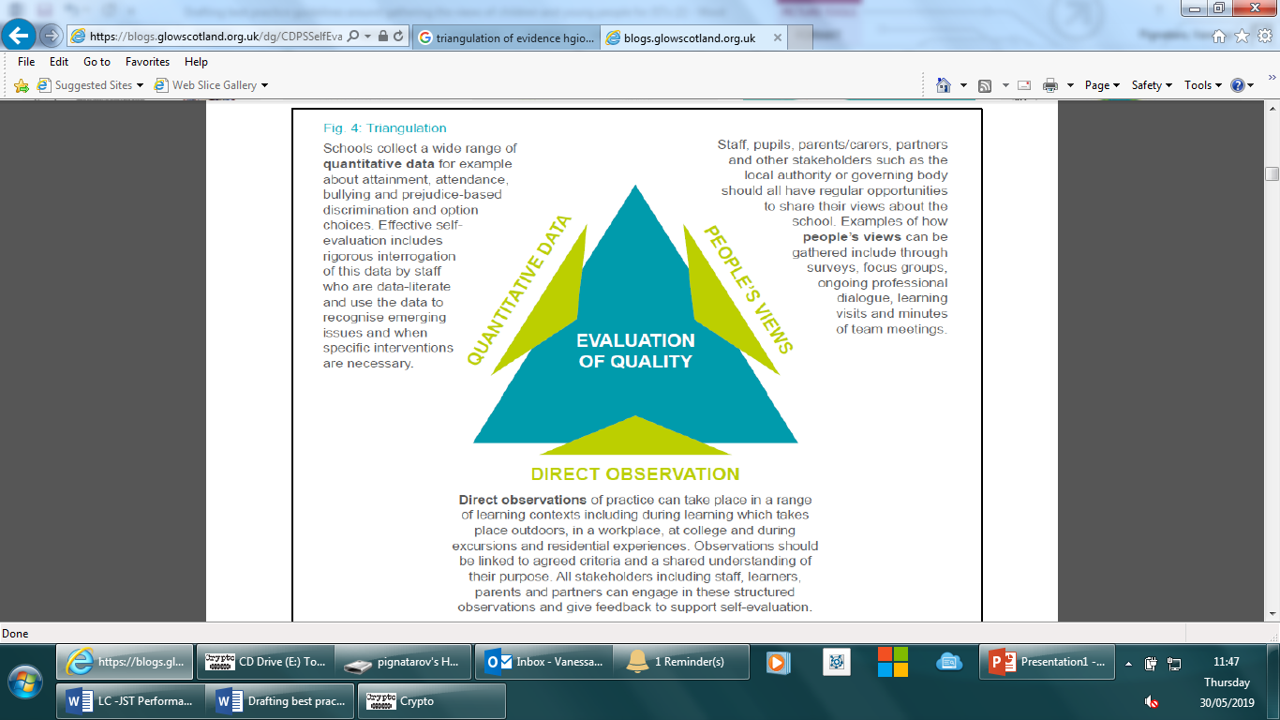

Direct observation of the process of gathering views.

Direct observation of how these views are represented and considered during LC-JSTs.

# Appendix A - An overview of the Scottish legislative context relating to consulting with children and young people.

**The Children (Scotland) Act 1995** incorporates Article 3, 5 and 12 of the UNCRC into Scottish legislation, making it necessary for all children and young people to be consulted over any important decisions which are made about them.

**The Children and Young People Scotland Act (2014)** further incorporated the UNCRC into Scottish law. It promotes an ethos of positive relationships where children are respected, listened to and supported to participate.

The **Standards in Scotland’s Schools etc. Act 2000** places a duty on the local authority to take account of the views of children and young people.

*“…the authority must, so far as is reasonably practicable, have regard to the views of children and young people (if there is a wish to express them) in decisions that significantly affect their education.”*

**Education (Additional Support for Learning) (Scotland) Act 2004 as amended, and Supporting Children’s Learning, Statutory Guidance (2017)**

This act puts an emphasis on children’s right to be involved in decisions relating to their education.

*“All children and young people should have the opportunity to make their views known about decisions which affect them. They should have the opportunity to express their opinions and have these opinions taken seriously. They should be encouraged to contribute to decision-making processes, the setting of educational objectives, the preparation of learning plans, reviews and transition planning. They need to know that what they have to say will be respected, listened to and, where appropriate, acted on.”* (Scottish Government, 2017, p.110)

The statutory guidance emphasises the importance of consultation with children and young people needing to be set within an **ethos** of children’s views being valued.

*“In order to express views, children and young people need to have experience of being asked for their views, being listened to, making some choices and having some influence over what they do. Schools and early years settings should create a climate where seeking children’s views and encouraging participation in decision-making are part of everyday activities.”* (Scottish Government, 2017, p.110)

**Facilitation - Some children will require support to express their views**. The Education (Additional Support for Learning) (Scotland) Act 2004 as amended states:

*“When seeking the views of parents, young people and, where appropriate, children, and when carrying out an assessment, education authorities need to take into account the parents’, young person’s or child's* ***preferred method of communication.”***

The statutory guidance also suggests **methods** which could be used:

*“There are many reasons why a child or young person may have difficulty in expressing his/her views. For example, communication with young children requires a range of different strategies which could include play, art, and the use of mobile, audio and video technology.”* (Scottish Government, 2017, p.112)

It also advises on **considerations**:

*“When noting views, particularly where the child or young person has communication support needs, it is helpful to consider two factors. Firstly, what the child or young person actually expressed, whether through speech, in writing, audio recording, sign or other form of communication such as facial expression or body posture. Secondly, what interpretation was made of the child’s or young person’s view and by whom. Both should be noted.”* (Scottish Government, 2017, p.112)

**Consent –** The statutory guidance advises that parental consent is not necessary to seek and take account of children’s views.

*“It should be noted that the Act does not require the education authority to have parental consent before seeking and taking account of children’s views. Even where the parents do not wish their child’s views to be sought the education authority are still under a duty to seek and take account of the child’s views; where a child is concerned, education authorities are to seek and take account of the views of both the child and the parent unless they are satisfied that the child lacks the capacity to express a view.”* (Scottish Government, 2017, p.112)

**Every Child Included and Supported Policy (2016)**

This provides a local authority context for supporting Glasgow’s children. It suggests two tools which can support consultation with children.

*“Although there are many ways in which adults might consult with children and young people Glasgow Psychological Service has been involved in the development of two specific tools which link directly to GIRFEC and the wellbeing indicators: Nurturing Me and the Glasgow Motivation and Wellbeing Profile (GMWP).”*

# Appendix 2: Tools and methodologies to support meaningful consultation

|  |  |  |
| --- | --- | --- |
| **Tools and methodologies** | **Short description** | **When might it be useful to use this?** |
| **Mosaic approach** | A multi-method approach developed by Clark and Moss involving gathering views using drawings, maps, cameras, discussion with children and observation, as well as incorporating staff and parent views.  A short information sheet on the mosaic approach can be found on the Glasgow Psychological GLOW website. For a fuller description of the approach please see the book below.  Book reference:  Clark, A and Moss, P (2011). *Listening To Young Children: The Mosaic Approach* (2nd ed.). London: National Children's Bureau. | This is useful for very young children or children who have speech language and communication needs, as each method within the approach can be chosen, as appropriate, to facilitate the child to express a view. Each ‘tile’, or information from each method used, can be put together to build a mosaic picture of the child’s lived experience. |
| **Person centred planning PATH** | A creative planning tool in which the young person and people around them visualise a preferred future and work backwards to identify the steps towards this vision of the future. It focuses on the future and a positive or preferred outcome and involves goal setting.  More information on how to use the PATH tool can be found [here](https://www.access-unlimited.co.uk/assets/6.-PATH-Participants-Factsheet-LR3.pdf%20) and [here.](https://inclusive-solutions.com/person-centred-planning/path/) | May be most useful with young people in upper primary and secondary education. It is good to involve families in this process and also peers where possible and appropriate.  This tool focuses on the future and is best used when it is not necessary to go over information from the past. |
| **Person centred planning MAPs** | A creative planning tool in which the young person and people around them spend time looking at the past, articulate a preferred future and what a negative outcome would look like. It then draws on child’s interests and strengths to identify a solution.  More information on how to use the MAP tool can be found [here.](https://inclusive-solutions.com/product/maps-process-step-by-step-guide/) | May be most useful with young people in upper primary and secondary education. It is good to involve families in this process and also peers where possible and appropriate.  This tool helps work towards a positive future and is best used when it is necessary for the story so far to be shared. |
| **Solution focused questions and art based materials.** | The solution-focused approach poses questions to children to help them to identify what they want in a certain aspect of their life, understand what is within their capacity, and explore what they are doing to move towards this. It can help identify strengths that could be built upon and possible strategies and supports that could be explored to work towards the preferred future.  Solution focussed approaches can be used in conversation and through the use of visuals and art based approaches. Please see the information sheet on the Glasgow Psychological Service GLOW website.  The NSPCC solution focused practice toolkit for working with children and young people can be found [here.](https://learning.nspcc.org.uk/media/1073/solution-focused-practice-toolkit.pdf) | The approach can be adapted to suit the abilities of a range of children, through the use of visuals, art based materials and appropriate phrasing of questions. |
| **GMWP** | The Glasgow Motivation and Wellbeing Profile (GMWP) is a 50 item questionnaire and planning sheet that explores a young person’s motivation and sense of wellbeing in the learning context. It elicits the young person’s view of themselves and their emotions including their vulnerabilities; it gives them an opportunity to reflect on their feelings and current experiences and it encourages them to consider how they can increase their own motivation and sense of wellbeing.  Though the 50 item version of the GMWP is the primary version, there are also other versions which can be considered:  GMWP- 20 item version with all positive statements, (excel).  GMWP- 20 item version with all positive statements with Boardmaker symbols, (paper).  Also consider using the observer version of the 50 item GMWP, and include specific examples to support some of the statements where possible. Although we should try to facilitate children and young people to express their views, observations of the child and young person can give insight into a child or young person’s lived experience. | Different versions exist to suit different needs.  The 50 item version is recommended for use with 8-17 years old. Please refer to the guide for how this tool can be used to facilitate meaningful consultation.  The 20 item version is similar to the 50 item version but only contains 20 all positive statements. This may be useful when it is thought that the young person may not be able to complete the 50 item version with support.  The 20 item version with Boardmaker symbols can be printed and used with young people who would benefit from the use of visuals. This can then be translated onto the 20 item electronic version to produce the charts which map the answers in relation to the SHANARRI indicators.  It is important to read the guide in how to use this tool to facilitate a meaningful discussion, completing all parts of the GMWP.  Additionally, a desired outcome could be discussed following from the information elicited. It may be useful to add this and information from the strengths, issues and actions identified in the planning sheet in the SOA grid.  Please find all materials on the Glasgow Psychological Service GLOW website. |
| **Nurturing me** | ‘Nurturing Me’ is a GIRFEC tool which captures the voice of the child. The main purpose is to allow the child to have their voice heard in relation to their perspective on their wellbeing. It is a mediated tool using concrete materials which allows children and young people to identify key people in their lives alongside the child’s perspective on the closeness and importance of that relationship.  Please find Nurturing Me guidance and materials on the Glasgow Psychological Service GLOW website.  (Available in paper, as an app on the IPad or as a PC version) | This tool can be used with preschool to primary aged children. Please refer to the guide for how this tool can be used to facilitate meaningful consultation. The guide also supports the drafting of a solution focussed report from the child’s answers. Aspects from this can be easily mapped onto the SOA grid. |
| **Direct work with children and parents bag activities** | This toolkit developed by Glasgow South Children and Families team includes activities to explore the child or young person’s view on specific topics.  Some activities within this toolkit may be useful in gathering young people’s views in relation to the people in their life, worries they may have or school.  The full toolkit is continuing to be developed and can be accessed through Social Work Services. | Each task has a specified use and age range. |
| **Social stories/ comic strip conversations** | These approaches, developed by Carol Gray, are short descriptions of a situation, event, activity or conversations, presented in a concrete way.  More information on social stories and comic strip conversations, including apps that can help create these, can be found [here.](https://www.autism.org.uk/about/strategies/social-stories-comic-strips.aspx) | These tools may be particularly useful to prepare young people to participate in or feed back the outcome of a LC-JST to children and young people, particularly children who might benefit from information being presented in a concrete way, including children and young people with autism. |
| **Talking mats** | Talking Mats is a picture-based communication tool with engaging pictures and symbols.  It is also available in a digital format.  Training may be required. More information can be found on the Talking Mats website linked [here.](https://www.talkingmats.com/about-talking-mats/) | Talking mats can be used with children and young people with a wide range of ages (nursery through to adulthood) and additional support needs, including those with speech language and communication needs and has previously been used with children who are care experienced. |
| **Multi-Element Model Pupil discussion** | These pupil discussion materials, developed by Dr Katy Bravery and Dr Katy Goymour, are part of a wider ‘Multi-Element Model’ (LaVigna & Willis, 1995) exploring the function of a particular behaviour and used to support young people.  The tool explores the young person’s strengths, their perception of any issues and explores environmental factors contributing to a behaviour, skills they would like to develop and reward strategies as well as reactive strategies.  Visual cards are used to facilitate exploration of these strategies.  Involves the young person in explicitly contributing to solution planning. | Particularly useful to gather a young person’s views in relation to distressed behaviour, particularly those who might benefit with the use of visuals; and involving the young person in solution planning.  Materials and support in using this tool can be accessed through your link EP. |
| **Interactive ‘My World Triangle’** | The Interactive My World Triangle was developed by NHC Online and is based on the Scottish Government My World Triangle.  Please access the Interactive ‘My World Triangle’ [here.](http://triangle.plexusmedia.co.uk/) | This interactive tool may be useful to gather views of children and young people with a range of additional support needs as it has different question sets and allows the user to create their own question sets too. |

## Considerations when choosing tools/ methodologies

* Guidelines for best practice and models of participation.
* Age.
* Developmental stage.
* Communicative ability.
* The child or young person’s interest. For example if they are creative, art based methods may be useful.
* How tool or methodology is introduced.
* How tool and methodology is used. It is important to follow the user guide - the tools and methodologies described when used properly can facilitate a rich and meaningful consultation.