NAME OF SCHOOL

Mental Health and Wellbeing Policy
2019-2020

INSERT SCHOOL LOGO

Table of Contents

Rationale and Towards the Nurturing City 3
Lead members of staff 4
Getting it Right for Every Child 5
Planning 6
Teaching about Mental Health 6
Sign Posting 7
Warning Signs 7
Responding to concerns raised by pupils 8
Mental Health Guidance for Staff 9
Confidentiality 9
Working with Parents /Carers 10
Glasgow education policies and Guidance 12
Training and Policy Review 13

Appendices
A: Glasgow’s Mental Health Improvement Framework 14
B: Guidance and advice on issues affecting young people 17
C: Sources of Support outside of School 20
D: Talking to pupils when they express a mental health concern 22
E: Referring to CAMHS and contact information 25
F: Supporting the Wellbeing of staff in our school 29

Rationale
In an average classroom, three children will be suffering from a recognised mental health condition. By developing and implementing practical, relevant and effective mental health policies and procedures we can promote a safe and stable environment for the many pupils affected both directly, and indirectly by mental ill health.

Policy Statement

Mental health can be defined as, “a state of well-being in which every individual realises his or her own potential, can cope with the normal stresses of life, can work productively and fruitfully, and is able to make a contribution to her or his community. With respect to children, an emphasis is placed on the developmental aspects, for instance, having a positive sense of identity, the ability to manage thoughts, emotions, as well as to build social relationships, and the aptitude to learn and to acquire an education, ultimately enabling their full active participation in society”
(World Health Organisation, 2014).

At our school, we aim to promote positive mental health for every member of our staff and pupil body. We pursue this aim using both universal, whole school approaches and specialised, targeted approaches aimed at vulnerable pupils. Factors such as poverty, deprivation and domestic abuse can impact on mental health making some children and young people more vulnerable however it must be recognised that mental health issues can affect anyone at any time.

In addition to promoting positive mental health, we aim to increase understanding and awareness of common mental health issues. If staff are alerted to the early warning signs of mental ill health then appropriate supports can be accessed or put in place. By developing and implementing practical, relevant and effective mental health policies and procedures we can promote a safe and nurturing environment for pupils affected both directly, and indirectly by mental ill health.

This document describes the school’s approach to promoting positive mental health and wellbeing. This policy is intended as guidance for all teaching staff and non-teaching staff.

This policy should be read in conjunction with our medical information in cases where a pupil’s mental health overlaps with or is linked to a medical issue and the Additional Support for Learning policy where a pupil has an identified additional support need. Every Child is Included and Supported

Towards the Nurturing City
It is Glasgow’s ambition to be ‘the nurturing city’. A nurturing city has schools in which children and young people feel they belong, they are listened to and they and their families are valued. The ethos of nurturing schools is supportive and all staff are clear about their roles and responsibilities. In nurturing schools, staff continually and collaboratively evaluate their practice to ensure that it promotes the wellbeing of all children and young people. They understand that supporting all children and young people and ensuring they make the best possible progress depends on the curriculum they provide, on learning and teaching of the highest quality and on their commitment to continuing professional development.

Our Policy Aims to
- Promote positive mental health in all staff and pupils
- Increase understanding and awareness of common mental health issues
- Alert staff to early warning signs of mental ill health
- Provide support to staff working with young people with mental health issues
- Provide support to pupils suffering mental ill health and their peers and parents/carers

Lead Members of Staff
Whilst all staff have a responsibility to promote the mental health of pupils. Staff with a specific, relevant remit include:

AMEND AS REQUIRED FOR YOUR ESTABLISHMENT

Child Protection Co-ordinator
CLPL Lead
Head of Health & Wellbeing
Mental Health Lead & MH First Aider
First Aider Lead

Any member of staff who is concerned about the mental health or wellbeing of a pupil should speak to the Pupil Support staff in the first instance. If there is a fear that the pupil is in danger of immediate harm, child protection procedures should be followed with an immediate referral to the designated Child Protection Co-ordinator, or Head Teacher and Management Circular 57 implemented. Link to MC 57
If the pupil presents a medical emergency then the normal procedures for medical emergencies should be followed, including alerting the first aid staff and contacting the emergency services if necessary.

Where a referral to CAMHS is appropriate, this will be led and managed by the Pupil Support Year Head.

Getting it Right For Every Child (GIRFEC)

Glasgow Education Services’ vision of having nurturing approaches embedded in all Glasgow establishments is a direct result of our understanding of the potential negative impact of trauma and difficult early experiences in childhood (commonly described as ACEs) on children’s life-long physical, social, emotional and cognitive development.
Nurturing approaches allow key adults to create safe contexts for learning, underpinned by an understanding of children’s attachment and development needs. Strong, nurturing relationships support children and young people to develop skills, strengths and resilience. These can act as protective factors throughout life.

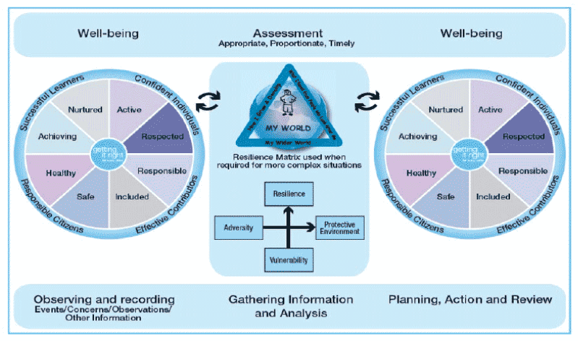

In Glasgow our assessment of need or risk sits within the National Practice Model for Getting it Right For Every Child and should be made, in collaboration with the key people in a child’s life, using the My World Triangle and the risk matrix and should be considered in the language of the eight Wellbeing Indicators. This approach supports our understanding that it is not necessarily the number of Adverse Childhood ACEs, or trauma of itself, that will impact negatively on children’s attainment and success in life, but rather the absence of protective factors, including supportive, nurturing relationships and opportunities to develop resilience and a range of coping strategies. Use of the risk matrix ensures that both risks and protective factors are considered as part of a holistic assessment.

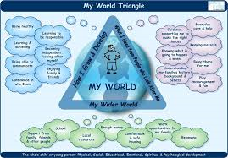

Planning
When a child or young person is identified as having a mental health condition, it is important that a Planning meeting is arranged to support their individual needs. This should be drawn up by relevant members of staff and will involve the pupil, the parents and relevant health professionals. This can include:
- Who is a partner to the plan
- Reason for the plan - including details of a pupil’s condition, special requirements & precautions, medication and any side effects
- Summary of the child’s needs against the well-being indicators
- Desired outcomes
- Resources
- Timescales for action and change
- What needs to be done and by whom - who to contact in an emergency
- Any contingency arrangements, if necessary
- Arrangements for reviewing the plan

Teaching about Mental Health
The skills, knowledge and understanding needed by our pupils to keep themselves and others physically and mentally healthy and safe are included as part of our developmental Life Skills and Health and Wellbeing Curriculum.

The specific content of lessons will be determined by the specific needs of the cohort we are teaching but there will always be an emphasis on enabling pupils to develop the skills, knowledge, understanding, language and confidence to seek help, as needed, for themselves or others.

We will follow the Curriculum for Excellence Health & Wellbeing guidelines to ensure that we teach mental health and emotional wellbeing issues in a safe and sensitive manner which helps rather than harms.

Signposting
We will ensure that staff, pupils and parents are aware of sources of support within school and in the local community. What support is available within our school and local community, who it is aimed at and how to access it is outlined in Appendix A and C.

We will display relevant sources of support in communal areas such as the ADD LOCATIONS HERE, toilet doors and noticeboards and will regularly highlight sources of support to pupils within relevant parts of the curriculum. Whenever we highlight sources of support, we will increase the chance of pupil help-seeking by ensuring pupils understand:

- What help is available
- Who it is aimed at
- How and where to access it
- What is likely to happen next

Warning Signs
School staff may become aware of warning signs which indicate a pupil is experiencing mental health or emotional wellbeing issues. These warning signs should always be taken seriously and staff observing any of these warning signs should communicate their concerns to a member of Pastoral Care or Senior Leadership Team.
Some potential signs may be:-

- Changes in eating / sleeping habits
- Changes in activities e.g. giving up hobbies, clubs
- Expressing feelings of failure , uselessness, despair
- Increasing isolation, becoming socially withdrawn
- Changes in academic attainment
- Frequent absences from school
- Deterioration in physical appearance
- Changes in clothing e.g. long sleeves in summer
- Talking about self-harm or suicide
- Abusing drugs / alcohol
- Changes in peer relationships
- Physical illness e.g. stomach pain, headaches
- Aggressive responses to offers of support

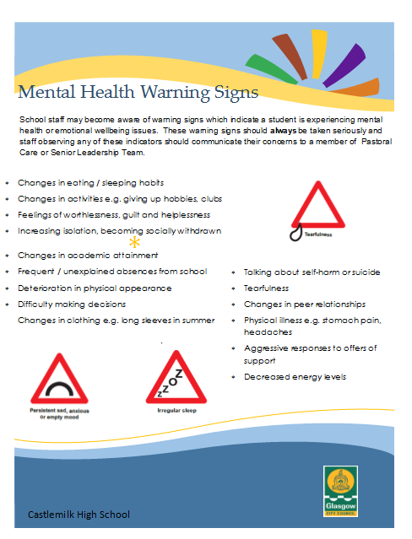

Responding to concerns about mental health?
A pupil may choose to talk about concerns about themselves or a friend to any member of staff, so all staff need to know how to respond appropriately to a concern expressed by a young person. (See mental health protocol).

If a pupil chooses to disclose concerns about their own mental health or that of a friend to a member of staff, the member of staff’s response should always be calm, supportive and non-judgemental.

Staff should listen, rather than try to give advice and our first thoughts should be of the pupil’s emotional and physical safety rather than of exploring ‘Why?’ For more information about how to respond to mental health concerns raised by a young person sensitively see appendix D.

All mental health concerns should be recorded in writing and held within the Pupil’s Pastoral Notes. This written record should include:
- The name of the member of staff to whom the concern was made
- Any significant events (risks to the young person or others)
- The agreed outcome
This information should be shared with all appropriate staff who will offer support and advice about next steps. This may involve taking the concern to a Staged Intervention Meeting (SIM), making a referral to the Learning Community Joint Support Team (LC-JST) or contacting the Duty Clinician at the local CAMHS Team for advice. See Appendix E for contact details.

Mental Health Guidance for Staff

In the event of a pupil disclosing information to you, staff have been advised to follow the following protocol. The protocol poster will be displayed in all classrooms.

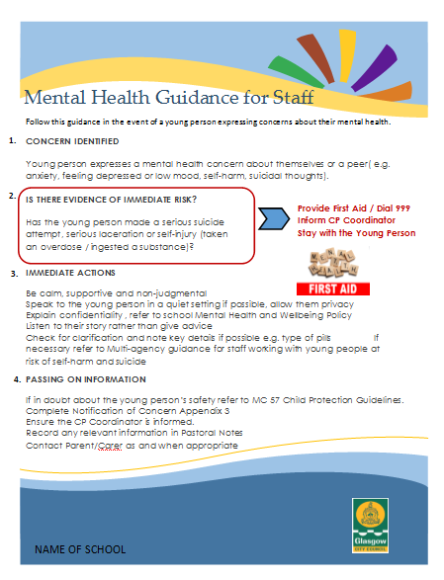

Confidentiality
We should be honest with regards to the issue of confidentiality. If it is necessary for us to pass our concerns about a pupil on then we should discuss with the pupil:
- Who we are going to talk to
- What we are going to tell them
- Why we need to tell them
We should never share information about a pupil without first telling them. Ideally, we would receive their consent, though there are certain situations when information must always be shared with another member of staff and/ or a parent, e.g. where a young person up to the age of 16 is at risk.

It is always advisable to share disclosures with a colleague, usually the Pupil Support staff, as this helps to safeguard our own emotional wellbeing as we are no longer solely responsible for the pupil, it ensures continuity of care in our absence and it provides an extra source of ideas and support. We should explain this to the pupil and discuss with them who it would be most appropriate and helpful to share this information with. Parents should be informed and pupils may choose to tell their parents themselves.

If a child gives us reason to believe that there may be underlying child protection issues, parents should not be informed, but the Child Protection Co-ordinator, INSERT NAME , must be informed immediately. Link to MC 57

Working with Parents/ Carers
Parents/ Carers are often very welcoming of support and information from the school about supporting their children’s emotional and mental health. In order to support parents/ carers we will:
- Highlight sources of information and support about common mental health issues on our school website;
- Ensure that all parents/carers are aware of who to talk to, and how to get about this, if they have concerns about their own child or a friend of their child;
- Make our mental health policy easily accessible to parents;
- Share ideas about how parents/carers can support positive mental health in their children through information evenings;
- Keep parents/carers informed about the mental health topics their children are learning about in HWB and share ideas for extending and exploring this learning at home.

Where it is deemed appropriate to inform parents/carers, we need to be sensitive in our approach. Before speaking to parents/carers, we should consider the following questions (on a case by case basis):
- Can the meeting happen face to face? This is preferable.
- Where and when should the meeting happen?
- Who should be present? Consider parents/carers, the pupil, other members of staff.
- What are the aims of the meeting?

It can be upsetting for parents/carers to learn of their child’s issues and many may respond with anger, fear or upset during the first conversation. We should be accepting of this (within reason) and give the parent/carer time to reflect.

We should always highlight further sources of information and give them leaflets to take away where possible as they will often find it hard to take much in whilst coming to terms with the news that you are sharing. Sharing sources of further support aimed specifically at parents/carers can also be helpful too e.g. parent/carer helplines and forums.

We should always provide clear means of contacting us with further questions and consider arranging a follow up meeting or telephone call in the near future as parents/carers often have many questions as they process the information. Finish each meeting with agreed next steps and always keep a brief record of the meeting on the pupil’s Pastoral Notes.

TO BE INCLUDED ONLY IF YOU HAVE STAFF TRAINED IN THESE, IF NOT THEN DELETE.

Mental Health First Aiders in School
The following members of staff are qualified Scottish Mental Health First Aiders.

Name | Department/Location

SafeTALK Trained Staff in School
The following members of staff have completed SafeTALK training:-

Name | Department/Location

ASIST (Applied Suicide Intervention Skills Technique) Trained Staff in School

The following members of staff have completed ASIST training:-

Name | Department/Location

Glasgow Education Services Policies and Guidance

The following documents can be easily accessed online:

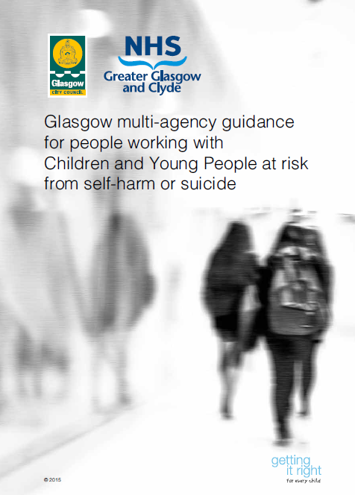
Multi-agency guidance for people working with children and young people at risk from self-harm or suicide Multi Agency Guidelines

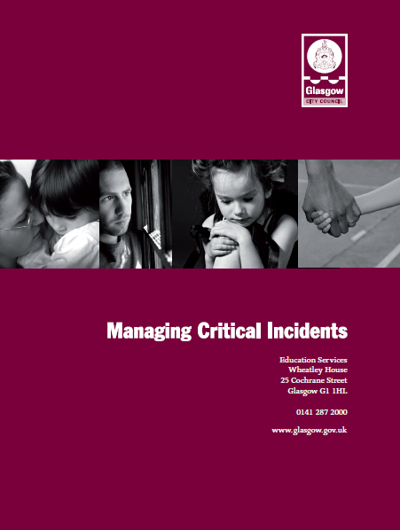
Critical incident Guidelines Critical Incident Guidelines, Critical Incident Appendices

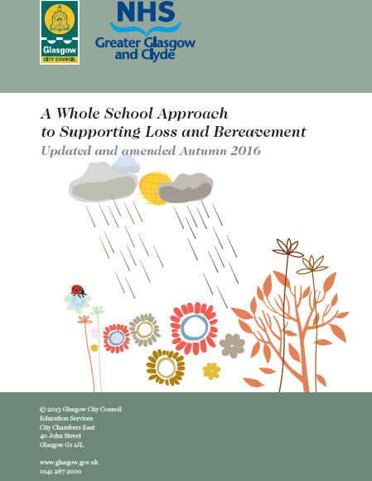
A Whole School Approach to Supporting Loss and Bereavement Loss and Bereavement Guidelines

Training
As a minimum, all staff will receive regular training about Nurture and recognising and responding to mental health issues and receive annual child protection training in order to enable them to keep all pupils safe.

Training opportunities for staff who require more in depth knowledge will be considered as part of our performance management process and additional Continuing Lifelong Professional Learning (CLPL) will be supported throughout the year where it becomes appropriate due developing situations with one or more pupils.

Where the need to do so becomes evident, we will host twilight training sessions for all staff to promote learning or understanding about specific issues related to mental health.

Suggestions for individual, group or whole school CLPL should be discussed with INSERT NAME, our CLPL Coordinator who can also highlight sources of relevant training and support for individuals as needed.

Policy Review
This policy will be reviewed every 3 years as a minimum. It is next due for review in September 2021.

Additionally, this policy will be reviewed and updated as appropriate on an ad hoc basis. If you have a question or suggestion about improving this policy, please contact the school INSERT DETAILS

This policy will always be immediately updated to reflect personnel changes.

Appendix A: Greater Glasgow and Clyde’s Mental Health Improvement Framework

To support implementation of the mental health improvement framework in Glasgow, a six element model was created to reflect the key categories for action required within each partnership area, with the recommendation that this be utilised in local partnership structures (Community Planning and/or Children Services Planning) to translate into local action plans. The model is supported by cross cutting themes of training and communication and addressing child poverty.

Resilience Development in Communities
Strong network of youth services, voluntary and community organisations, confident and skilled to support and intervene
Resilience Development in Schools
Whole school approach to mental health and wellbeing – ethos, curriculum, positive behaviour, anti-bullying, pastoral care…
One Good Adult Importance of dependable adult to supporting and protecting mental health of children and young people – e.g. strengthen parenting, mentoring, guidance, befriending initiatives

Guiding Thru the Service Maze
Children, families & young people have range of support options for early intervention and can be helped to find their way to appropriate help quickly
Responding to Distress
Frontline staff in many agencies are confident and supported to intervene and help children and young people in situations of distress, including self harm and risk of suicide
Peer Help & Social Media
Those who share their problems enjoy better mental health - build opportunities for young people to provide peer support, and to use social media for wellbeing

There has been a wide range of activity and resource development over the past eight years since the framework was developed. The six core elements have not been addressed in isolation; rather they are intrinsically interlinked and underpinned by tackling poverty, disadvantage and inequalities as well as having getting it right for every child (GIRFEC) core values and principles at the heart of it.

Promoting Resilience in Young People, in Families and the wider community

In our school we have taken the mental health improvement framework and mapped the range of supports that we offer in developing resilience and supporting wellbeing with the pupil at the centre but also working with families and the wider community to promote positive mental health.

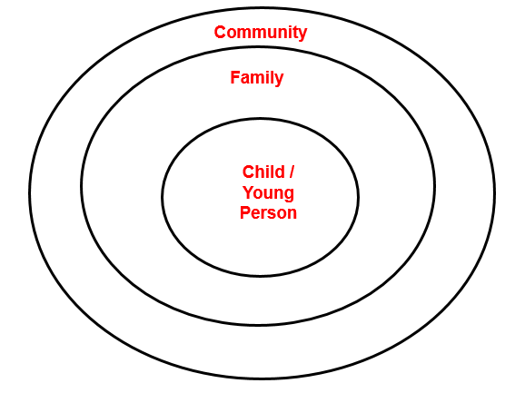

Examples of how we do this are provided below:

Support available to the Child / Young Person

INSERT SUPPORTS SPECIFIC TO YOUR ESTABLISHMENT

Support available to Families

INSERT SUPPORTS SPECIFIC TO YOUR ESTABLISHMENT

Support available to the wider community

INSERT SUPPORTS SPECIFIC TO YOUR ESTABLISHMENT

Appendix B: Information and guidance on mental health issues seen in young people

Below, we have sign-posted information and guidance about the issues most commonly seen in school-aged children. The links will take you through to the most relevant page of the listed website. Some pages are aimed primarily at parents but they are listed here because we think they are useful for school staff too.

Support on all of these issues can be accessed via Young Minds (www.youngminds.org.uk), Mind (www.mind.org.uk) and (for e-learning opportunities) Minded (www.minded.org.uk).

Self-harm
Self-harm describes any behaviour where a young person causes harm to themselves in order to cope with thoughts, feelings or experiences they are not able to manage in any other way. It most frequently takes the form of cutting, burning or non-lethal overdoses in adolescents, while younger children and young people with special needs are more likely to pick or scratch at wounds, pull out their hair or bang or bruise themselves.

Online support
SelfHarm.co.uk: www.selfharm.co.uk
National Self-Harm Network: www.nshn.co.uk

Books
Pooky Knightsmith (2015) Self-Harm and Eating Disorders in Schools: A Guide to Whole School Support and Practical Strategies. London: Jessica Kingsley Publishers

Keith Hawton and Karen Rodham (2006) By Their Own Young Hand: Deliberate Self-harm and Suicidal Ideas in Adolescents. London: Jessica Kingsley Publishers

Carol Fitzpatrick (2012) A Short Introduction to Understanding and Supporting Children and Young People Who Self-Harm. London: Jessica Kingsley Publishers

Depression
Ups and downs are a normal part of life for all of us, but for someone who is suffering from depression these ups and downs may be more extreme. Feelings of failure, hopelessness, numbness or sadness may invade their day-to-day life over an extended period of weeks or months, and have a significant impact on their behaviour and ability and motivation to engage in day-to-day activities.

Online support
Depression Alliance: www.depressionalliance.org/information/what-depression

Books
Christopher Dowrick and Susan Martin (2015) Can I Tell you about Depression?: A guide for friends, family and professionals. London: Jessica Kingsley Publishers

Anxiety, panic attacks and phobias
Anxiety can take many forms in children and young people, and it is something that each of us experiences at low levels as part of normal life. When thoughts of anxiety, fear or panic are repeatedly present over several weeks or months and/or they are beginning to impact on a young person’s ability to access or enjoy day-to-day life, intervention is needed.

Online support
Anxiety UK: www.anxietyuk.org.uk

Books
Lucy Willetts and Polly Waite (2014) Can I Tell you about Anxiety?: A guide for friends, family and professionals. London: Jessica Kingsley Publishers

Carol Fitzpatrick (2015) A Short Introduction to Helping Young People Manage Anxiety. London: Jessica Kingsley Publishers

Obsessions and compulsions
Obsessions describe intrusive thoughts or feelings that enter our minds which are disturbing or upsetting; compulsions are the behaviours we carry out in order to manage those thoughts or feelings. For example, a young person may be constantly worried that their house will burn down if they don’t turn off all switches before leaving the house. They may respond to these thoughts by repeatedly checking switches, perhaps returning home several times to do so. Obsessive compulsive disorder (OCD) can take many forms – it is not just about cleaning and checking.

Online support
OCD UK: www.ocduk.org/ocd

Books
Amita Jassi and Sarah Hull (2013) Can I Tell you about OCD?: A guide for friends, family and professionals. London: Jessica Kingsley Publishers

Susan Conners (2011) The Tourette Syndrome & OCD Checklist: A practical reference for parents and teachers. San Francisco: Jossey-Bass

Suicidal feelings and thoughts
Young people may experience complicated thoughts and feelings about wanting to end their own lives. Some young people never act on these feelings though they may openly discuss and explore them, while other young people die suddenly from suicide apparently out of the blue.

Online support
Prevention of young suicide UK – PAPYRUS: www.papyrus-uk.org

On the edge: ChildLine spotlight report on suicide: www.nspcc.org.uk/preventing-abuse/research-and-resources/on-the-edge-childline-spotlight/

Books
Keith Hawton and Karen Rodham (2006) By Their Own Young Hand: Deliberate Self-harm and Suicidal Ideas in Adolescents. London: Jessica Kingsley Publishers

Terri A.Erbacher, Jonathan B. Singer and Scott Poland (2015) Suicide in Schools: A Practitioner’s Guide to Multi-level Prevention, Assessment, Intervention, and Postvention. New York: Routledge

Eating problems
Food, weight and shape may be used as a way of coping with, or communicating about, difficult thoughts, feelings and behaviours that a young person experiences day to day. Some young people develop eating disorders such as anorexia (where food intake is restricted), binge eating disorder and bulimia nervosa (a cycle of bingeing and purging). Other young people, particularly those of primary or preschool age, may develop problematic behaviours around food including refusing to eat in certain situations or with certain people. This can be a way of communicating messages the child does not have the words to convey.

Online support
Beat – the eating disorders charity: www.b-eat.co.uk/about-eating-disorders

Eating Difficulties in Younger Children and when to worry: www.inourhands.com/eating-difficulties-in-younger-children

Books
Bryan Lask and Lucy Watson (2014) Can I tell you about Eating Disorders?: A Guide for Friends, Family and Professionals. London: Jessica Kingsley Publishers

Pooky Knightsmith (2015) Self-Harm and Eating Disorders in Schools: A Guide to Whole School Support and Practical Strategies. London: Jessica Kingsley Publishers

Pooky Knightsmith (2012) Eating Disorders Pocketbook. Teachers’ Pocketbooks

Appendix C: Sources of support outside of school

Support for Young People

Organisation | Main contact details | Topic addressed
Samaritans | Call free on 116 123 (UK)  Email: jo@samaritans.org | Confidential support service and are open 24 hours a day, 7 days a week.
ChildLine | 0800 1111: www.chidline.org.uk | Get help and advice about a wide range of issues, talk to a counsellor online
Breathing Space | Call for free on 0800 83 85 87  www.breathingspace.scot | Advice and support if you need someone to talk to. Their phone line is open 6pm-2am on Monday to Thursday and 6pm-6am on Friday to Monday.
Beat | The Beat Youthline is open to anyone under 25. Youthline: 0345 634 7650  www.b-eat.co.uk/ | UK’s leading charity supporting anyone affected by eating disorders, anorexia, bulimia, EDNOS or any other difficulties with food, weight and shape.
Aye Mind | www.ayemind.com/ | Making a digital toolkit for all who work with young people too, to boost their ability to promote youth wellbeing
Young Scot | Call 0808 801 0338 www.youngscot.org/ | It has information on a range of topics including mental health
LGBT Youth Scotland | Call us: 0131 555 3940 Text us: 07786 202 370 https://www.lgbtyouth.org.uk/  Email us: info@lgbtyouth.org.uk | Here to help support lesbian, gay, bisexual and transgender young people
SAMH | www.samh.org.uk/ | SAMH is the Scottish Association for Mental Health. SAMH believe there is no health without mental health. We're here to provide help, information and support.
See Me | https://www.seemescotland.org/ | See Me is Scotland's programme to tackle mental health stigma and discrimination
TESS: Text and Email Support Services | Text: 0780 047 2908  www.selfinjurysupport.org.uk follow links to email | For girls and young women affected by self-injury

Support for Parents/ Carers

Organisation | Main contact details | Topic addressed
The Samaritans | Call free on 116 123 (UK)  Email: jo@samaritans.org | Confidential support service and are open 24 hours a day, 7 days a week.
Young Minds | Parent helpline: 0808 802 5544  www.youngminds.org.uk | Free, confidential online and telephone support providing information and support
Parent Line Scotland | Call: 08000 28 22 33  Email: parentlinescotland@children1st.org.uk | Scotland’s free helpline, email and web-chat service, for anyone caring for or concerned about a child - open 9am- 9pm Mon to Fri.
GP | Contact your GP at your local Surgery | Speak to your GP if you are worried about your child’s mental health
NHS Choices | http://www.nhs.uk/conditions/stress-anxiety-depression/pages/mental-health-helplines.aspx | Whether you're concerned about yourself or a loved one, the helplines listed can offer expert advice

Appendix D: Talking to pupils when they express concerns about their mental health or wellbeing

The advice below is from pupils themselves, in their own words, together with some additional ideas to help you in initial conversations with pupils when they disclose mental health concerns. This advice should be considered alongside relevant school policies on pastoral care and child protection and discussed with relevant colleagues as appropriate.

Focus on listening

“She listened, and I mean REALLY listened. She didn’t interrupt me or ask me to explain myself or anything, she just let me talk and talk and talk. I had been unsure about talking to anyone but I knew quite quickly that I’d chosen the right person to talk to and that it would be a turning point.”

If a pupil has come to you, it’s because they trust you and feel a need to share their difficulties with someone. Let them talk. Ask occasional open questions if you need to in order to encourage them to keep exploring their feelings and opening up to you. Just letting them pour out what they’re thinking will make a huge difference and marks a huge first step in recovery. Up until now they may not have admitted even to themselves that there is a problem.

Don’t talk too much

“Sometimes it’s hard to explain what’s going on in my head – it doesn’t make a lot of sense and I’ve kind of gotten used to keeping myself to myself. But just ‘cos I’m struggling to find the right words doesn’t mean you should help me. Just keep quiet, I’ll get there in the end.”

The pupil should be talking at least three quarters of the time. If that’s not the case then you need to redress the balance. You are here to listen, not to talk. Sometimes the conversation may lapse into silence. Try not to give in to the urge to fill the gap, but rather wait until the pupil does so. This can often lead to them exploring their feelings more deeply. Of course, you should interject occasionally, perhaps with questions to the pupil to explore certain topics they’ve touched on more deeply, or to show that you understand and are supportive. Don’t feel an urge to over-analyse the situation or try to offer answers. This all comes later. For now your role is simply one of supportive listener. So make sure you’re listening!

Don’t pretend to understand

“I think that all teachers got taught on some course somewhere to say ‘I understand how that must feel’ the moment you open up. YOU DON’T – don’t even pretend to, it’s not helpful, it’s insulting.”

The concept of a mental health difficulty such as an eating disorder or obsessive compulsive disorder (OCD) can seem completely alien if you’ve never experienced these difficulties first hand. You may find yourself wondering why on earth someone would do these things to themselves, but don’t explore those feelings with the sufferer. Instead listen hard to what they’re saying and encourage them to talk and you’ll slowly start to understand what steps they might be ready to take in order to start making some changes.

Don’t be afraid to make eye contact

“She was so disgusted by what I told her that she couldn’t bear to look at me.”

It’s important to try to maintain a natural level of eye contact (even if you have to think very hard about doing so and it doesn’t feel natural to you at all). If you make too much eye contact, the pupil may interpret this as you staring at them. They may think that you are horrified about what they are saying or think they are a ‘freak’. On the other hand, if you don’t make eye contact at all then a pupil may interpret this as you being disgusted by them – to the extent that you can’t bring yourself to look at them. Making an effort to maintain natural eye contact will convey a very positive message to the pupil.

Offer support

“I was worried how she’d react, but my Mum just listened then said ‘How can I support you?’ – no one had asked me that before and it made me realise that she cared. Between us we thought of some really practical things she could do to help me stop self-harming.”

Never leave this kind of conversation without agreeing next steps. These will be informed by your conversations with appropriate colleagues and the schools’ policies on such issues. Whatever happens, you should have some form of next steps to carry out after the conversation because this will help the pupil to realise that you’re working with them to move things forward.

Acknowledge how hard it is to discuss these issues

“Talking about my bingeing for the first time was the hardest thing I ever did. When I was done talking, my teacher looked me in the eye and said ‘That must have been really tough’ – he was right, it was, but it meant so much that he realised what a big deal it was for me.”

It can take a young person weeks or even months to admit they have a problem to themselves, let alone share that with anyone else. If a pupil chooses to confide in you, you should feel proud and privileged that they have such a high level of trust in you. Acknowledging both how brave they have been, and how glad you are they chose to speak to you, conveys positive messages of support to the pupil.

Don’t assume that an apparently negative response is actually a negative response

“The anorexic voice in my head was telling me to push help away so I was saying no. But there was a tiny part of me that wanted to get better. I just couldn’t say it out loud or else I’d have to punish myself.”

Despite the fact that a pupil has confided in you, and may even have expressed a desire to get on top of their illness, that doesn’t mean they’ll readily accept help. The illness may ensure they resist any form of help for as long as they possibly can. Don’t be offended or upset if your offers of help are met with anger, indifference or insolence, it’s the illness talking, not the pupil.

Never break your promises

“Whatever you say you’ll do you have to do or else the trust we’ve built in you will be smashed to smithereens. And never lie. Just be honest. If you’re going to tell someone just be upfront about it, we can handle that, what we can’t handle is having our trust broken.”

Above all else, a pupil wants to know they can trust you. That means if they want you to keep their issues confidential and you can’t then you must be honest. Explain that, whilst you can’t keep it a secret, you can ensure that it is handled within the school’s policy of confidentiality and that only those who need to know about it in order to help will know about the situation. You can also be honest about the fact you don’t have all the answers or aren’t exactly sure what will happen next. Consider yourself the pupil’s ally rather than their saviour and think about which next steps you can take together, always ensuring you follow relevant policies and consult appropriate colleagues.

Appendix E: Referring to Child and Adolescent Mental Health Services (CAMHS)?

CAMHS operate within very specific criteria as defined by CAMHS HEAT Target. For a child or young person to be referred and seen by CAMHS they must meet both conditions below:-

Condition 1 (basic threshold)
- A child/young person has or is suspected to have a mental disorder or other condition that results in persistent symptoms of psychological distress.
Condition 2 (complexity and severity threshold) There is also the existence of at least one of the following:
- An associated serious and persistent impairment of their day to day social functioning.
- An associated risk that the child/young person may cause serious harm to themselves or others.

Examples of CAMHS Referrals

- Moderate/severe anxiety
- Moderate/severe low mood
- Self-harm
- Suicidal thoughts/intent
- Eating Disorders
- Distorted body image
- Psychosis
- Voice hearing, hallucinations
- Mood disturbance
- Tics/Tourette's
- Obsessive Compulsive Disorder (OCD)
- Post Traumatic Stress Disorder (PTSD)
- Attention Deficit and Hyperactivity Disorder (ADHD)
Often with complexity e.g. within the context of early trauma, difficult family relationships, social work involvement, Care Experienced (Looked After), underlying neurodevelopment difficulties e.g. autism spectrum conditions, learning disability, ADHD, language/SLT difficulties, sensory difficulties and physical health difficulties e.g. diabetes, coordination problems etc.

CAMHS Referrals process

- Referrals are screened every day by duty clinician(s) to determine whether or not they are appropriate for CAMHS and whether they need prioritised.
- The Duty clinician may contact the referrer for further information (or for complex referrals in some teams may be discussed at a referral meeting).
- If you unsure about suitability of a referral or if a referral is urgent then you should contact the local team and ask for the duty clinician.

Information required when making a referral to CAMHS

It is important that the referrer provides as much information as possible (and with consent) to CAMHS to allow them to confirm that the referral meets the 2 conditions as stated.

- Child / Young Person’s Name
- Child / Young Person’s Date of Birth
- Details of the Referrer (if not the General Practitioner GP)
- (If possible, it is helpful to copy your letter to GP for their information with family’s consent)
- Indication of the degree of urgency of your referral (Emergency/Routine)
- CHI number (if from health services)
- Current Home Address and contact telephone number
- The name of their GP and, if possible, Care First number if known to Social Work Services
- Outline of family composition and background (including who has parental responsibility for them if under 16 years)
- If they, or the person who has parental responsibility: have consented to a referral to CAMHS, whether an interpreter is required, access requirements for any member of the family, any possible literacy difficulties with parents.
- What school they attend
- Details of any other agencies (past or present) involved with any family member and relevant family
- Details of social or medical background, any risk factors within family/home environment
- Description of the difficulties that make you think they may have a moderate to severe mental health problem, including: Onset and duration, relevant family, medical or educational difficulties, relevant recent events, interventions already tried, other services referred to, any disability, including sensory impairment and nature/extent of that disability
- Please indicate if you wish to be copied into letters regarding appointment details (and family consent)
- For eating problems please provide current weight and height, and the speed and amount of any changes in the young person’s physical and mental state.

Additional Helpful Information

- As much detail as possible about the difficulties:
- When difficulties started (and anything happening at that time)
- How often difficulties occur, any typical patterns or triggers (e.g. better/worse at home or school, better/worse in morning/evening, in busy environments, when told no…etc).
- What helps/what makes difficulties worse?
- What strategies or supports are in place or have already been tried by the family and in school? (e.g. nurture group, parenting supports, befriending).
- The impact of difficulties on all aspects of their life e.g. details of whether difficulties interfere with learning, socialising, home life, activities.
- Do you personally have any ideas about what might be maintaining the difficulties or what might need to change to improve the situation?

Contact Details for CAMHS in NHS Greater Glasgow and Clyde

North CAMHS
Callander Street Clinic
11 Callander Street, Glasgow G20 7JZ
Tel: 0141 232 9010

South CAMHS
Twomax Centre, Old Mill Studios, 5th Floor,
187 Old Rutherglen Road, Glasgow G5 ORE
Tel: 0141 300 6380

North East CAMHS
Templeton on the Green, 1st Floor,
62 Templeton Street, Glasgow
Tel: 0141 227 7515

West CAMHS
West Centre, 60 Kinfauns Drive,
Glasgow G15 7TS
Tel: 0141 207 7100

East Renfrewshire CAMHS
Barrhead Health Centre
213 Main Street, Barrhead,
Glasgow G78 1SL
Tel: 0141 800 7886

West Dunbartonshire CAMHS
Acorn Centre, Vale of Leven Hospital,
Main Street, Alexandria G83 OUA
Tel: 01389 817324

Renfrewshire CAMHS
Aranthrue Centre, 103 Paisley Rd,
Renfrew, PA4 8LH
Tel: 0141 886 5921

Inverclyde CAMHS
Larkfield Child and Family Centre,
Larkfield Road, Greenock, PA16 OXN
Tel: 01475 504447

Appendix F: Supporting the Wellbeing of staff in our school

