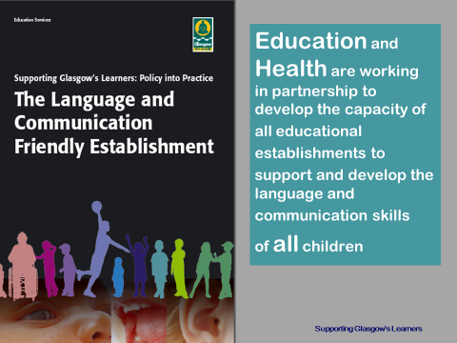

LCFE journey so far and contribution to closing the gap
- 96 establishments engaging with the LCFE process
- Of those, 60% have over 70% of their population in SIMD 1 and 2
- 18% have over 90% of their population in SIMD 1 and 2
- Implementation science approach taking forward those establishments who are ready for change
- Robust quality assurance process that is based on school self-evaluation. Programme of validation and follow up visits. Multi-agency team with peer head. Peer head role built in as sustainable aspect of programme.
- Supported by peer observation to support embedding and sustainability
- Mentoring role to build capacity and sustainability – model for peer observation

Impact
LCFE validated establishments make significantly more use of the evidence-based strategies that speech and language therapist and educational psychologist advise (as evidenced in the recent SLT/ Education Review exercise). They seek more consultation with SLT prior to referring an individual child. Non-validated establishments seek more support than validated.
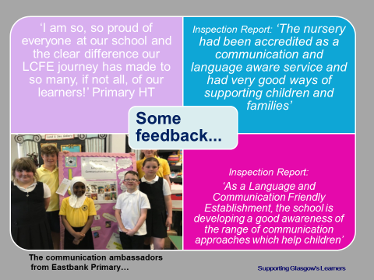

Next Steps
- 13 establishments to be validated February- June 19.
- Gather evidence around impact – reference group of heads planned for May 19. Data analysis to be carried out – i.e. JST/CIG referral rate for validated establishments.
- Continue to ensure robust quality assurance programme and to make sustainable by further extending the peer head role and training for peer heads
- 3 year objective to have all local authority 112 nurseries validated
- Contribute to the training and development of Leaders of Early Learning (LEL) and new graduates
- In response to increasing levels of interest, increase the profile of LCFE through Twitter, Open Doors (26.02.19) and head teacher forums
- Seminar proposal for Scottish Learning Festival submitted for 2019.

Inclusion Support & Development Groups
We are continuing to deliver Inclusion Support & Development Groups (SDGs) jointly with Speech & Language Therapy to education staff from Early Years establishments and Primary Schools (across 5 sessions) on an area basis. Groups are being well attended this session. We have strengthened the initial needs analysis process and the format of each group reflects identified needs of participants.
(See report session 2017-18)
Next Steps
- Call back meetings being taken forward this session to carry out long-term evaluation with participants; focus on what impact attending the SDG had on their practice/ impact on establishment as a whole.
- Evaluation meeting for all facilitators (EPs & Speech Therapists) in May 19.
- Evaluation report to be written and distributed – By August 19.

Alternative Autism Strategies
Two training sessions with a call back re-connector are being delivered between January and May 2019. These will highlight the support needs of children and young people whose profile of needs doesn’t readily respond to more widely recognised autism-friendly practices and who require new understanding and alternative strategies to support their needs. The courses are available to ASL staff and staff working in mainstream establishments who have completed the advanced autism course available through the Autism Resource Centre (ARC).
This training is proving to be very popular with 30 participants attending each session.

Glasgow Psychological Service Speech Language and Communication Needs City Lead Group is led by Jane Evans, Senior Educational Psychologist who is based in our NE office

