Sam
Sam is in his preschool year and is currently being assessed by the Local Autism Team for possible ASD. He attends 5 mornings but is struggling to cope with the free flow of nursery floor. He likes repetitive activities and prefers solitary play. He can respond well to one to one support but there are 30 children in the nursery and Sam does not like to being given direct instructions. Sam has good receptive language and expressive skills. When told that he cannot do something Sam can rapidly become distressed, or when asked by staff to move on from one activity to the next. He can become very agitated and will try to run away and if confronted will lash out by kicking or trying to hit staff. This can happen several times each session when he is asked to engage with other children, for example at story time or at snack time.
Sam's parents do not want to share what his behaviour at home is like, they will blame the nursery for asking him to do too much and want him to have more one to one support.
San has recently started to target another child who has additional support needs. He recently bit the other child when he tried to take a plastic shovel from Sam at the sand pit. This led to staff having to intervene and the other child's parents had to be contacted due to the injury.
Questions
Who are the key people for Sam?
What further information may be required?
What risks does Sam present to staff, other children, self?
What needs might Sam have (All Behaviour is Communication)?
What adaptations may be required to support Sam?
Are there others that need to be involved in the risk assessment / plan?
Who should be aware of the risk assessment plan?
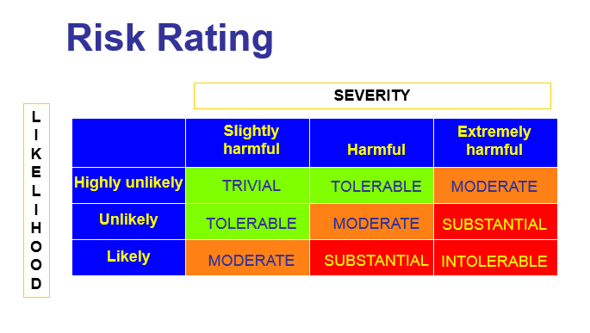
Now look at the risk assessment proforma and discuss how you would complete it for Sam?

Julie
Julie is in Primary 5 and lives with her grandparents who have custody and have looked after her for the past 6 years. Julie's mother has a long history of alcohol abuse and has weekly supervised access through Social Work Services, she does not have any contact with her father.
Julie's grandparents are elderly and although they do the best they can for Julie they find it difficult to manage her behaviour at home. Her grandfather takes an authoritarian approach and believes in a strong discipline.
Over the past year Julie has started to become distressed in class, this often coincides with access visits to her mother.
Julie's behaviour can escalate very quickly, she will swear at staff and try to leave the class. Recently she has run out of the class when distressed and has been found hiding in the stair well. Although she has not left the school, the SMT are worried that she may leave and put herself at risk.
On the last occasion the HT contacted the grandparents and her grandfather attended. This led to Julie becoming more distressed and her being taken home very upset.
Questions
Who are the key people for Julie?
What further information may be required?
What risks does Julie present to staff, other children, self?
What needs might Julie have (All Behaviour is Communication)?
What adaptations may be required to support Julie?
Are there others that need to be involved in the risk assessment / plan?
Who should be aware of the risk assessment plan?
Now look at the risk assessment proforma and discuss how you would complete it for Julie?

Peter
Peter is a Primary 7 pupil. Staff are aware of his trauma history and possible attachment issues. His father was imprisoned for murder and his mother has mental health issues. His mother was recently hospitalised following an overdose and Peter was accommodated in a Children Unit in Glasgow. He is the youngest person there. He has a Social Worker and a referral to Notre Dame Centre has been made.
Over the past few months since starting P7, he has started to present with behaviours such as walking out of class and punching the corridor wall. The majority of staff are concerned for him and are being sensitive to his changing needs however not all staff are sympathetic towards his difficult history and do not fully understand why he receives what they view as ‘special’ treatment. The HT and DHT have tried to involve Peter in other schools activities when he shows positive behaviour.
He has become increasingly resistant to doing work, despite previously being engaged in similar activities he has also begun randomly tearing or throwing away his work books. This pattern of behaviour does not relate to any previous triggers. Staff recognise that there is a need to intervene however they do not feel confident in how to de-escalate or, when he reaches crisis point, what options they have.
Questions
Who are the key people for Peter?
What further information may be required?
What risks does Peter present to staff, other children, self?
What needs might Peter have (All Behaviour is Communication)?
What adaptations may be required to support Peter?
Are there others that need to be involved in the risk assessment / plan?
Who should be aware of the risk assessment plan?
Now look at the risk assessment proforma and discuss how you would complete it for Peter?

