3. Results

3.1 ESTABLISHMENT 1
The data gathered from focus groups, interviews and questionnaires administered within Establishment 1 has been analysed and triangulated, for which the information gathered is presented under the following themed headings in this section: ‘How has FTT been implemented?’ illustrated as Figure 2; ‘Why has FTT been implemented this way?’ illustrated as Figure 3; ‘Next Steps for the implementation of FTT’ illustrated as Figure 4; ‘What has supported implementation of FTT?’ as Figure 5; ‘What are the potential barriers of implementation of FTT?’ as Figure 6; and finally ‘What has been the impact of FTT?’ illustrated as Figure 7.

3.1.1 How has FTT been implemented?
Questionnaires and interviews held within Establishment 1 identified a number of ways FTT has been implemented within the nursery, which will be further expanded upon within the next section.

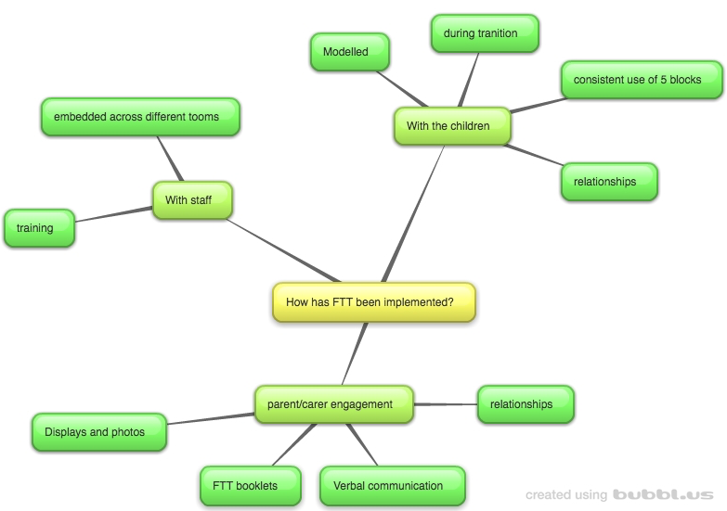

Figure 2: Establishment 1 – How has FTT been implemented?
The themes outlined above with regards to how FTT has been implemented in Establishment 1 have been collated from data gathered from staff questionnaires, staff interviews and parent/carer interviews.
It has emerged from the data that FTT has been implemented with staff through the initial KCA Training of FTT for which specific members of staff from the 0-2 room attended. Since this time, management “saw the good practice used and wanted to embed FTT in the older rooms”, and so the approach has been filtered through into the other playrooms.
Within these playrooms staff and parents/carers reported that the FTT approach has been implemented by members of staff “consistently using the five building blocks” in engaging with children, but also with other members of staff and parents/carers, thus modelling the approach with adults in the children’s lives. This modelling is reported to be of particular importance during times of transition - “the child knows and trusts me and can see if I’m cuddling the new adult, they can trust them too”. Thus, the modelling of the approach is used to promote relationships between the children and their new caregiver.
The approach has also been implemented through the engagement of parents/carers. This has taken a number of forms, inclusive of displays of the FTT building blocks alongside photos of the children and adults demonstrating the principles. Furthermore, the staff and parents/carers reported the relationship between the two parties to be “brilliant” which has played a factor in communicating the approach, either through discussion or through the modelling as described above. The FTT booklets have also been reported as being used to communicate the approach with parents/carers.

3.1.2 Why has ftt been implemented this way?
Questionnaires and interviews held within Establishment 1 identified a number of reasons FTT has been implemented the way it has within the nursery, which will be further expanded upon within the next section.
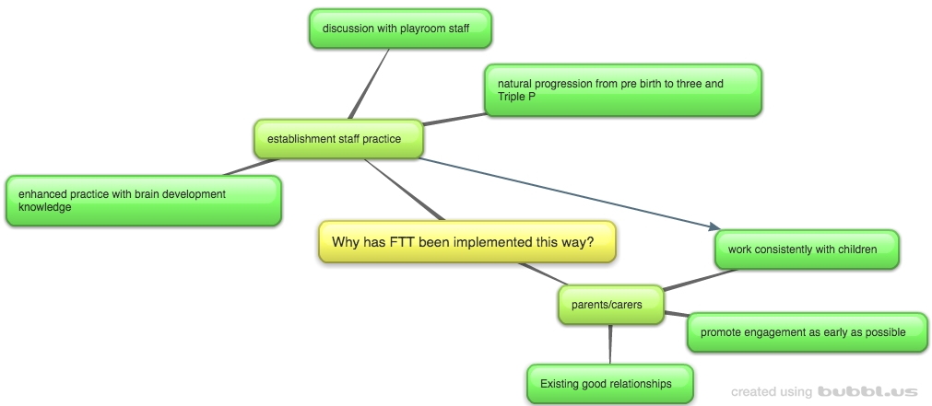

Figure 3: Establishment 1 – Why has FTT been implemented this way?
The illustrated themes in Figure X have been collated from the staff questionnaires and interviews as well as the parent/carer interviews. FTT has been implemented the way it has been illustrated in the previous section so as to be able to “enhance practice with the knowledge of brain development” throughout different playrooms, using an approach, FTT, that the staff deemed to be a “natural progression from what we were doing before” (named within other data gathering methods as Pre birth to 3 and Triple P). Furthermore, it was highlighted that this was done after discussion with all of the playroom staff.
In terms of why the aforementioned methods were used for engaging parents/carers, the staff in establishment 1 reported the existing good relationships supported implementation through modelling and verbal communication, with the aim to “promote engagement through the five building blocks as early as possible”. Engaging the parents/carers in FTT was done so as to promote consistent working with the children attending, with “everyone using the five blocks consistently”.

3.1.3 NEXT STEPS
Questionnaires and interviews held within Establishment 1 identified a number of next steps for the implementation of FTT nursery, which will be further expanded upon within the next section.

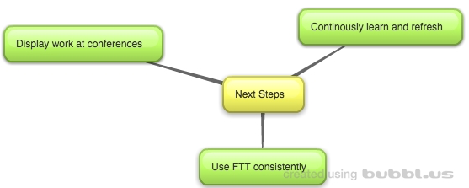
Figure 4: Establishment 1 – What are the next steps?
Illustrated above are the key themes emerging from analysis of the data, for which staff have identified follow up opportunities for FTT implementation as being able to “promote our work to other nurseries at conferences”. It was further established that in terms of implementation within the establishment, FTT needs to be continuously used by “all members of staff and parents so that we can work consistently using the five blocks”. It emerged that in order to do so, members of staff will need to continuously learn and refresh in the approach.

3.1.4 Supporting factors in implementation of ftt
Questionnaires and interviews held within Establishment 1 identified a number of supporting factors for the implementation of FTT within the nursery, which will be further expanded upon within the next section.

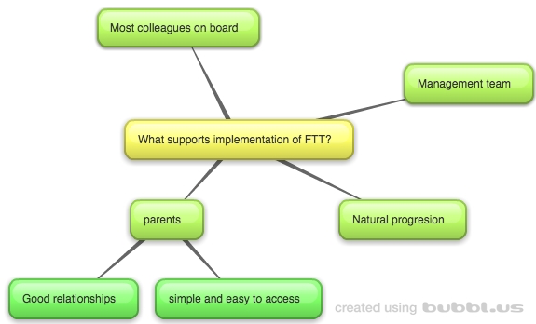

Figure 5: Establishment 1 – What supports implementation of FTT?
The themes illustrated in Figure 5 are collated from all methods of data gathering for Establishment 1.
Supports identified in implementing FTT have included the good relationships held between staff and parents/carers, which has allowed for “good verbal communication about the five blocks” as well as being able to model the principles of interaction for the children.
Furthermore, it was established from staff members that implementation of the approach was supported in the establishment as a whole by the ”majority of staff being on board” as well as the management team being in full support of implementing the approach across numerous playrooms in the establishment.
Lastly, another support of implementation of FTT was identified by staff as being a “natural progression of what we were already doing”, in relation to both the approaches being used within the establishment already (such as Triple P and the pre-birth to three document) and the good practice being used already, for which the FTT approach was enhancing by “raising awareness of the importance of interaction with children”.

3.1.5 Barriers in implementation of ftt
Questionnaires and interviews held within Establishment 1 identified a number of potential barriers for the implementation of FTT within the nursery, which will be further expanded upon within the next section.
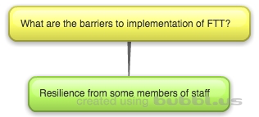

Figure 6: Establishment 1 – What are the barriers to implementation of FTT?
Only one barrier was identified within the data gathered from staff members and parents/carers regarding the implementation of FTT, which was that “some members of staff are not as willing to use the approach”. It was noted in discussion that some members of staff were used to more “traditional ways of working” however staff noted the approach was being more readily embedded across play rooms when the benefits of FTT were visible in the children, to be further expanded upon in the next section.

3.1.6 what has been the impact of ftt?
Questionnaires and interviews held within Establishment 1 identified the impact of FTT on the children, parents/carers and staff members of the nursery, which will be further expanded upon within the next section.

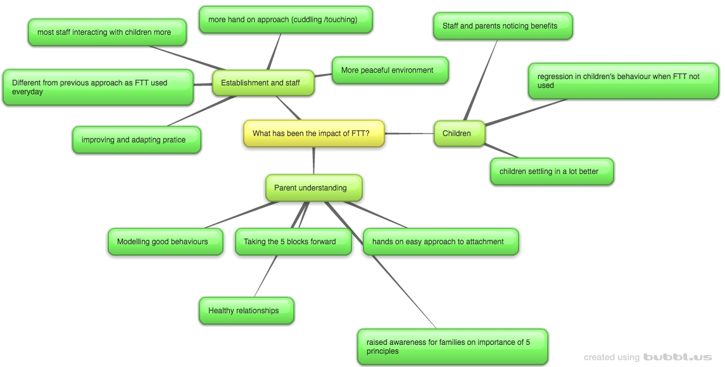
Figure 7: Establishment 1 – What has been the impact of FTT?
The above figure is an illustration of collated themes drawn from information gathered from staff members and parents/carers of children attending the establishment.
With regards to the staff members within the establishment, it was identified by staff that the practice within the nursery is adapting and improving due to the FTT approach. Further indicators of impact include that staff felt that FTT was different from other approaches as “we can use it visibly in our practice everyday” as well as being more hands on than other approaches in that it promotes cuddling and touch for promoting development. Furthermore, staff noted that the majority of staff were interacting more with the children attending due to the benefits seen from using the approach with the children.
These benefits have been documented in the data gathering from both parents and staff as the children settling into their environment much better since using the approach. Furthermore, members of staff noted that when a change in staff member meant the approach “was not being used, the child’s behaviour was regressing… using the approach again and letting the staff member know the child was much happier and more settled”.
Another indicator of the impact of the implementation of FTT was parent/carers understanding of the approach. It was identified during parent interviews that parents understood FTT as being an approach for promoting healthy relationships and “taking the five blocks forward”. Parents/carers also understood the approach to be a hands on approach to attachment, for which they felt their own interactions with their children were improved as well as being able to show family members the importance of engaging with the child.

3.2 ESTABLISHMENT 2
The data gathered from focus groups, interviews and questionnaires administered within Establishment 2 has been analysed and triangulated, for which the information gathered is presented under the following themed headings in this section: ‘How has FTT been implemented?’ illustrated as Figure 8; ‘Why has FTT been implemented this way?’ illustrated as Figure 9; ‘Next Steps for the implementation of FTT’ illustrated as Figure 10; ‘What has supported implementation of FTT?’ as Figure 11; and finally ‘What has been the impact of FTT?’ illustrated as Figure 12.

3.2.1 How has FTT been implemented?
Questionnaires and interviews held within Establishment 2 identified a number of ways FTT has been implemented within the nursery, which will be further expanded upon within the next section.

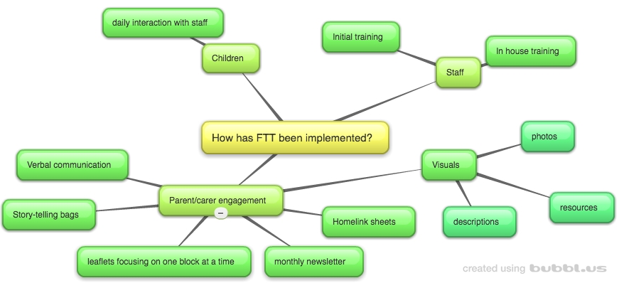
Figure 8: Establishment 2 – How has FTT been implemented?
Figure 8 above illustrates the collated themes emerging from the data gathered from parents/carers and staff of establishment 2.
It emerged from the data collected that FTT has been implemented with staff either attending the initial KCA training held last year, or through in house training from the establishment using the FTT resources.
Using this knowledge from either sets of training, staff members from establishment 2 have sought to engage parents/carers through a number of routes. This includes written documentation that has been handed to parents/carers regarding FTT, for which the establishment “focus on one of the blocks at a time for the leaflets and home link sheets to make it more manageable”. Data gathered also indicated an established link between the establishment’s storytelling bags that have gone home with the children form the nursery promoting interaction, as well as a monthly newsletter that is distributed amongst parents/carers. Lastly, all participants made mention of the visuals within the establishment promoting FTT through a combination of the resources provided and photos of the children attending with parents/carers or staff promoting the principles.
It also emerged from the data that the approach is implemented with the children through the daily interaction they have with staff, who are actively using the approach in the playroom to “enhance our existing skills”.

3.2.2 Why has ftt been implemented this way?
Questionnaires and interviews held within Establishment 2 identified a number of reasons FTT has been implemented the way it has within the nursery, which will be further expanded upon within the next section.
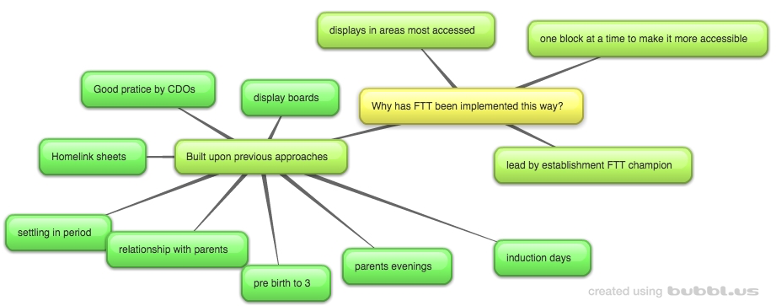
Figure 9: Establishment 2 – Why has FTT been implemented this way?
The above illustration is formed from collated data gathered from staff members.
A number of staff members commented on the previous approaches used within the nursery, which were built upon for the implementation of FTT. This is inclusive of parental interactions, such as parents evening, display boards and home link sheets. A number of these existing approaches were therefore selected to promote FTT making use of the “good relationships we have with parents here”.
In terms of the display boards, the establishment staff indicated that they endeavoured to promote FTT within the areas most accessed within the nursery, for example “we put photos and descriptions above the hooks where they put their jackets” so as to be able to make the resources as accessible as possible.
Focusing on one block at a time was established as an appropriate way to implement FTT as it was thought to “be easier to follow for our parents” when giving out leaflets.
The way in which the approach was implemented throughout this establishment was identified by staff members as by the FTT ‘champion’ within the nursery who sought to embed the approach.

3.2.3 NEXT STEPS
Questionnaires and interviews held within Establishment 2 identified a number of next steps for the implementation of FTT nursery, which will be further expanded upon within the next section.

Figure 10: Establishment 2 – What are the next steps?
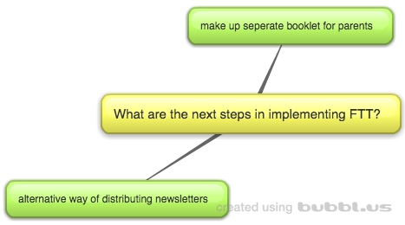
The above figure illustrates staff members’ views regarding the next steps of implementation.
The staff at this establishment felt that the newsletters were a good way to get information to parents/carers but “a lot of the time the newsletter ends up in the junk mail folder in the parents emails” – and so discussion took place considering other possible means of distributing newsletters.
Furthermore, all participating staff identified that they would like to be able to hand the parents/carers a separate booklet highlighting the importance of interaction and phones: “some need to know how important it is to be talking to your child instead of being on the phone”. All staff participating felt an easily accessible booklet would be beneficial for further promoting engagement.

3.2.4 Supporting factors in implementation of ftt
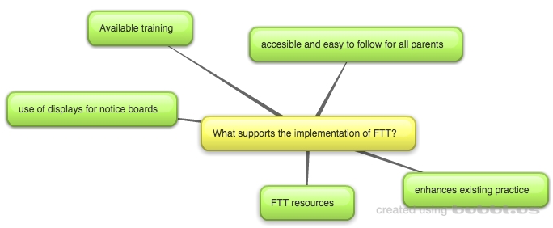
Questionnaires and interviews held within Establishment 2 identified a number of supporting factors for the implementation of FTT within the nursery, which will be further expanded upon within the next section.

Figure 11: Establishment 2 – What supports the implementation of FTT?
The above figure illustrates the collated views of participating staff members during data collection.
Staff members felt that the principles of FTT were being used in the establishment prior to the introduction of the approach, however FTT was enhancing existing practice by helping putting a name to it and “bringing in brain development”.
A number of staff also commented the usefulness of the FTT resources in terms of promoting engagement from parents/carers. This also has implications for the displays around the establishment as the resources provide visuals.
Further supports identified were that staff felt that the approach was “written in clear and easy to follow language for all of our parents to be able to access” thus promoting parent/carer engagement in the approach.
Lastly, the staff members of this establishment commented on the training of the approach, enabling staff members to be able to embed FTT in the establishment.

3.2.5 Barriers in implementation of ftt
Questionnaires and interviews held within Establishment 2 identified no potential barriers to the implementation of FTT.

3.2.6 what has been the impact of ftt?
Questionnaires and interviews held within Establishment 2 identified the impact of FTT on the children, parents/carers and staff members of the nursery, which will be further expanded upon within the next section.
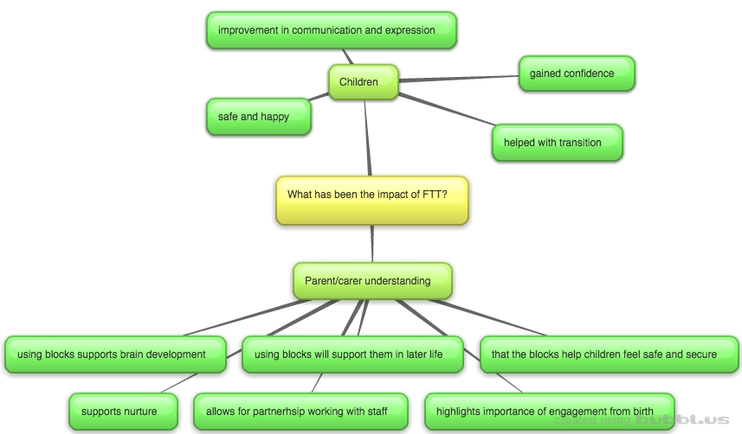

Figure 12: Establishment 2 – What has been the impact of FTT?
The above figure illustrates the collated views of staff members and parents/carers of establishment 2.
Part of the demonstrated impact in implementing the FTT approach in establishment 2 is the parents/carers understanding of what the FTT is and what the purpose of using it is. Parent/carer understanding included knowledge of what the five blocks were for, for which they identified “using the five blocks supports brain development” “using the blocks from FTT will support them when they have grown up and for later life”, and “that the blocks help children to feel safe and secure”. Furthermore, parents/carers were able to identify that FTT supports nurture, whilst “showing us the importance of interacting with our children from when they are born”. Furthermore, parents identified that the approach allows for partnership working with staff as it “means we are using the same approach consistently with our children”.
In terms of the impact of the approach with children, it was identified that participants perceived children to have “got more confident” and “feeling safe and happy” within the nursery and home environment. One parent also noted there had been improvements in their child’s communication and expression of emotion. Lastly, staff members noted that using the approach was helping in transition between rooms within the nursery, whereby children were settling in more quickly.

3.3 ESTABLISHMENT 3
The data gathered from focus groups, interviews and questionnaires administered within Establishment 3 has been analysed and triangulated, for which the information gathered is presented under the following themed headings in this section: ‘How has FTT been implemented?’ illustrated as Figure 13; ‘Why has FTT been implemented this way?’ illustrated as Figure 14; ‘Next Steps for the implementation of FTT’ illustrated as Figure 15; ‘What has supported implementation of FTT?’ as Figure 16; and finally ‘What has been the impact of FTT?’ illustrated as Figure 17.

3.3.1 How has FTT been implemented?
Questionnaires and interviews held within Establishment 3 identified a number of ways FTT has been implemented within the nursery, which will be further expanded upon within the next section.

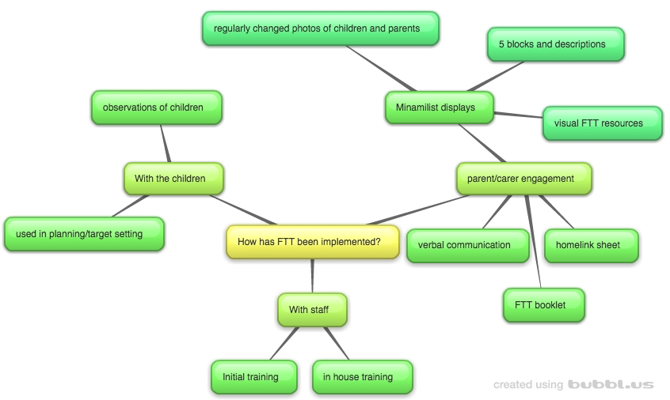

Figure 13: Establishment 3 – How has FTT been implemented?
The above figure illustrates the collated perceptions of staff members and parents/carers of establishment 3.
Staff members reported that FTT had been implemented throughout staff members through attendance at the KCA FTT initial training for some staff, as well as continuous in house training throughout the year for refresher knowledge.
Furthermore, implementation has included engaging the parents/carers through a number of approaches. These have included homelink sheets containing information regarding FTT, FTT booklets and verbal communication between staff members and parents/carers. Furthermore, the use of visuals has been widely used within the context inclusive of the FTT resources as well as visual representation of the five blocks, alongside descriptions of which of these are. These have been captured in “minimalist displays around the nursery” which include “regularly changed photos of children and adults illustrating the five blocks”.
Finally, with the children I their establishment, staff members discussed the ways in which the approach was being implemented in terms of their development. This included observations of children within the establishment “using the five blocks to see where they are” following on to the beginning of implementation of the five blocks in children’s planning documentation and individual target setting.

3.3.2 Why has ftt been implemented this way?
Questionnaires and interviews held within Establishment 3 identified a number of reasons FTT has been implemented the way it has within the nursery, which will be further expanded upon within the next section.
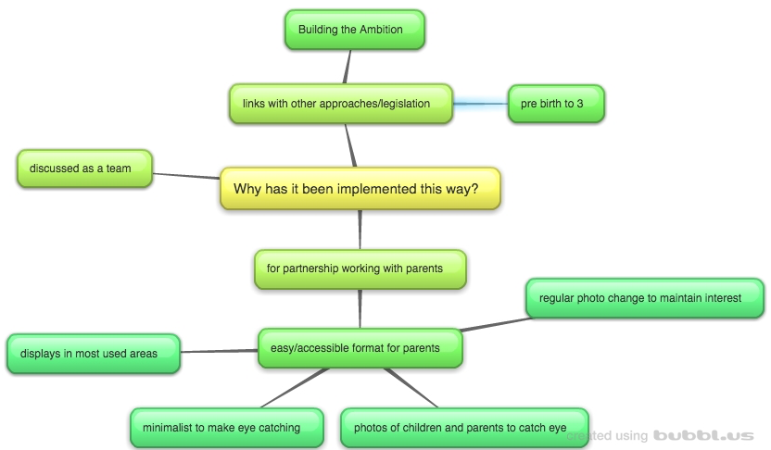

Figure 14: Establishment 3 – Why has it been implemented this way?
The above figure illustrates the collated views of the staff members within establishment 3.
Staff members noted that the FTT approach links in with other approaches and legislation utilised within the establishment, inclusive of Building the Ambition and pre-birth to 3.
Furthermore, staff noted the importance in working in partnership with parents by engaging them, using an “easy to understand format for the parents through our displays in the nursery”. In exploring the methods used for the displays during focus group discussion, staff members highlighted that the displays were in the areas where parents/carers were most likely to see them (inclusive of above coats outside the playrooms), which are “minimalist so that they “pop” out and are more eye catching” and include photos of the children that are regularly changed so as to “keep up the interest in looking at the displays”.
Staff also highlighted that the choice in implementation was discussed amongst the team and agreed on best course of action.

3.3.3 NEXT STEPS
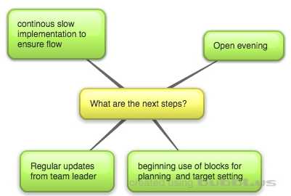
Questionnaires and interviews held within Establishment 3 identified a number of next steps for the implementation of FTT nursery, which will be further expanded upon within the next section.

Figure 15: Establishment 3 – What are the next steps?
The above figure highlights key themes triangulated from the views of staff members in establishment 3.
Next steps identified by the team acknowledge the upcoming open evening to be held where “nurseries can see how you can use FTT in every day practice”. Furthermore, staff members reported that the implementation of the approach throughout the establishment has been slow “we don’t want to bombard all at once – it needs to be a slow steady process to make sure it flows through the nursery” thus it was acknowledged that implementation would continue to be slow and steady. The identified next stage of the implementation within their establishment was using the five blocks within individual children’s planning and for use of target setting. In addition, staff had said they would continue to get regular updates from their tem leader as the implementation process continues throughout the establishment.

3.3.4 Supporting factors in implementation of ftt
Questionnaires and interviews held within Establishment 3 identified a number of supporting factors for the implementation of FTT within the nursery, which will be further expanded upon within the next section.
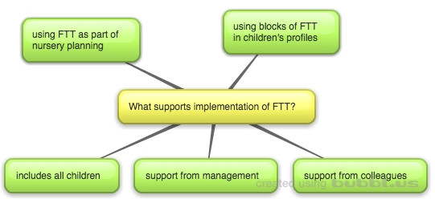
Figure 16: Establishment 3 – What supports implementation of FTT?
The above figure is an illustration of the collated views of staff members in establishment 3.
Staff members indicated that the support received from management as well as from colleagues within the establishment helped to support the implementation of FTT. Furthermore, the embedding of the approach within planning for the establishment and for individual children helped to “keep FTT at the front of our minds” within everyday practice. This point was further supported by staff members perceptions that the FTT approach is applicable to all children, and supports all children, and that it’s therefore “used In everyday practice”.

3.3.5 Barriers in implementation of ftt
Questionnaires and interviews held within Establishment 3 identified no barriers in implementation of FTT.

3.3.6 what has been the impact of ftt?
Questionnaires and interviews held within Establishment 3 identified the impact of FTT on the children, parents/carers and staff members of the nursery, which will be further expanded upon within the next section.

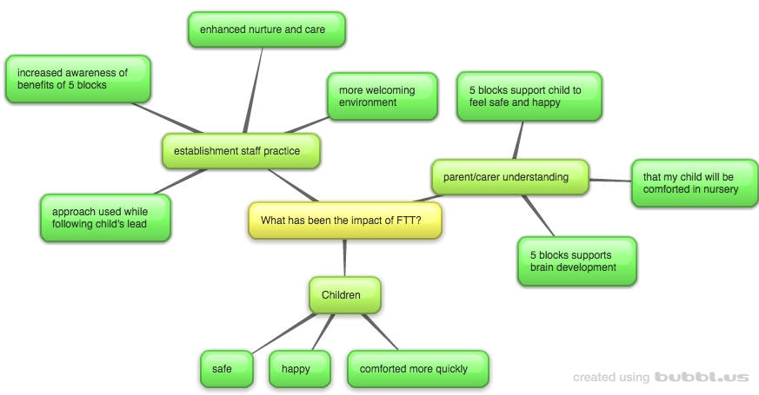

Figure 17: Establishment 3 – What has been the impact of FTT?
The above figure illustrates the perceived impact of FTT, triangulated from staff members and parents/carers of establishment 3.
In terms of staff practice, participants reported that they felt the environment was “more welcoming” whilst members of staff were more “enhanced in their practice in terms of their nurture and care with the children who come here”. Staff practice was also impacted upon reportedly due to increased awareness of the importance of the five blacks for engagement with children and the benefits of using them, for which the staff have said they now use while “we follow the child’s lead”.
Impact has also been demonstrated in terms of the parents/carers awareness and understanding of the FTT approach through the establishment, for which they have said that they know the “five blocks help to support the children’s brain development” as well as using the blocks to help their children “feel safe and happy”. In terms of their understanding of what the approach looks like in the establishment, they reported the know “their children are comforted in the nursery”.
This was further demonstrated in terms of impact of the approach on the children, where it was reported by a parent that their “child is comforted more quickly at home and at nursery” as well as reportedly being more safe and happy in general.

3.4 ESTABLISHMENT 4
The data gathered from focus groups, interviews and questionnaires administered within Establishment 4 has been analysed and triangulated, for which the information gathered is presented under the following themed headings in this section: ‘How has FTT been implemented?’ illustrated as Figure 18; ‘Why has FTT been implemented this way?’ illustrated as Figure 19; ‘Next Steps for the implementation of FTT’ illustrated as Figure 20; ‘What has supported implementation of FTT?’ as Figure 21; ‘What are the potential barriers of implementation of FTT?’ as Figure 22; and finally ‘What has been the impact of FTT?’ illustrated as Figure 23.

3.4.1 How has FTT been implemented?
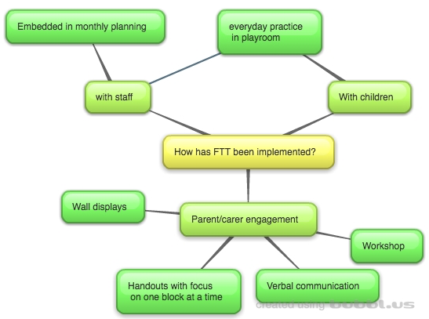
Questionnaires and interviews held within Establishment 4 identified a number of ways FTT has been implemented within the nursery, which will be further expanded upon within the next section.

Figure 18: Establishment 4– How has FTT been implemented?
The above figure illustrates key themes from the perceptions of staff members and parents/carers of establishment 4.
FTT has been implemented through parent/carer engagement with the approach, for which the establishment have adopted a number of different methods. This includes verbal communication with parents/carers as they come into the establishment, creating and distributing monthly handouts for which there is a focus on one block at a time, wall displays throughout the nursery with descriptions and visuals with the FTT resources, and lastly a parent workshop held with the aim to promote the approach.
Amongst staff, it was identified that monthly planning meetings “have FTT on the agenda” and so is a part in the day to day running within the establishment. This is demonstrated in further points made regarding the practice of the staff, for which their “everyday good practice enhanced by FTT” is used with the children attending the establishment.

3.4.2 Why has ftt been implemented this way?
Questionnaires and interviews held within Establishment 4 identified a number of reasons FTT has been implemented the way it has within the nursery, which will be further expanded upon within the next section.

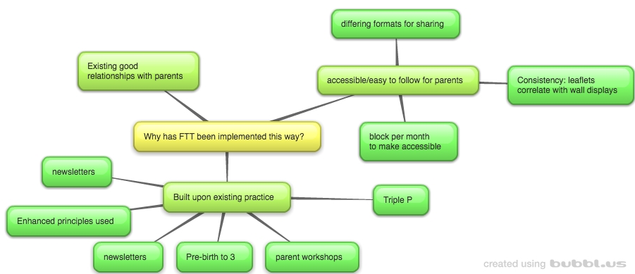
Figure 19: Establishment 4 – Why has FTT been implemented this way?

Figure 19 above demonstrates the themes emerging from the collated staff perceptions from establishment 4.
In considering the ways in which the establishment have engaged parents, they have implemented with the aim to make it as easy and accessible for parents to follow. This includes creation of different formats for sharing information (e.g. through workshops and also leaflets), as well as keeping consistency between methods of sharing as they “link the displays on the wall with the leaflets for the block that we’re doing that month”. The reasoning for choosing to focus on a block per month is also to make it more accessible and easy to follow for parents/carers. Utilisation of the existing good relationships with parents and carers has also reportedly informed the choice of implementation.
Furthermore, the staff members identified a number of approaches already being used within the establishment, from which have been built upon for the implementation of FTT. This has included following on from Pre-Birth to three and Triple P, as well as the means previously used to communicate with parents such as newsletters and workshops. It was also reported by staff that “we were already using the principles” and so the approach has enhanced existing good practice.

3.4.3 NEXT STEPS
Questionnaires and interviews held within Establishment 4 identified a number of next steps for the implementation of FTT nursery, which will be further expanded upon within the next section.
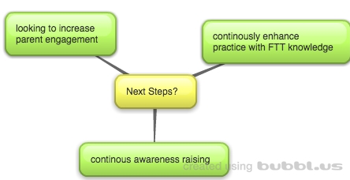
Figure 20: Establishment 4 – What are the next steps?
The above figure illustrates collated viewpoints of staff members in establishment 4.
Staff members identified that the implementation of FTT was ongoing and that practice was always adapting and improving. Furthermore, staff members felt that engaging parents had been difficult “we held a parent workshop but parents don’t have the time because they are all working” and so that the next step would be looking for ways to increase their awareness engagement in the approach.

3.4.4 Supporting factors in implementation of ftt
Questionnaires and interviews held within Establishment 4 identified a number of supporting factors for the implementation of FTT within the nursery, which will be further expanded upon within the next section.
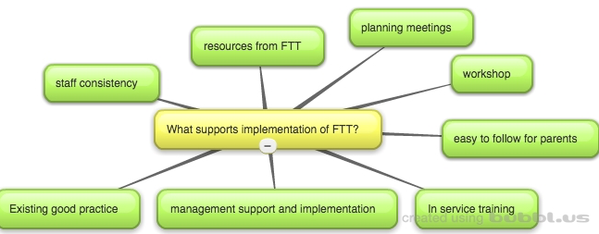

Figure 21: Establishment 4 – What supports the implementation of FTT?
Figure 21 illustrates collated viewpoints of staff members from establishment 4.
Staff members highlighted a number of supports for implementation of FTT, namely the amount of support from management for implementation throughout the establishment. This also took the format of in service training and workshops held for parents “using flipchart notes taken from the initial training” and planning meetings for the establishment. Staff members also reported that they felt that the format and language used within the resources for FTT is “good for parents to access – we have lots of parents who are EAL and the language is simple with lots of visuals to help”. Within the
establishment, staff also felt that the existing good practice of the CDOs supported the implementation as it enhanced their skills, as well as the consistent approach of staff who are trained in it.

3.4.5 Barriers in implementation of ftt
Questionnaires and interviews held within Establishment 4 identified a number of potential barriers for the implementation of FTT within the nursery, which will be further expanded upon within the next section.
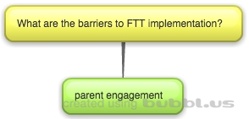

Figure 22: Establishment 4 – What are the barriers
One barrier emerged as a theme from discussion with staff members regarding implementation of FTT, which was regarding the parent engagement. As mentioned in a previous section, the staff members perceive this to be difficult and that they need to raise more awareness with parents.

3.4.6 what has been the impact of ftt?
Questionnaires and interviews held within Establishment 4 identified the impact of FTT on the children, parents/carers and staff members of the nursery, which will be further expanded upon within the next section.
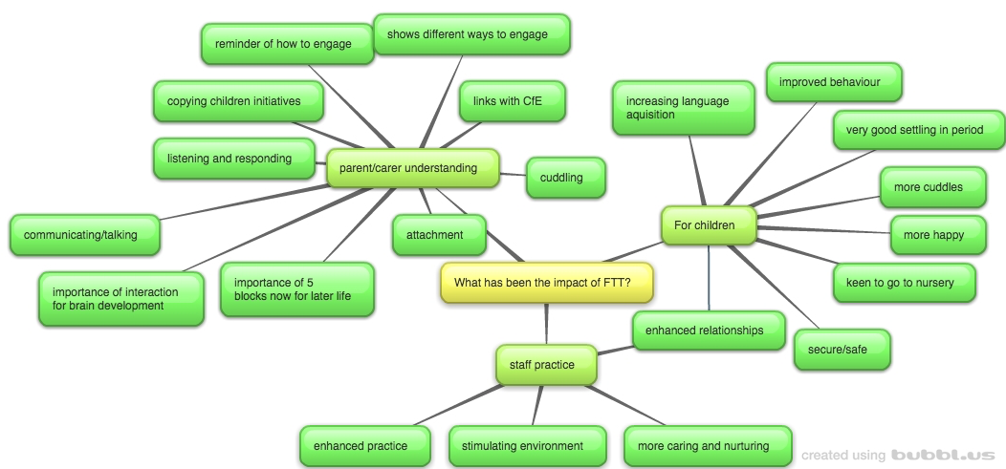
Figure 23: Establishment 4 – What is the impact of FTT?
The figure above illustrates themes triangulated from parents/carers and staff from establishment 4.
One way of demonstrating the impact of implementation within the establishment is the understanding of the parents/carers of the FTT approach. Parents/carers shared their knowledge inclusive of the importance of the 5 blocks for “development and later life” as well as the importance of the blocks in terms of brain development. Furthermore, parents/carers are aware that the approach is a reminder of how to engage with children, as well as demonstrating the importance of different ways of interacting with them such as “cuddling” “copying children’s initiatives” and “listening and responding when they are communicating with you”. In terms of existing theory and documentation, parents/carers also reported links between FTT and attachment as well as the CfE.
In terms of staff practice, views gathered regarding impact stated that “our existing good practice has been enhanced” whilst facilitating a “stimulating” and “a more caring and nurturing environment”. From this participants had also acknowledged that relationships with the children had been enhanced.
Other impact on children attending establishment as perceived by participants is that they have had a “very good settling in period” and are demonstrating that they are keen to go into the establishment. In addition, reports of better behaviour and an increase “in amount of language used” was recorded, alongside portraying to be more happy and cuddly both at home and in the establishment.

