An evaluation and implementation analysis of the approach
‘Five to Thrive’

FTT is an approach developed by Kate Cairns Associates (KCA) identifying five activities to establish secure attachment relationships and are required for healthy brain development through mindful co-learning and co-regulation, namely: Respond; Cuddle; Relax; Play and Talk (Kate Cairns Associates, 2014). The training and resources focus upon enhancing engagement between caregiver and child to support in developing the child’s emotional regulation. It is further stated that without another to support regulation, particularly in our earliest years, brain development is severely affected.
The approach provides training around the importance of feeling safe and demonstrates, through use of resources provided on the website and at the training sessions, means of promoting and instilling the five aforementioned activities in order to establish secure attachment relationships. Therefore the purpose of the FTT approach is to support services to create an optimal environment, where children feel safe so as to be able to develop and learn to their full potential. The programme also provides a number of resources to support implementation and evaluation of the approach by using the five activities within services. This is inclusive of a number of activities, case studies, as well as a means to evaluate the impact for which the approach has had. A total of one hundred and twenty members of staff working within Glasgow City Council attended this initial training provided by KCA on 10th February 2015, and have since had full access to all of the resources provided.
- The aim of the project was to explore the implementation and effectiveness of an approach, Five to Thrive (FTT), with the focus upon answering two research questions:
  - What are the perceptions of those linked to early years establishments regarding the implementation of FTT?
  - What are the perceptions of those linked to early years establishments regarding the impact of the implementation of FTT?

- A multi-method design informed data gathering from parents/carers and members of staff from four early years establishments to provide qualitative data, strengthened by quantitative data.

- Semi-structured interviews took place with parents/carers of children attending one of the four participating establishments to gather both qualitative and quantitative data. Furthermore, staff questionnaires for those positioned in participating early years establishments were distributed for both qualitative and quantitative data gathering. Information from these questionnaires informed prompts for later focus groups/interviews to be held with staff members to enrich the data.

- The design of the research facilitates analysis of participants perceptions under six broad themes informed by the aims of the research:
  - ‘How FTT has been implemented?’
  - ‘Why FTT has been implemented this way?’
  - ‘What are the next steps for implementation of FTT?’
  - ‘what has supported implementation of FTT?’
  - ‘What have been the barriers to implementation of FTT?’, and
  - ‘What is the impact of implementation of FTT?’.

  - An implementation science framework was adopted so as to investigate where potential barriers and strengths may be to inform further implementation of the approach.

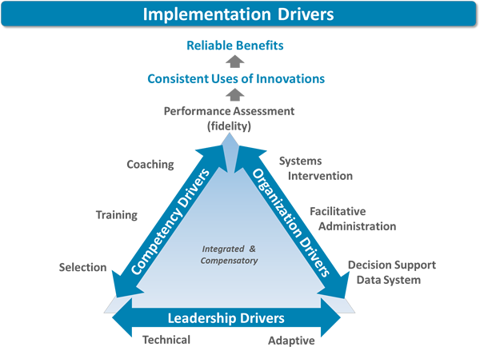
How has FTT been implemented?
- Key findings included:
  - Verbal communication with parents/carers for implementing the FTT approach.
  - Visuals across establishments
  - Daily interactions with children
Core components of Implementation science met include: Initial training, coaching and mentoring, facilitative administration supports (visuals), and staff selection.
Why has it been implemented this way?
- Key findings include:
  - Links with existing documents (CfE, building the ambition)
This links with the core component of Implementation science: systems intervention (external factors e.g. funding, policies etc).

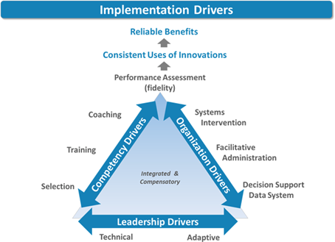
What are the next steps?
- Key findings include:
  - Share good practice (conferences, workshops etc)

This links with core components of Implementation science: Performance Assessment (Fidelity) (Fixsen et al. 2015). Within this component it is highlighted that the continuous improvement aspect supports implementation of an approach.

What are the supporting factors?
- Key findings include:
  - Management
  - Colleagues
This links with core components of Implementation science: staff selection and leadership drivers. Highlighted within the framework is that leadership is not isolated to one individual and is instead distributed. In the early stages it is more likely for leadership roles to be ‘adaptive’. It may be in time however that leadership takes the form of more broadly allocated leadership roles. The form in which this takes should be reflective of the current context to enable most effective implementation.
What are the barriers?
- Key findings include:
  - Parental engagement
  - Resistance from a minority of staff
These highlight the benefit of a ‘decision support data system’ (this project) in identifying barriers. These findings also highlight the importance of training and coaching, as those resisting were unfamiliar with the approach.

What has been the impact of FTT?
- Key findings at staff level include:
  - ‘enhanced nurture and care’
  - ‘improved practice’
  - ‘increased awareness of importance of the five activities for engagement’
  - ‘hands on approach’ including more cuddles for the children attending.
  - A more ‘peaceful environment’

- Key findings at parent/carer level include:
  - Increased awareness of FTT supporting relationships
  - Increased awareness of using the 5 FTT factors to help children feel safe and happy
  - Knowing that child would be comforted at nursery
  - Awareness of need to work in partnership with nursery
  - Awareness of what the 5 FTT building blocks are
  - Awareness of five building blocks and link with brain development
  - That FTT is an approach that shows and reminds how to engage with babies from birth

- Key findings at child level include:
  - Children are ‘settling in better’ to the nursery
  - Children appear to feel ‘safe and happy’
  - Children ‘comforted more easily than previously’
  - ‘improved relationships with children’
  - ‘improvement in communication and expression’
  - ‘increasing language acquisition’
  - ‘child loves going to nursery’
  - ‘regression in children’s behaviour when approach is not being used’.
These findings highlight the benefit of ‘performance assessment’ (this project) in considering the impact on those involved has been affected by fidelity to the implementation science components, as a high degree of fidelity has been met (as shown in all other themes) as all the components have been considered.

- There are a number of limitations of this study, including that word count restrictions have meant that while establishments were analysed as separate entities in the results section, they were not in the discussion section. Discussion of each establishment’s findings may have been useful for considering the differences in implementation and why they were diverse in some ways.

- Implications and recommendations:
  - An implication for research could be suggested as evaluating the approach using a pre and post measure to evaluate the change over time. In considering a potential limitation of the current research, this could be done using a random selection to support a more reliable means of data collection.

  - Another implication stemming from the methodology is the difficulty in facilitating focus groups of an appropriate size. The key factor contributing to this was the inability for practitioners to leave the playroom due to the necessity of the child: staff ratio. Reflecting upon this the researcher has wondered if practitioners are therefore able to spend enough of their working day being able to think and discuss approaches such as FTT with colleagues. One of the aforementioned aims of the Pre-birth to-three document (Scottish Government, 2010) is to “Enable practitioners to build in time to 'think' as well as 'do'”. This methodological limitation could suggest that this may not be the case, and so an implication for research could potentially be to investigate this aspect further.

  - In using the core components of the Implementation Science framework, the researcher was able to pinpoint where establishments fulfil criteria for successful implementation. This also highlighted that while components were adhered to, implementation differed per establishment. An implication for practice for early years establishments would therefore to be mindful that whilst sharing good practice and strengths in implementing FTT may be beneficial, implementation can and will differ according to a number of factors for each early years establishment (for example management structure, the demographics of the establishment, etc).

  - It was found to be difficult both by the researcher and by establishments to be able to engage with parents/carers on a face-to-face setting. Reflecting on this however, given that the initial training was targeted specifically to early years practitioners working with 0-3 aged children it is more than likely that the vast majority of this particular group of children’s caregivers have other commitments. In sharing good practice amongst establishments, it may be beneficial to build upon strengths in parent/carer engagement that does not require additional time spent on a face-to-face basis (e.g. Twitter, Facebook, Blogs)

  - In considering the effectiveness of the approach documented in this paper, it would be recommended that the FTT training included more members of staff in early years establishments. The impact of early years experiences on brain development and therefore adult life has been well researched as outlined in the literature review. The importance of sharing this knowledge in an accessible way for all caregivers and providing the resources that support this is therefore crucial. FTT has been shown in this study to do so, and to do so with positive outcomes for children, when implemented according to the core components of implementation science. Thus, an implication for practice would be to provide the data to support application for funding for further training for early years practitioners.

