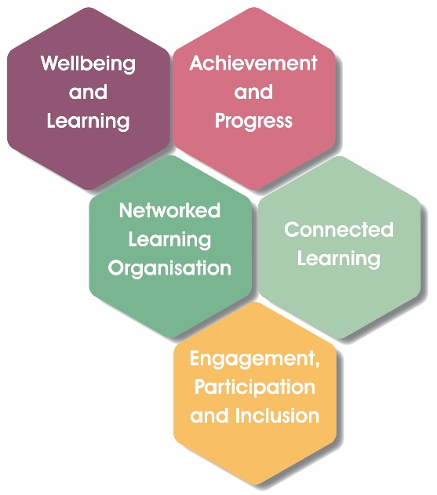

Service Name
ELC Standards & Quality Report (SQR)
Year 1 (2026)

This summary report is provided for parents/carers and partners to outline our achievements and improvements during 2026 and to share our improvement priorities for 2027. Throughout last session, we took forward our improvement priorities as detailed in our Service Improvement Plan (SIP). Using our approaches to self-evaluation, we have detailed in this report the impact of our work and identified how we plan to continue to improve outcomes for our children and families.

The context of the service
Our achievements and improvements in 2026

Our Improvement Plan priorities for 2027

 | Quality Improvement Framework - ELC | Evaluation
 | Leadership and management of staff and resources
 | Children experience high quality spaces
 | Playing, learning and developing
 | Curriculum
 | Learning, teaching and assessment
 | Nurturing care and support
 | Wellbeing, Inclusion and equality
 | Children’s progress

How to find out more about our service
Contact us directly if you require further information about our service, or if you wish to comment on this report.

Our contact e-mail address is:

Our telephone number is:

Our service address is:

Further information is also available …..

