

SERVICE IMPROVEMENT PLANNING – YEAR 1: 2027 (updated, if needed, at the end of April/ August/ November, but keeping any previous versions)

Nursery |  |  |  |  |  |  |  |  |  |  |  | Learning Community |  |  |  |  |  | Community
Head of ELC | Heather Douglas |  |  |  |  |  |  |  |  |  |  | Area Manager - ELC / MLO
Leadership Team Compliment | HoN- | DHoN- |  |  |  | TL- |  |  | LPA- |  |  | Staffing Compliment |  |  |  |  |  | CDO- |  |  | CDO PT- |  |  |  |  | SfLW - | Student-
Nursery Roll |  |  |  |  |  |  |  |  |  |  |  | Attendance Rate (%)
Ethnicity |  |  |  |  |  |  |  |  |  |  |  | Number of Complaints
ACEL Data (%) | Talking & Listening |  |  |  |  |  |  | Reading |  |  |  |  |  |  | Writing |  |  |  |  |  |  | Numeracy
MOST RECENT HMIE | Curriculum |  |  |  |  |  | Learning, teaching and assessment |  |  |  |  |  | Wellbeing, inclusion and equality |  |  |  | Learning, teaching and assessment |  |  |  |  |  |  | Childrens progress
MOST RECENT CI | Leadership and management of staff and resources |  |  |  |  |  | Playing, learning and developing |  |  |  |  |  | Nurturing care and support |  |  |  | Staff skills, knowledge, values and deployment |  |  |  |  |  |  | Nurturing care and support
DATA | NUMBER |  |  |  | PERCENTAGE |  |  |  |  |  | DATA |  |  |  |  |  |  |  | NUMBER |  |  |  |  |  | PERCENTAGE
SIMD 1 & 2 |  |  |  |  |  |  |  |  |  |  | Support Plans
CP Register |  |  |  |  |  |  |  |  |  |  | Individual Risk Assessments
Care Experienced |  |  |  |  |  |  |  |  |  |  | PEEPs
Vulnerable Case Files |  |  |  |  |  |  |  |  |  |  | Speech & Language Input
ASN (Stages 3 & 4) |  |  |  |  |  |  |  |  |  |  | Occupational Health Input
WAPs |  |  |  |  |  |  |  |  |  |  | Funded 2s (if applicable)
Deferrals |  |  |  |  |  |  |  |  |  |  | Medical Needs (AR1) |  |  |  |  |  |  |  | Details -
EAL |  |  |  |  |  |  |  |  |  |  | Meeting National Standard |  |  |  |  |  |  |  | YES/ NO (Care Inspectorate Grades 4 and above)
SERVICE Grand Challenges 2027-29 (Grand challenges are the long-term strategic changes you intend to achieve over the 3 year cycle. Throughout the current 3 year cycle of improvement all establishments should focus on the Grand Challenges of Progress, Wellbeing and Inclusion)

SERVICE Grand Challenge 1: (copy/paste aligned SERVICE Grand Challenge from above)
Mission: (medium term strategic change achievable within the current year of the cycle)
Expected Outcomes | Measures of Impact | Commitments (Sprints) | Lead Responsibility | Target Date  (April/August/November)
April/ August/ November - Review and Analysis of Data: Evaluative Comments (used to support progress and completion of SER)

SERVICE Grand Challenge 2: (copy/paste aligned SERVICE Grand Challenge from above)
Mission: (medium term strategic change achievable within a year)
Expected Outcomes | Measures of Impact | Commitments (Sprints) | Lead Responsibility | Target Date  (April/August/November)
April/ August/ November - Review and Analysis of Data: Evaluative Comments (used to support progress and completion of SER) |  |  |  |  | SERVICE Grand Challenges 2027-29 (Grand challenges are the long-term strategic changes you intend to achieve over the 3 year cycle. Throughout the current 3 year cycle of improvement all establishments should focus on the Grand Challenges of Progress, Wellbeing and Inclusion)

SERVICE Grand Challenge 3: (copy/paste aligned SERVICE Grand Challenge from above)
Mission: (medium term strategic change achievable within a year)
Expected Outcomes | Measures of Impact | Commitments (Sprints) | Lead Responsibility | Target Date  (April/August/November)
April/ August/ November - Review and Analysis of Data: Evaluative Comments (used to support progress and completion of SER)

SERVICE Grand Challenge 4: (copy/paste aligned SERVICE Grand Challenge from above)
Mission: (medium term strategic change achievable within a year)
Expected Outcomes | Measures of Impact | Commitments (Sprints) | Lead Responsibility | Target Date  (April/August/November)
April/ August/ November - Review and Analysis of Data: Evaluative Comments (used to support progress and completion of SER)
MAINTENANCE AGENDA
Please use the space below to note any other improvement actions initiated in previous years which are continuing to be a focus in the coming year but not your identified priority for 2027.

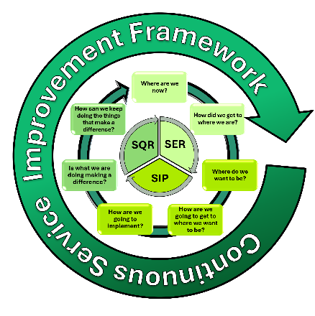

PPl

Service Maintenance Grand Challenge | Area of Focus | Quality Indicator
April/ August/ November - Review and Analysis of Data: Evaluative Comments (used to support progress and completion of SER)

