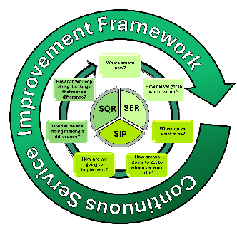
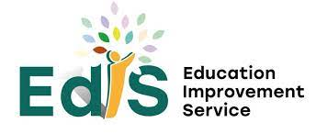


SELF-EVALUATION REPORT (YEAR 1)
November 2026

Service Name
Learning Community
Area Service Manager - ELC
Head of ELC | Heather Douglas

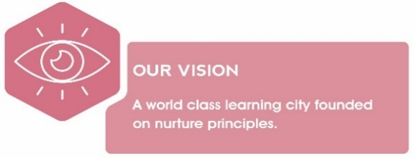
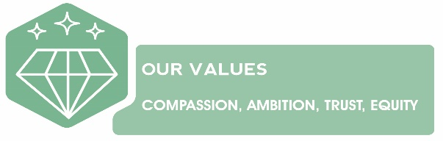
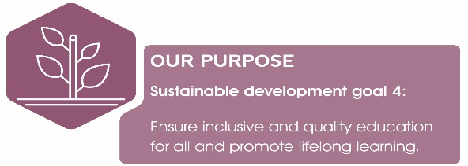
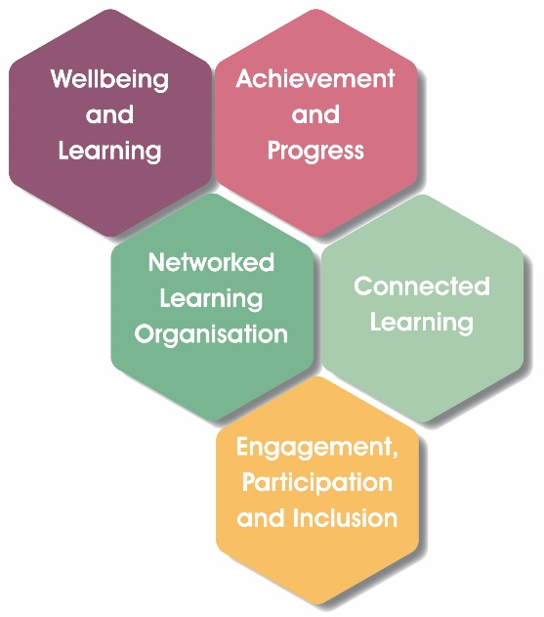

EVALUATIVE STATEMENTS
QI. Leadership and management of educators and resources (CI)
How well are you doing?  Evaluative statements describing the impact of improvement actions detailed in your current Improvement Plan (measured against expected outcomes) | How do you know?  Describe the evidence you have gathered which details impact on pedagogy and learners | What are you going to do now?  What are your next steps/ priorities in this area?
Using the descriptors from the Quality Improvement Framework - ELC, how do you evaluate your progress within this Quality Indicator? (Please highlight)

Unsatisfactory Weak Satisfactory Good Very Good Excellent

EVALUATIVE STATEMENTS
QI. Children experience high quality spaces (CI)
How well are you doing?  Evaluative statements describing the impact of improvement actions detailed in your current Improvement Plan (measured against expected outcomes) | How do you know?  Describe the evidence you have gathered which details impact on pedagogy and learners | What are you going to do now?  What are your next steps/ priorities in this area?
Using the descriptors from the Quality Improvement Framework - ELC, how do you evaluate your progress within this Quality Indicator? (Please highlight)

Unsatisfactory Weak Satisfactory Good Very Good Excellent

EVALUATIVE STATEMENTS
QI. Playing, learning and developing (CI)
How well are you doing?  Evaluative statements describing the impact of improvement actions detailed in your current Improvement Plan (measured against expected outcomes) | How do you know?  Describe the evidence you have gathered which details impact on pedagogy and learners | What are you going to do now?  What are your next steps/ priorities in this area?
Using the descriptors from the Quality Improvement Framework - ELC, how do you evaluate your progress within this Quality Indicator? (Please highlight)

Unsatisfactory Weak Satisfactory Good Very Good Excellent

EVALUATIVE STATEMENTS
QI. Curriculum (HMIe)
How well are you doing?  Evaluative statements describing the impact of improvement actions detailed in your current Improvement Plan (measured against expected outcomes) | How do you know?  Describe the evidence you have gathered which details impact on pedagogy and learners | What are you going to do now?  What are your next steps/ priorities in this area?
Using the descriptors from the Quality Improvement Framework - ELC, how do you evaluate your progress within this Quality Indicator? (Please highlight)

Unsatisfactory Weak Satisfactory Good Very Good Excellent

EVALUATIVE STATEMENTS
QI. Learning, teaching and assessment (HMIe)
How well are you doing?  Evaluative statements describing the impact of improvement actions detailed in your current Improvement Plan (measured against expected outcomes) | How do you know?  Describe the evidence you have gathered which details impact on pedagogy and learners | What are you going to do now?  What are your next steps/ priorities in this area?
Using the descriptors from the Quality Improvement Framework - ELC, how do you evaluate your progress within this Quality Indicator? (Please highlight)

Unsatisfactory Weak Satisfactory Good Very Good Excellent

EVALUATIVE STATEMENTS
QI. Nurturing care and support (CI)
How well are you doing?  Evaluative statements describing the impact of improvement actions detailed in your current Improvement Plan (measured against expected outcomes) | How do you know?  Describe the evidence you have gathered which details impact on pedagogy and learners | What are you going to do now?  What are your next steps/ priorities in this area?
Using the descriptors from the Quality Improvement Framework - ELC, how do you evaluate your progress within this Quality Indicator? (Please highlight)

Unsatisfactory Weak Satisfactory Good Very Good Excellent

EVALUATIVE STATEMENTS
QI. Wellbeing, Inclusion and equality (HMIe)
How well are you doing?  Evaluative statements describing the impact of improvement actions detailed in your current Improvement Plan (measured against expected outcomes) | How do you know?  Describe the evidence you have gathered which details impact on pedagogy and learners | What are you going to do now?  What are your next steps/ priorities in this area?
Using the descriptors from the Quality Improvement Framework - ELC, how do you evaluate your progress within this Quality Indicator? (Please highlight)

Unsatisfactory Weak Satisfactory Good Very Good Excellent

EVALUATIVE STATEMENTS
QI. Children’s progress (HMIe)
How well are you doing?  Evaluative statements describing the impact of improvement actions detailed in your current Improvement Plan (measured against expected outcomes) | How do you know?  Describe the evidence you have gathered which details impact on pedagogy and learners | What are you going to do now?  What are your next steps/ priorities in this area?
Using the descriptors from the Quality Improvement Framework - ELC, how do you evaluate your progress within this Quality Indicator? (Please highlight)

Unsatisfactory Weak Satisfactory Good Very Good Excellent

