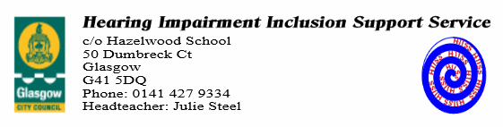
Referral Form

Staff Member Referring
School/nursery
Name
Position
Contact Number
Date of Referral
Pupil Details
Name
Class
D.O.B
HW Plan | Yes No
Does the child wear hearing aids?
Has the pupil been supported by the service in the past?
Educational Psychologist (If applicable)
Speech and Language Therapist (If applicable)
Has the child’s parent/guardian given permission for referral including contacting audiology department (Health) to get further information about child’s hearing?
Reason for Referral
(Please give brief details of why you have contacted us)

