EARLY YEARS SUPPORT SERVICE
REFERRAL PROFORMA

Name of Child: Date of Birth: Stage:

Current Early Years establishment:

Current pattern of attendance: (Full days / half days)
 | Monday | Tuesday | Wednesday | Thursday | Friday
AM
PM

Has parent/guardian been consulted about this request for support:
Other Agencies Involved with contact details if known: (SLT, Educational Psychologist, OT, Health visitor etc)
Agency: | Name: | Contact Details:
Purpose of Referral to EYSS: (think about specific advice, or key areas you wish to be addressed by / with our service)
Current nursery placement targets:

Do any Child Protection issues exist?
Have these concerns been raised to the Authority

using Management Circular 57?

Has an application been made for a deferred year in nursery? Yes / No
Brief Developmental Background (including developmental milestones, general health, Specific health conditions, hospitalisation, vision, hearing, feeding and sleeping patterns).
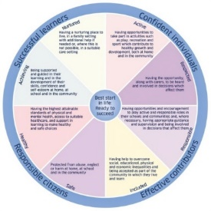
Brief overview of Assessment Profile: (Include language, communication style/strategies, motor skills, cognitive abilities, social and emotional development, play)
Safe-

Healthy –

Achieving –

Nurtured

Active –

Respected –

Responsible –

Included –

Progress in learning and what works, evidence of what has been tried and impact: (what have you tried – specifically what has worked and what has not)

Additional Comments/ Extract of minutes:

Referrer: _____ __________ _________ Date: ___________

Please attach SIIM minutes where attendance is noted and agreed actions are indicative that a referral to the EYSS is appropriate as per “Referral process to EYSS” guidelines.

