Inclusion in Glasgow’s Nurturing City

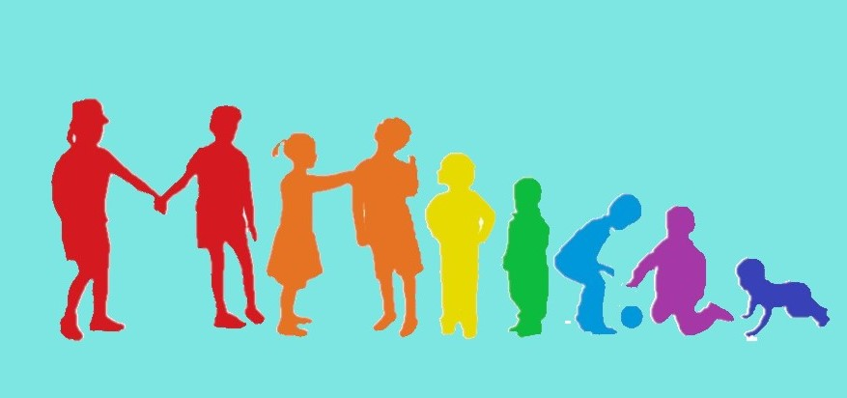

The Policy Framework

‘Every Child is Included and Supported’ was updated in 2011 in response to legislative changes and a review carried out during 2009-2010. In 2013, Glasgow’s Psychological Service (GPS) issued a paper on how we take forward inclusion in the context of our nurturing city. This informed the development of our policy which was further updated in 2016 with accompanying support guides.
At the heart of our strategy is our vision for schools within a nurturing city:
A nurturing city has schools in which children and young people feel they belong, they are listened to and they and their families are valued. The ethos of nurturing schools is supportive and all staff are clear about their roles and responsibilities. In nurturing schools, staff continually and collaboratively evaluate their practice to ensure that it promotes the wellbeing of all children and young people. They understand that supporting all children and young people and ensuring they make the best possible progress depends on the curriculum they provide, on learning and teaching of the highest quality and on their commitment to continuing professional development.
Other policies in our Service supplement ‘Every Child is Included and Supported’. Our ‘Promoting Positive Behaviour’ policy supports our approach to inclusion in that it “….articulates our commitment to the inclusion of all children and young people and our belief that they should fulfil their full potential whilst in our care. More recently, Glasgow’s Anti Bullying policy issued in 2019 and our ‘Equalities Framework to support schools’ in 2021.
Our overall vision for inclusion was recently encapsulated in a short video sketch “Putting Children First” which was shown at our ASL Conference in February 2020 and can be accessed on https://youtu.be/87VCjD7-I7E

The national legislative landscape which supports inclusion and equality in education includes:
- Disability Strategies and Pupils’ Educational Records (2002);
- Additional Support for Learning (Scotland) Act 2004 (as amended 2009);
- Getting it right for every child (GIRFEC 2006)
- Equality Act (2010);
- Children and Young People Act (2014); and
- Education (Scotland) (2016).

More recently we have had the publication of the ‘Vision Statement for Success’ following the ASL review conducted by Angela Morgan in 2020, and UNCRC has been incorporated into legislation to support children’s rights.

How Good Is Our School 4 states that ‘Inclusion means taking positive action and intervening in order to enable achievement for all by building and fulfilling the potential of every child, young person and adult’. The ’Presumption of Mainstream’ was reinforced following the 2017 Scottish Government consultation ‘Excellence and Equity in Education’ which said: “An inclusive approach, with an appreciation of diversity and an ambition for all to achieve to their full potential, is essential to getting it right for every child and raising attainment for all. Inclusion is the cornerstone to help us achieve equity and excellence in education for all of our children and young people.”
Finally, Glasgow is committed to the international vision of UNESCO’s Global Education 2030 Agenda particularly Goal 4 which aims to “ensure inclusive and equitable quality education for all”.

Taking Stock- Where are we now?

Glasgow schools and nurseries have worked exceptionally hard over the years to take forward inclusive practice and many children, young people and their families have benefitted significantly from this. As well as supporting the presumption of mainstream in our schools, Glasgow is quite unique in that has a range of different types of ASL stand-alone schools as well as different types of enhanced provision in mainstream schools to support our children and young people with a range of needs more complex additional support needs.

We have supported a range of developments to take forward inclusion. New guidance was issued to support a better understanding of Glasgow’s Staged Intervention model. We also reviewed our support for Wellbeing Plans and developed practical guidance to complete these supported by a range of webinars and training. This coincided with the resumption of network meetings for ASL coordinators and PT Pastoral Care colleagues whilst continuing to support our Child Protection Coordinators and Care Experienced Designated Managers. We are signposting staff to our excellent range of training support, including specific training related to supporting children with ASD, from our colleagues in GPS and LCR outreach team colleagues. The Inclusion Team are developing webinars on inclusive practice as well as highlighting inclusive practice opportunities on our new website. The LC JST practice guidelines have just been reviewed and our SIIM meetings have extended across all sectors including the recent development of the ASL specific SIIMs meetings.

During the pandemic we have been connecting and collaborating more with colleagues in Glasgow’s Health and Social Care Partnership (HSCP) and our community partners in the Third Sector. We have also seen how some children and young people engage better with remote, digital learning compared to attending a traditional school environment. These are areas we will continue to explore as we develop new and better ways to support our children and young people.

In recent times, we reviewed our City Inclusion Group model to introduce three Area Inclusion Groups for each part of the city. In 2019 the Head of Inclusion and Equalities spoke to all Headteachers across the city and emphasised that the new AIG were no longer to be viewed as primarily the way to seek an alternative pathway for children and young people but instead referrals to them are about seeking further support for a child. We will continue to develop and AIG model which seeks to;
- Support a shared moral purpose
- Set out a framework to support selection of pathways where appropriate
- Deliver solutions within local and community context
- Create flexible pathways-move away from placement
- Support paradigm shift for schools, parents, community though:
  - Challenge
  - Training and development
  - Peer coaching – specialist skills transfer through coaching
  - Parental engagement
- Support improvement – attainment and achievement
- Excellence and Equity

What does the AIG data tell us?

We now have AIG data from the previous five years which allows us to see trends across all areas, Learning Communities, and individual schools and nurseries. Some of the data will be highlighted at forthcoming Headteacher meetings. The data is helpful in allowing us to plan next steps and should be viewed in collaboration with many messages and discussions the AIG and Inclusion team have heard and listened to in recent years. Some of its main messages include;

The number of referrals from mainstream early years establishments and from mainstream schools
for new standalone ASL places has continued to significantly increase over the past five years:
This has led to an increase in provision in some of our bases and most of our ASL schools.
Virtually all of them can’t expand their capacity further.

Despite stating in 2019 that referrals to the AIG should be for support, most referrals to the AIG ask
for a change to a learner’s pathway. There is no significant change in relation to the distribution of
requests for alternative pathways from each area. Not all pathways are granted but each are carefully
investigated by members of the AIG teams.

A significant amount of the requests for change to pathways are for boys – 4:1

There is a significant peak in requests for ASL pathways at the end of nursery and in P7.
There can be requests for change at all stages and this has included in senior phase of secondary.
Some requests for change to pathway are from enhanced provision to standalone provision which
can have significant implications for the young person and the receiving school.

There is clear evidence that the culture and ethos of the school, particularly the Headteacher, in relation
to inclusive practices and solutions is critical.

The bases in schools were set up as co-located provision to meet the needs of children and young
people who would benefit from access to learning alongside their peers with a view that most would
spend more and more time in mainstream classes as they progressed through school. This was
particularly the encouraged practice is secondary schools to help young people to transition to adult life.
However, the reality is that few children and young people transition from ASL school to mainstream
and even from co-located to almost all time in mainstream classes

Through tracking of the numbers over the past five years, it can be seen that some Learning Communities
and schools have consistently high numbers of referrals to the AIG for alternative pathways.
Some Learning Communities and schools have consistently low referral rates for pathways.

We know our children and young people have a range of additional support needs which requires us to be flexible and responsive.
We want:
- As many of our children and young people to be able to learn in their local communities
- All our specialist provision to be flexibly matched to the needs of children and young people
- Children and young people with additional support needs to have successful transitions
- Children and young people to learn in the most inclusive environments possible to suit their needs; and
- Every ASL school or enhanced provision to meet the needs of children with autism

Again, please take time to look at the short video sketch “Putting Children First” which was shown at our ASL Conference in February 2020 and can be accessed on https://youtu.be/87VCjD7-I7E

Myth Busting

The data is helping us to understand what some of the challenges are that we need to find solutions to. However, we have also been involved in lots of discussions with colleagues, parents and partners where things are said that are not always accurate and need challenged.
The number of ASL places has increased significantly from 1685 10 years ago to 2054 in 2019 and now 2296 in 2021
We keep reducing the ASL provision in our ASL schools and Bases and now you want to reduce it further.

P1 is a play pedagogy based curriculum. It is also a key developmental time where children need speech partners and peer social interaction to help them develop.
P1 is such a different experience to an early years environment. Some of our children won’t cope.

We need an alternative pathway after P7 since this young person won’t cope in a busy, large secondary school.
What do we really know about our local secondary schools? Most now have nurture/support bases, targeted interventions, bespoke curriculum opportunities, good transition programmes.

We have done everything that’s possible to support this child/young person.
No one is questioning that but many of our colleagues on the AIG who work in bases and other schools can have different solutions. Sometimes the answer isn’t a different pathway but different opportunities, perhaps from partners, and not always in a school setting

We never refer to the AIG. We do this one time and don’t get an alternative pathway for a child we think really needs this.

As above but also the AIG has a holistic picture of need for their area and needs to prioritise placements , which are not unlimited, on the basis of need.

The Big Questions to consider…..

Improving our approach to inclusion will require CHALLENGE and SUPPORT. Some things will need to be done differently. We will get better at sharing and supporting each other and this will lead to improved outcomes for our children and young people. We start from a strong base with lots of great ideas already. We want to hear what you think are some of the solutions. In this next section we have posed some of the big questions and a few ideas.
More professional learning opportunities…..improved info on our website,,,,drop in support sessions……focus on curriculum..

How do we continue to improve our
inclusive practice?
Develop an inclusive leadership programme….more challenge from our AIG colleagues on practice/stats/referrals….peer coaching

Communication of outcomes….parental understanding of how decisions are reached….More discussions between HTS

How do we improve our inclusive leadership?
What does our AIG model need to change/improve?
Targeted support from outreach staff…work with parents…training in challenging discussions
More visits….webinar focus…..clearer info on school websites re curriculum

How do we reduce the movement of
children from mainstream to ASL?
Scrutiny of AIG data….review of our provision for examples across collocated provision
How do we share the changes to our service to improve our understanding of what we each do?
Working with Third sector partners…remote learning….IT Apps
What did we learn from the Pandemic that can help
to improve our inclusive practices?
How do we share consistency of approaches to ensure access to mainstream?

