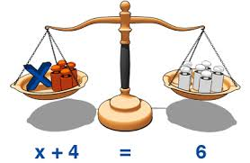**Solving Equations**

1. Solve each of the following equations :



2. Solve each of the following equations :



3. Solve each of the following equations :



4. Solve each of the following equations :



5. Solve each of the following equations :

