Data ‘Snapshot’ of Young People’s Achievements

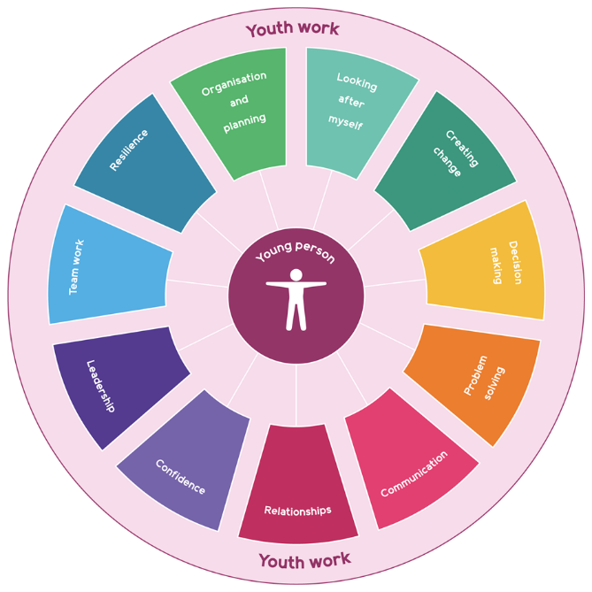
Using the Youth Work Skills Framework to share data on achievements.
We want to pull together a ‘snapshot’ of the young people’s achievements through youth work in FVWL. We’re using the Youth Work Skills Framework to provide a shared language for reviewing achievements across all of the programmes that submit data. Please follow the guidance below to complete the form on page 3 of this document.
- First familiarise yourself with the skills framework and associated ‘indicators’ that might be measured to track skills development (see overleaf / on our website Skills Framework_infographic (youthlinkscotland.org)). Then, on page 3 of this document:
- Record some brief details about the programme you are reporting on (ideally, we want you to share information from your work with young people between August 2021 and August 2022).
- Then identify the skills you have been supporting these young people to develop. We do not expect you to have been measuring progress in all 11 skills, so please tell us which skills are most relevant to the youth work experiences you are offering young people.
- Based on existing evaluation data for the programme and time period you have selected, tell us how many young people have made progress in these skills over the time period you are reviewing.
- Then, using feedback from young people through your existing evaluation process, supplemented by data you are gathering through the current review process, provide just a few of the best examples of qualitative feedback / observations from young people, teachers, parents and other stakeholders that evidences progress in relation to these skills. If you don’t already hold feedback from teachers and parents, just leave these sections blank – we don’t want you to have to gather additional data – just to share what you already have.
- Finally, please tell us how many awards were completed over this time period and which awards were completed.

Confidence  I can seek out learning opportunities and support  I can participate in new opportunities and experiences  I can identify the new skills and knowledge I’ve developed  I can use my learning and skills in different settings  I can look for new challenges  I can ask for information and support  I can learn from my mistakes | Resilience  I can show determination to achieve my goals  I can adapt and be flexible as the facts / situation changes  I can keep going even when I’m finding things difficult  I can show courage to take action even when the outcome is uncertain  I can try again if I don’t succeed the first time | Looking after myself  I can identify goals for my physical/mental health and take action to achieve them  I can manage my feelings  I can ask for help if I need it  I can explain the consequences of harmful behaviour on myself  I can understand the role of peer pressure in harmful behaviour  I can understand my human rights, including those set out in UNCRC | Building Relationships  I can recognise and seek out positive relationships  I can make new friends  I can manage friendships  I can show respect towards others  I can see things from another person’s perspective  I can engage with people outside my friendship group  I can resolve conflict peacefully within my relationships  I can understand professional relationships and boundaries
Communication  I can express my thoughts and feelings to appropriate adults  I can speak in a group and share my opinions  I can listen to other people’s opinions  I can take time to understand what someone is communicating to me  I can recognise and address prejudice and discrimination  I can construct and defend an argument  I can ask for help if I don’t understand  I can communicate effectively using a range of methods  I can use social media responsibly | Organising and planning  I can set my own goals  I can take responsibility for tasks  I can break down big objectives into smaller tasks  I can plan and prioritise tasks  I can work to deadlines  I can finish tasks I start | Decision making  I can think critically about information  I can ask for more information and support  I can identify risk and explain it to others  I can explain why I made a choice  I can take responsibility for my actions  I can participate in decision making processes | Problem solving  I can identify problems  I can break problems down into smaller parts to find a solution  I can contribute to creative solutions  I can challenge and question my own and others’ opinions
Teamwork  I can work with others on group tasks  I can support other young people in a group  I can understand the role of power within groups  I can give and receive feedback  I can follow instruction  I can be reliable | Leadership  I can identify my strengths  I can share my learning and skills with others  I can be a positive role model through my own behaviour  I can shape the direction or progress of a group  I can motivate others  I can delegate tasks  I can support others in their learning  I can act with integrity  I can bring out the best in others  I can engage and include a wide range of people | Creating change  I can identify new ways of working  I can understand the principles of social justice  I can recognise how my actions impact on others locally, nationally and globally  I can take action on issues that are important to me  I can play an active role in delivering change in my community  I can engage in democratic structures  I can represent the views of young people  I can influence decision-making | Communication  media responsibly

Falkirk

Youth work programme name | Braes High School S5&6 Positive Transitions Programme (CLD, Education & S.D.S Partnership)
Age of participating young people | 15-17yrs
Youth work setting (school, community, other) | School
Total number of young people in the group | 11
Time period over which programme took place (ideally we want to hear about recent programmes – over the last 12 months) | August ’22 – Present (Programme finishes May’23)  5 periods per week (2x 1h 40 minute periods & 1x 50 minute period)
A brief description of the youth work activity | The Positive Transitions Programme is a collaboration between Education, Community Learning & Development (CLD) and Skills Development Scotland. Targeted S3-S6 pupils participate in a weekly course which is aligned with a variety of attainment qualifications and accreditation. Building from the development of personal and social skills in S3, through to employability skills in S4-6.  Pupils benefit from a tailored package which is targeted at their specific areas for development. They have opportunities to learn in school, in the wider community and in work place visits and work experience placements.  100% of the young people who took part in the programme last session are in positive destinations.  - Targeted personal and social development  - Increased HWB  - Learning in new environments  - Community-based learning  - Increased pupil ownership of spaces  - Increased pupil ownership of personal development work  - Innovative approaches to learning and teaching for our most vulnerable learners  - Highly successful partnership working
A brief description of the methods you used to gather impact data | SHANARRI, Outcome Star, Term and End Of Year Evaluations, Core Skills Assessment, Shaping The Programme, CLD Worker & Teaching Staff Observations and Feedback, Attendance Stats, 5 Ways to Wellbeing.

Skill  Focus on skills most relevant to your programme. If a skill is not relevant to the progress / impact you are measuring, write N/A in check box | Number of young people in your cohort who made progress in this skill | Best examples of young people’s feedback on their progress in relation to this skill | Best examples of youth work practitioner feedback / observations on young people’s progress in relation to this skill | Best examples of teacher feedback on young people’s progress in relation to this skill (where applicable / if available) | Best examples of parent / carer feedback on young people’s progress in relation to this skill (if available)
Confidence | 11 | “I feel a lot more confident when meeting new people as I don’t worry about how I’m going to be able to talk to them”. | “Young people keen and willing to take part in new activities without questions, doubts or hesitation”. | “Significant increase in confidence from those having the opportunity to go on work experience, particularly from identified pupils”
Communication | 11 | “I can now lead tasks and speak to people who I don’t normally speak to in school”. | “The group being able to lead practical team building sessions in front of each other and to the class. At first the young people would barely speak and when they did it was only with people they knew from around school”. | “All the group have improved on their communication skills. This is particularly evident from… who communicated rules of a game he helped to create, this was huge progress from him”.
Building positive relationships | 11 | “This group has helped me make friends and it allows me to speak to people in my year group. I find it hard to talk to people and make friends. This group has made it easier to communicate in school”.  “Thank you for everything you have done for me during the past few years. I have really enjoyed being part in your amazing school and summer programmes. I have never met a person like you before. Thank you”. | “The team building element to the programme has encouraged young people to work together and support one another. From this, positive relationships have been formed, with the group now competing as one against staff in challenges and our programme competitions”. | “All have gelled really well together and have built positive relationships with themselves and with myself as their teacher…. made a fantastic impression when he first joined and quickly gained a positive destination”.
Resilience | 10 | “I never really wanted to try anything new. I used to try find excuses not to do it. I now attend groups and classes outside of school as I feel more comfortable in myself now. Being supported to do the boxing programme really helped my confidence”. | “Our young people have demonstrated great resilience on an individual and group level. For some the challenge of trying something new has been difficult. For others, communicating with their fellow peers and leading group tasks. It’s great to see the group persevere and overcome their challenges”. | “Resilience has been improved across the board with many pushed out of their comfort zones in completing tasks and by taking part in various work experience opportunities”.
Looking after myself | 9 | “It has allowed me to get job skills” | “We have shaped our learning programme together with the young people identifying issues and needs around managing money and being able to live independently. We have supported this through inputs from Youth Scotland and creating a household skills and learning programme” | “We have identified that the group don’t have breakfast in the morning so in partnership with CLD we provide them with breakfast which has lots of benefits in terms of their wellbeing and learning”.
Organising and Planning | 9 | “I have developed my organising and planning through our team building challenges where I have learned to develop strategies and plan out how I and our team can complete each task”. | “Young people now take time at the start of each team building challenge to plan a strategy and organise themselves into different roles and responsibilities. This is transferrable into any working environment” | “All have had the opportunity to organise, plan and lead various outdoor and classroom based sessions which has developed these skills immensely”.
Decision making | 11 | “It’s helped me make new positive choices and if I’m stuck, to know a solution”. | “Young people are demonstrating good decision making skills within their practical group tasks, both individually and as a team” | “… is a pupil with a learning disability who has recently left school to take up an apprenticeship as a fishmonger at a local Processing Plant. The support Training received allowed him to gradually build his confidence where he was able to develop a number of key skills through the programme. The pupil, his family and staff at Braes communicated regularly about the best options for his future and …made the decision to take up the job offer”. | Participant’s father stated, “… has come on leaps and bounds this last year and is much more confident where he made the decision to leave school and take up employment. He is enjoying his new job as he feels safe and supported and is learning new things every day”.
Problem solving | 11 | “I enjoy the puzzles and challenges in transitions and I know they have helped my problem solving and teamwork skills”. | “Young people have now developed a critical and lateral way of thinking whilst engaging in team building challenges. They have worked through this process together and now ‘think outside the box’ when faced with a challenge to overcome” | “All pupils develop their problem solving skills on a weekly basis. Taking part in challenging activities and encouraging them to think outside the box has helped them across the curriculum”.
Teamwork | 11 | “As a team we have been able to read the instructions of a new game and explain it to one another. This has helped me as a person as it helps me work with new people”. | “Our young people have been encouraged and challenged to work with various partners and in a variety of different groups. This has helped them understand group dynamics and how to manage their feelings when working with different personalities as part of a team”. | “The whole programme is built on an ethos of team work where the staff and pupils all work together with a common goal. The pupils shape the programme which allows them to focus on the areas of development and through a series of practical teamwork challenges they develop a wide variety of transferrable skills”.
Leadership | 11 | “It’s helped me get better at leading the group and being confident with others”. | “Young people have demonstrated planning and leading individual and group sessions during the programme. This has been to a high standard” | “The pupils took a lead role with our Braes Pantry at Christmas time coordinating the planning, packing and delivery of parcels to families facing financial disadvantage”. | Participant’s mum commented that, “… has really enjoyed the responsibility and has grown in confidence by taking on a lead role in this programme.”
Creating change | 11 | “It gives me the ability to learn new skills. I was shocked when I completed my C.V, as in such a short period of time I had all these qualifications and experience”. | “This programme has allowed young people the opportunity to discover an insight into the world of work. Allowing them to gain experience and develop as young adults. So far, this has led to 4 young people gaining full time apprenticeships this year” | “…. is a pupil on the S5/S6 Positive Transitions Programme has developed his confidence through the programme which has led him to be able to speak in front of the entire staff group at Braes High as part of the Pupil Self-Evaluation Leaders”. | “The opportunities this programme affords to our young people is invaluable. Firstly, the pupils have an experience that develops their interpersonal and employability skills that enhance any academic achievements. Secondly, the programme allows pupils to transfer these skills into real life situations through experiences and apprenticeships, through strong community links, giving pupils a clear pathway from the Senior Phase into life beyond school”.
Number of youth awards completed – please list awards undertaken | 7  Bronze DofE  Money For Life  UPS Road Code  Saltire Award – The Ascent  – 4 young people left school during academic year due to achieving full time apprenticeship. |  | “It’s great for our young people to see the value of informal, practical learning and how it can bolster your C.V with additional qualifications and accreditation”. | “A flexible an individualised approach allows us to cater for the needs of the young people on the programme in order for them to achieve a positive destination”. | “This programme offer our young people opportunities to gain awards that they would otherwise not have. We know this will have a positive impact on their experience in school and their outcomes beyond Braes”.
How many young people from this cohort have taken part in activities relating to learning for sustainability (e.g. outdoor learning / climate crisis / social justice)? | 11 | “Fun, minted and positive”. | “Our young people have been part of a needs led programme which is aimed at life beyond school, particularly the transition from school into the world of work”. | “Through our programmes we incorporate outdoor learning as part of our DofE. Working practically outdoors is good for improving our young people’s MHWB, developing their core skills, building relationships and allowing them to support each other as team”. | “We are always looking to build skills for life, learning and work in school and this programme is essential for the young people involved in creating positive opportunities for the future”.

