Attendance Targeted Intervention Process
To ensure effective interventions are adopted to improve attendance and prevent absence for identified learners, a thorough process should be adhered to. The team at Forth Valley and West Lothian RIC have created this step-by-step guide to support establishments in targeted intervention process.
The Process
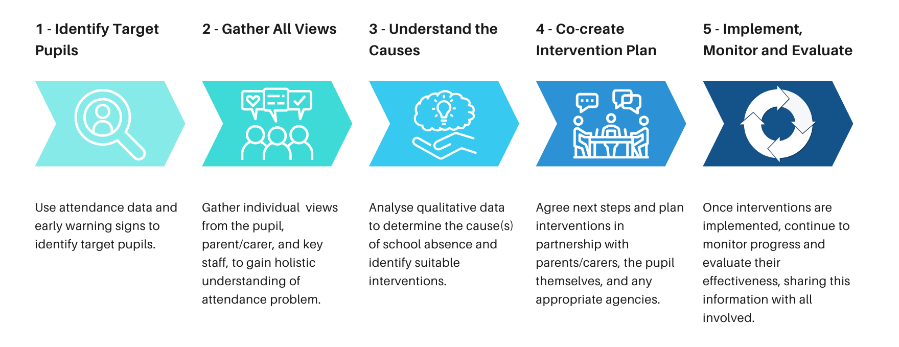
Appendix 1

Step 1 – Identify Target Pupils

The first step in the process is to identify pupils whose attendance is of concern using available attendance data.
What should we look for in the data?
- Pupils with absence below particular threshold (see policy)
- Pupils with a certain number of days missed over a period of time
- Patterns in school absence i.e. every Friday missed
It is also important to analyse the data of vulnerable groups, such as SIMD Quintile 1, PEF, Care Experienced and ASN, as pupils within these groups are more likely to experience problems attending school.
Reasons given for school absence should also be closely tracked and monitored. Cases where frequent somatic reasons are given or there are high numbers of unexplained absences, may require further investigation or intervention.

Early Intervention
Staff, especially class teachers and pastoral staff, should be aware of the importance of closely monitoring early warning signs, which may indicate impending absence problems. This will allow early preventative measures to be put in place to avoid acceleration of the attendance problem. Here are some examples of early warning signs:
- Frequent or sporadic late coming
- Regularly asking to leave class or be sent home
- Frequent somatic complaints (nausea, headaches, stomach pains etc.)
- Emotional/ reluctant to come to school in the morning
- Issues with areas of the school building
- Issues transitioning between classes
- Disruptive behaviours

The diagram below is the Spectrum of School Attendance and its Problems. Staff may find this useful as a tool to support the identification of targeted pupils, the severity of the attendance problem, and therefore, the level of intervention required. It reinforces the notion that school attendance is a process and not merely a desired outcome.
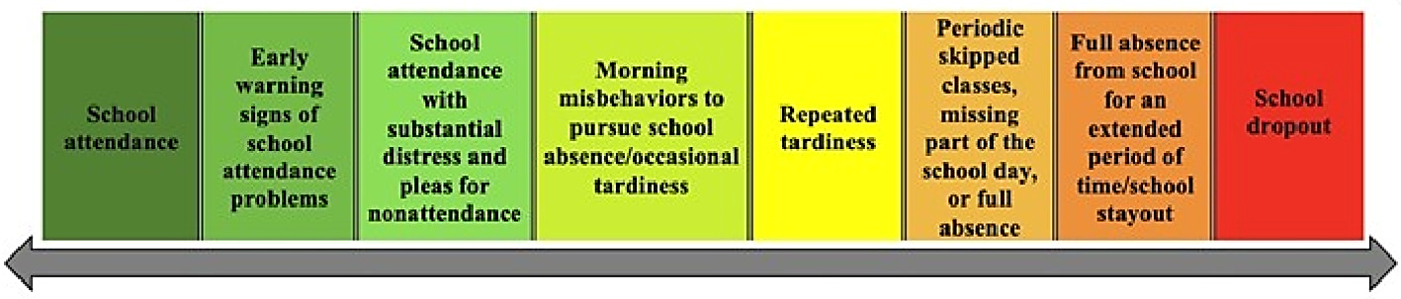

Dr C.A. Kearney, 2019 - Reconciling contemporary approaches to school attendance and school absenteeism Part 2

Continuous tracking and monitoring of attendance data should take place to identify emerging attendance issues and ensure necessary interventions are implemented to prevent further absence.

Step 2 – Gather All Views
The next step is to gather the views of the child, and key adults around them, to gain a holistic understanding of the reasons they are finding it difficult to attend.
We recommend using the School Refusal Assessment Scale (SRAS-R) to gather the views of the pupil and their parent/ carer. Click here to access the School Refusal Assessment Scale Guidance. It has links to electronic versions of the pupil and parent questionnaires (including interactive versions for early level pupils) and provides instructions on how to conduct the questionnaires. Please note the title has been re-worded using more compassionate language to avoid potential harmful consequences caused by the negative connotations of the term ‘school refusal’.
If the SRAS-R is not suitable to use with the child, or the information acquired through the SRAS-R does not provide the level of depth required, other targeted consultation methods and tools are available to use. Click here to access Alternative Ways to Consult with Learners.
The views of key staff should also be considered for identified pupils. Click here to access a Staff School Absence Questionnaire .

Step 3 – Understand the Causes
Once both qualitative and quantitative data is gathered, it is crucial to drill down into the data to correctly identify the cause(s) of the absence. This will allow appropriate interventions to be implemented.
The School Refusal Assessment Scale Excel Scoring Tool can be used to score the SRAS-R child and parent questionnaires. The tool will combine the scores to identify the main type of school absence for that individual pupil. This is explained further in the School Refusal Assessment Scale Guidance.
Through the information gathered from the SRAS-R, push and pull factors can then be identified. These are experiences which are pushing a child out of school or pulling them away from school. It may also be possible to identify push and pull factors which could encourage them to attend.
Once data around the attendance issue has undergone thorough analysis, and the type of absence, along with push and pull factors are identified, interventions can be considered.

Step 4 – Co-create Intervention Plan
Once a secure understanding of the cause(s) of the absence is obtained, along with the identification of possible push and pull factors, an intervention plan should be co-created between key staff (attendance lead, class teacher, pastoral staff, family support worker, administration staff etc.), parents or carers, any supporting agencies, and the child or young person themselves.
Sometimes a pupil at risk of school absence will be known to external professionals. Professionals might include, for example:
● Education Welfare Officer
● Social Worker
● Advisory/Specialist/Outreach Teacher
● Educational Psychologist
● Clinical Psychologist or other mental health professional
● Paediatrician
External professionals may be available to provide recommendations to inform the interventions that are put in place by the school.
It is important to note that any interventions must be directly linked to the identified cause(s) of absence and tailored to the individual child and their school absence problems. An intervention which has previously had a positive impact, may not be appropriate or successful in another individual case - one size does not fit all. Targeted Intervention resources are in section 3 of the self-evaluation toolkit and in the resources section of our Interactive Attendance Guide.
Please refer to your local authority guidance for Targeted Intervention planning and procedures.

Step 5 – Implement, Monitor and Evaluate
Any interventions should then by closely monitored and evaluated, through analysing quantitative data and regularly gathering qualitative data from all involved stakeholders.

