“Research indicates that developmentally appropriate practice is most conducive to effective learning. For example, it suggests that there is no long-term advantage to children when there is an over-emphasis on systematic teaching before 6 or 7 years of age. A key message is that approaches to fostering learning need to be flexible to take account of the needs of the child and will change as children develop. (Scottish Executive, 2007: 5)
Building the Curriculum 2: active learning in the early years discusses the fundamental importance of creating stimulating and effective real life and imaginary experiences for children, in order to fully engage and challenge their thinking. It advocates taking advantage of the opportunities for learning presented through Spontaneous play, Planned, Purposeful play, Investigating and exploring, Events and life experiences, and Focused learning and teaching. (BtC 2, Scottish Executive, 2007) These are essential features which underpin high quality play pedagogy and are considered and threaded throughout this Framework.
Play is central to every child’s physical, mental, social and emotional health and wellbeing. It is fundamentally important for developing 21st century skills, such as resilience, problem solving, collaboration and creative, critical thinking. Children are born with an instinctive drive to learn through play and exploration. Scotland’s National Practice Guidance for Early Years, Realising the Ambition, promotes the importance of children being given time to play each day, in order to follow their own line of enquiry or individual interests. It advocates the need to have a consistent pedagogical approach and play based curriculum, for the “playing, learning child” across the Early Level, into primary one and beyond. (Education Scotland, 2020: 45)
Rationale: How Good is our Play for learning? was developed by Practitioners from Forth Valley and West Lothian Regional Improvement Collaborative (FVWL RIC). Its purpose is to support senior leaders in monitoring the quality of learning and teaching through play in playrooms and classrooms. Historically school monitoring agendas largely focussed on the quality of adult-led learning to support professional judgements. Although these agendas contribute greatly towards defining quality in learning and teaching, most did not include play as a main driver for learning. In addition, although many senior leaders may share values in common within the quality assurance process, such as recognising the power of play in children’s learning, what constitutes as quality can be subjective and differ considerably.
Aim: This framework is underpinned by the Rights of the Child. In particular, it aims to reinforce the delivery of Articles 29 and 31 in supporting “the development of the child’s personality, talents and mental and physical abilities to their fullest potential through play.“ (UNCRC: 29. 31). It has been created to support and empower senior leaders to analyse quality play for learning. It reinforces informed judgements through an Adult-led, Adult-initiated and Child-led lens. It is also hoped that practitioners may use the framework to self evaluate their own practice, in order to inform change. This in turn will allow each provision to maintain and improve its quality, equity and efficiency and ensure that each child’s unique needs are being met.

Scotland’s National Practice Guidance for Early Years, Realising the Ambition, places value on the work of Julie Fisher. Fisher explains the three main contexts in which children learn within any high-quality establishment as:

Adult-lead learning: Practitioners focus children’s thinking - the adult has planned objectives/outcomes and stays with children whilst learning takes place.
Adult-initiated learning: Practitioner’s fathom/ignite children’s thinking - the adult sets up a starting point, invitation, provocation or stimulus with planned intentions and then stands back to wait, watch and wonder. Children engage independently until the adult joins to observe, interact or enhance learning.
. Child led learning: Practitioners follow children’s thinking - resources, experiences and outcomes are freely chosen by the child and are under the control of the child. This may or may not involve direct interaction with the adult.

)

“There is no contest between child-led and adult led learning. It is the one without the other that gives young children an impoverished educational experience.’ (Fisher, as cited in Interacting or Interfering, 2016)

Aspiration: How Good is our Play for learning? aspires to promote a shared understanding of the delivery of high-quality play pedagogy across FVWL Regional Improvement Collaborative. It seeks to empower practitioners and senior leaders to tell the story of how play is valued across the Early Level and beyond.

To enable this, the framework connects the three main contexts in which children learn; Adult-led, Adult-initiated and Child-led learning, to interactions, experiences and spaces, to ensure children are offered a consistent pedagogical approach to high quality Play for Learning.

Every learning environment in terms of interactions, experiences and spaces – both outside and indoors – tells a story about how play is valued. The learning environment in the early stages of primary school should not look or feel starkly different from a motivating ELC environment. The level of provocation might be greater, the interaction might be more challenging, and the experiences on offer might be different, but the school environment should be conducive to learning through play. Achieving a consistent pedagogical approach across the ELC sector and the early primary stages should be a key aspiration. . (Realising the Ambition, 2020: 47)

Interactions
The social environment of interactions should provide children with opportunities to continue to develop positive relationships with others; while also supporting and developing an understanding of the notion of boundaries; self-regulation, negotiation and choice. As the complexity of the child’s play develops, learning should be facilitated through a cyclical process of responsive and intentional planning. This should include observations, interpretation and documentation of learning, and facilitation in order to extend children’s thinking.
Adult-led | Adult-initiated | Child-led
The following statements carry across all three contexts of Adult-led, Adult Initiated and Child-led lens as they underpin the foundations of play pedagogy within each environment:
- Warm, respectful relationships with families and partners inform future play pedagogy and practice.
- Interactions are playful, nurturing, positive, relevant and focussed on enhancing learning
- Adults support children as enthusiastic and motivated lifelong learners, developing the four capacities of a Curriculum for Excellence.
- Adults ensure they only interact where and when appropriate to move learning forwards
- Adults regularly reflect on impact of learning episodes and their own interactions with children
- Adults step in to reassure, given unspoken encouragement and provide children with quiet, unassuming support if overcome with uncertainty
- Play is limitless and allows learners to develop at their own pace supported by adults and peers

Adult focus children’s thinking.  - Adults value children as agents in their own right; actively listening to them and acing upon what they hear.  - Effective non-verbal communication and tone of voice are used by the adult to ensure interactions are positive, purposeful and reciprocal  - Adults are attuned to each child, listening carefully to them and responding to their unique needs and interests.  - Adult-child interactions build effectively on, or scaffold the children’s existing knowledge, understanding and spoken language.  - During adult-led / directed experiences, the adult leads the interactions around planned objectives / outcomes and stays with children whilst learning takes place  - Adult led / direct teaching is developmentally appropriate and flexible e.g., young children are not asked to listen to adult-led agendas for a long period of time, if a child ‘gets’ the concept quickly then they can re-join the child-led play  - Adults are responsive to children’s learning dispositions needs and interests. | Adults ignite children’s thinking.  - The adult provides a provocation or stimulus which acts as a starting point in order to solve problems, try out new theories and develop new skills.  - Adults provide rich opportunities for children to work independently or collaboratively.  - WATCH – What is the child trying to achieve?  - WAIT – Is the child progressing on their own?  - WONDER – How have they arrived at this line of enquiry?  - WHAT – What could I provide to extend future learning?  - Adults make judgements on when a shift in learning is required. Through scaffolding, explaining, informing or posing problems to extend thinking.  - Adults are skilled at enticing reluctant learners to interact and engage in learning.  - Adults can join play but should follow the child’s lead where possible. They use interactions and observations to strengthen and deepen trusting relationships. | Adults follow children’s thinking.  - True play is owned by children themselves; they lead it, drive it forward and react to experiences, spaces and resources. They take control of the time and outcomes.  - Children engage individually or in self-chosen groups during their self-guided investigation and explorations.  - Children develop self-awareness and understanding of their world by pondering, imagining, wondering, and revisiting real life situations during play.  - Children are relaxed genuine, natural and respectful with each other, and with warm and attentive adults.  - Children are learning to communicate their ideas, thoughts and feelings through holding meaningful conversations, explaining, suggesting, reasoning, and negotiating through child-led play.  - Children are confident in self-directing their play, they respect boundaries, negotiate and are resilient.  - Children may notice the available adult during play, choose to ask questions to consolidate their ideas or invite into play as a partner, to share an experience.
Experiences
To support cognitive development the learning environment should be rich in opportunities for children to engage with concepts and foster skills for learning, such as reasoning, creativity and problem solving. The choice of experiences on offer should reflect an environment of open-ended possibilities in which children can feel intrinsically motivated to explore and investigate through play - including taking calculated risks and learning from mistakes.
Adult-led |  | Adult-initiated |  | Child-led
The following statements carry across all three contexts of Adult-led, Adult-initiated and Child-led lens, as they underpin the foundations of play pedagogy within each environment.
- Adults have adopted a child’s curriculum – a child-centred outdoor, indoor curriculum delivered through play pedagogy.
- Adults understand that each child arrives at school with a different relationship with ‘Play’ and model play individually.
- Adults balance the time they themselves spend observing and engaging in child-initiated, adult-led and adult-initiated playful experiences, and plan appropriately for all.
- Children’s interests and playful learning remain central to the potential learning outcomes.
- Digital pedagogies are embedded.

Adult focus children’s thinking.  - Adults recognise the immense value of Play and promote learners ‘Right to Play’ within curriculum delivery.  - Children are actively engaged in their learning.  - Adults use children’s natural dispositions for learning and prior experiences to plan responsive, playful and motivating learning episodes.  - Adult led learning is playful, short, sharp and focussed to introduce new and specific concepts and skills.  - Adults differentiate experiences to secure the progression of each child across the totality of their learning and development.  - Adults reflect on significant observations to enhance and improve their approaches to teaching and learning, to surprise, personalise, mesmerise, energise and to inspire wonder. | Adults ignite children’s thinking.  - Adults' knowledge of learners is crucial to providing experiences that will optimise children's learning.  - Target tasks are planned and utilise open-ended resources.  - Target tasks motivate and challenge children to sustain a high level of thinking, practice new skills and extend learning.  - Adults are skilled at enticing reluctant learners to interact and engage in learning.  - Homework tasks can revisit, reinforce or extend adult initiated learning.  - Adults respond, teaching in the moment, using observations to build on children’s strengths to plan meaningful next steps in learning.  - Children engage in adult and child co-constructed experiences.  - Adults show they value play by joining in.  - Adults give children time and resources to practice, rehearse, repeat and revisit learning through play. |  |  | Adults follow children’s thinking.  - Adults value child led play. Time for this is planned for and protected.  - Self-directed approaches are viewed as an integral part of the day where children initiate and demonstrate mastery and control of their learning.  - Children demonstrate high levels of engagement, are relaxed and appear happy (Leuven Scale).  - Children facilitate and celebrate individual lines of enquiry during this true, self-directed study.  - Children bond together, for a shared purpose. They develop social skills such as empathy and inclusivity, disagreeing and compromising in a way that is productive, meaningful and successful.  - The fear of failure is removed, as importance is placed on process over outcome.  - Children can experiment and test hypotheses by applying skills and previously taught concepts in a relaxed manner.  - Children understand they learn through making mistakes.  - Children self-select play resources to structure their own active play, to assess risk, learn respect and keep safe.  - Children have ownership of resources.
Spaces
As previously mentioned, designing learning environments requires consideration of the interactions, experiences and spaces on offer. Physical spaces, both outside and indoors, should be constantly reviewed to incorporate a wide range of responsive, familiar, and exciting new play opportunities. Notice how the children interact with their environment and respond to their interests and use of their spaces.
Adult-led |  | Adult-initiated | Child-led (both outdoors and Indoors).
The following statements carry across all three contexts of Adult-led, Adult-initiated and Child-led lens, as they underpin the foundations of play pedagogy within each environment.
- Play is valued by all
- Spaces are set up to empower children’s curiosity, creativity, collaboration, critical thinking, and communication.
- Adults and children reflect on their significant observations, to plan relevant environmental changes.
- Adult-led learning is delivered in parallel with adult initiated and child-led play
- Spaces and routines within the environment are flexible to allow for shorter or extended periods of play as appropriate.
- The environment is warm, welcoming and nurturing enabling children to develop a sense of self and belonging.
- Opportunities for outdoor learning and the use of spaces out with the classroom are maximised
Adults focus children’s thinking.  - Adults harness the school values within the spaces. They model kindness and respect and support and encourage children to do the same.  - Adult-led spaces remain consistent with child-centred play pedagogy, e.g. spaces created for small groups.  - Adults ensure the space is welcoming, authentic, aesthetically pleasing, culturally representative of diverse family and community, and embraces nature.  - Adults ensure there are open spaces, opportunities for music, soft lighting, rest areas, a wide range of objects, stimulating materials and loose parts to inspire curiosity.  - Visuals and meaningful wall displays are used to aid positive relationships, effective communication and support learning.  - Children’s learning and achievements are made visible e.g. on wall displays; in floor books.  - Adults ensure children have regular access to outdoor spaces for play and learning.  - Adults and children share and celebrate their experiences and learning from, and with home and the community.  - Adults reflect with children to plan improvements to the spaces.  - Adult use a variety of spaces, both indoors and outdoors, for adult-led learning experiences i.e. ‘teaching’ does not always take place at a teaching table. |  | Adults ignite children’s thinking.  - Adults provide an environment to support and challenge by providing open-ended provocations to spark interests and aid exploration and enquiry.  - Spaces are well organised, flexible and responsive to enhance flow, interdisciplinary learning and promote children’s application of new learning.  - Spaces are communication and language, maths and numeracy rich  - Spaces are reflective of current learning and offer new provocations.  - Spaces are co-constructed between adult and child.  - Adults are mind-minded and attuned to notice how individuals and groups of children are using spaces:  - Open-ended resources are added and removed at appropriate times to support, challenge and extend children’s learning.  - Open-ended resources allow for intentional and unintentional learning opportunities.  - Children are encouraged to record their learning and celebrate success.  - Spaces allow for different types of play and encourage both physically active and quiet, calm play both indoors and outdoors. | Adults follow children’s thinking.  - The space will give children the opportunity to develop essential life skills creativity, problem solving, self-help and digital skills.  - Spaces should include a rich variety of new and familiar textures, colours, shapes, sizes and origins to enable children to find the extraordinary in the ordinary.  - The environment influences the nature of interactions and allows the adult and child to share a context.  - Spaces support and empower children to be in control of their own learning.  - The space offers children home from home comforts.  - Children are encouraged to revisit learning, map events and real life experiences through role play, malleable play, social play, sensory play and risky play.  - With learner’s permission, work can be shared and celebrated when the class is together again, which will boost individual confidence and wellbeing as well as inspire their peers.  - Spaces, both outdoors and indoors have designated areas that children can go to, if they find the environment overwhelming  - Spaces are adaptive and responsive to children’s emotions, interests and needs.
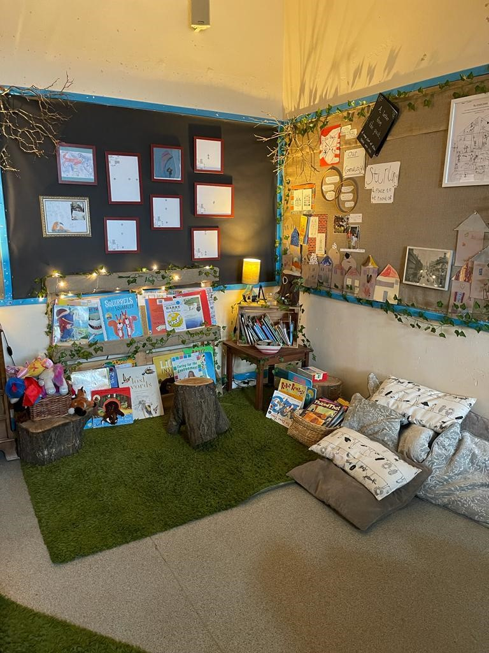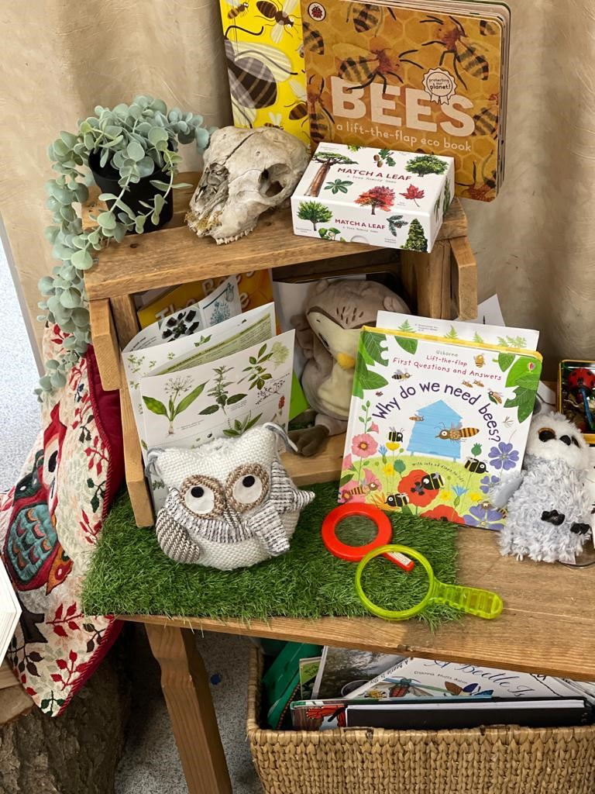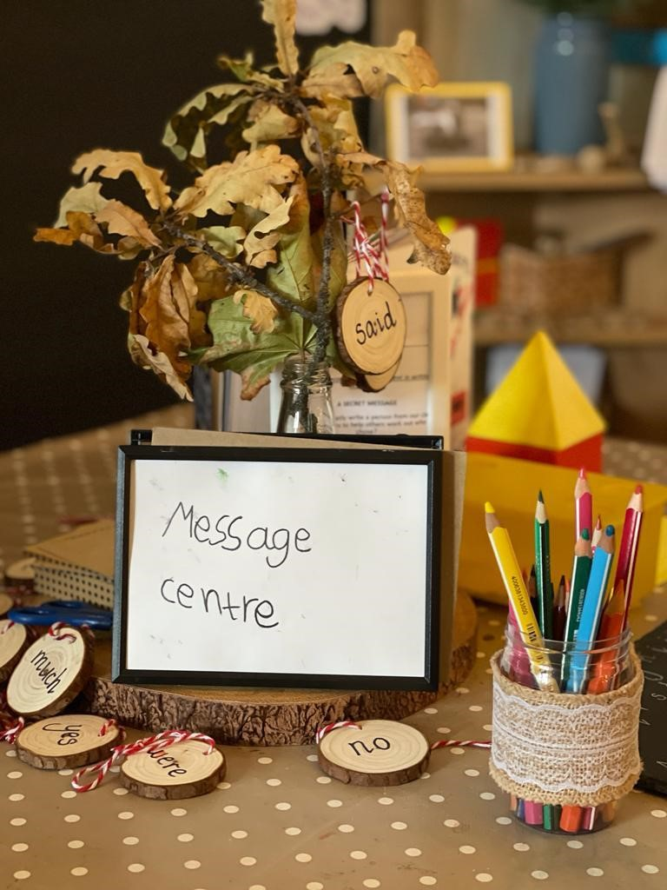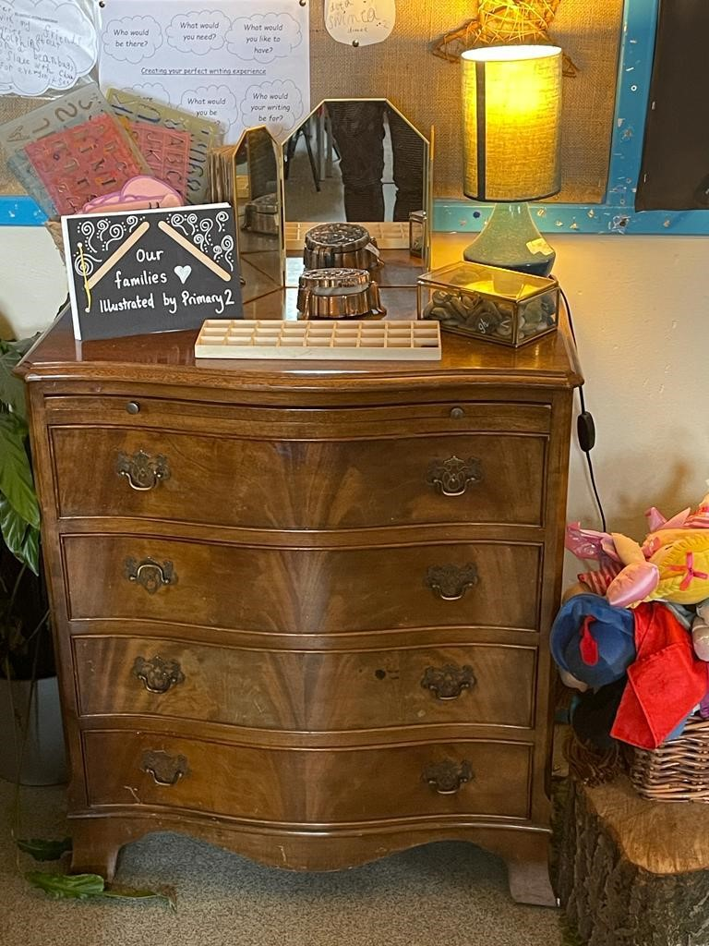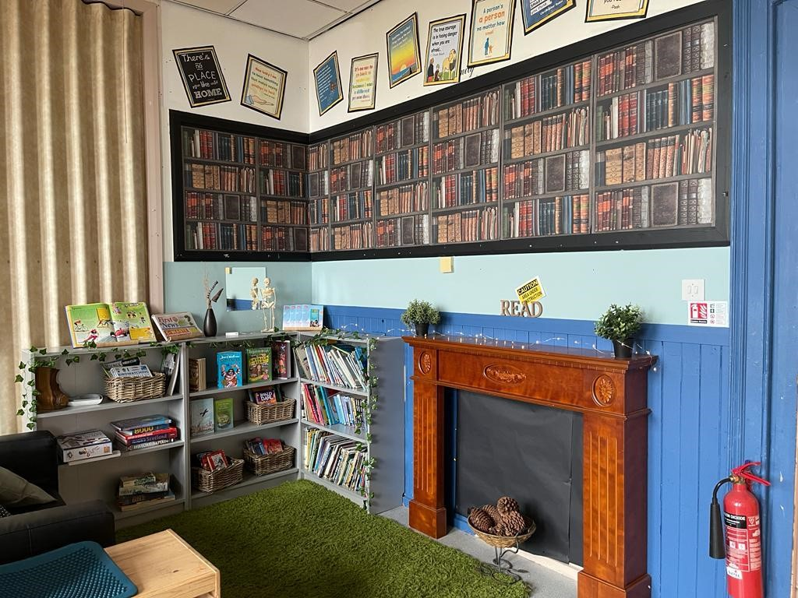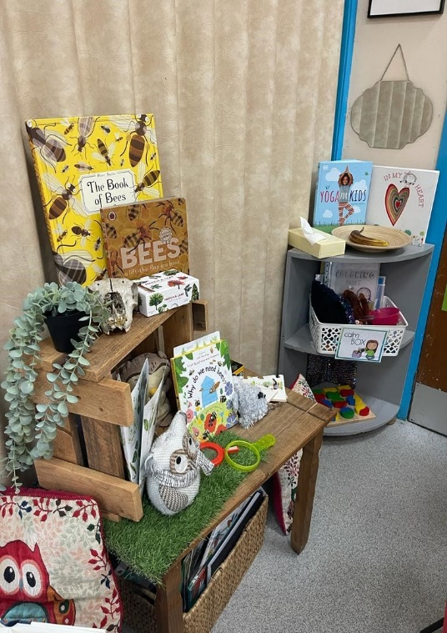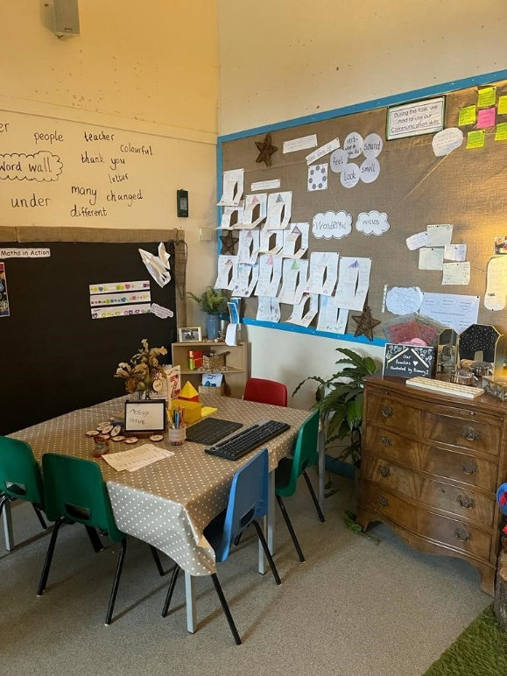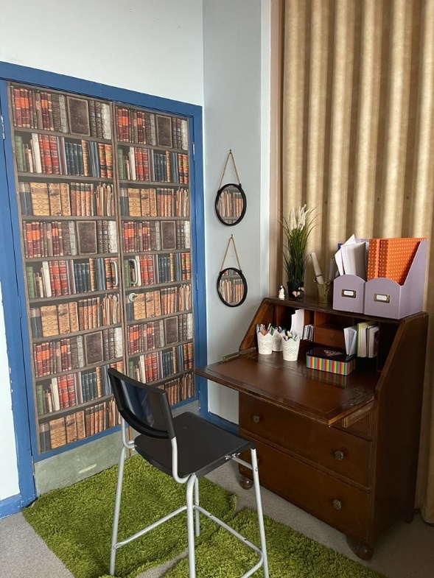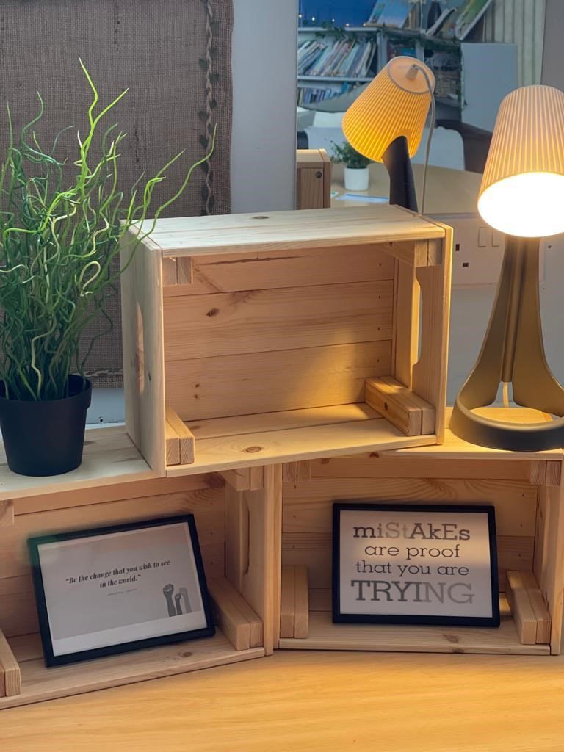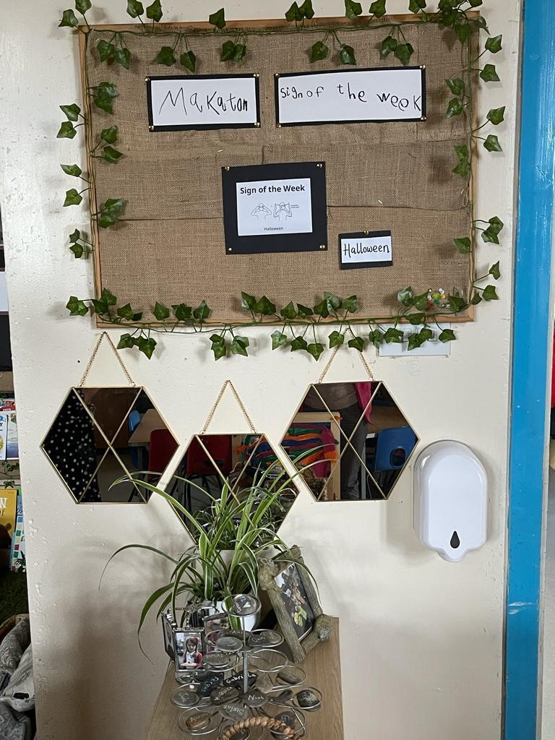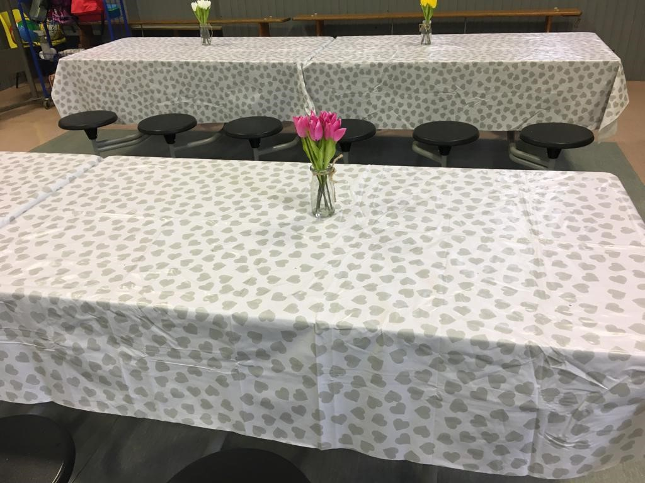
Children are valued as agents in their own right. They have co-created shared values, vision and purpose for their shared classroom space.

Adults observe and support children’s innate impulses during play, in order to further support and encourage these natural learning processes to take place/ progress over time.

Play and learning spaces are welcoming, aesthetically pleasing and motivating. Children have access to rest areas, and sensitive adults who nurture confidence, joy, and curiosity.

For FVWL RIC Sharing of Good Practice Glow Tile: Interactions, Experiences and Spaces
The environment as the third educator…Each space has clear purpose and direction and supports all other spaces to ensure progression and continuity of learning.
The delivery of Article 31 in particular ensures all children’s right to play is promoted, particularly for those facing barriers to play. Children care for each other, their resources and all living things through play.

The classroom space places value on the importance of the rights of the child (UNCRC), relationships, communication, interactions, the diversity of family and unique communities working together,
Children view adults are partners in play with guided participation embedded in learning culture.
A real and relevant curriculum is delivered through a blended approach of intentional and unintentional play opportunities.
Daily routines and pace of the day are carefully planned for.
Adults and children listen and communicate respectfully using all their senses.
Growth mindset and having a go at learning is promoted by all and is embedded in ethos.

