 

**FVWL RIC Numeracy Academy**

**Blended Learning Support**



**Cuisenaire Challenge**

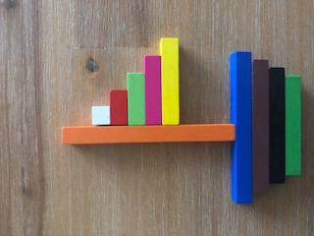

1. Can you work out the total value of the boat if the white rod has the value of 1, red 2, light green 3..… orange 10?
2. If the white rod has the value of 2, red 4, light green 6 .….. orange 20 – what is the total value of the boat?
3. What if the white rod has the value of 4, would you able to predict the total value of the boat? Identify what the pattern is.

Don’t have a set of Cuisenaire handy – why not try <https://mathsbot.com/manipulatives/rods> ?

Make up your own shape and challenge someone at home? Decide what value you want to give the white rod.

Once you have an answer, draw and/or write down the way you worked it out, take a picture and send it back so that we can see how you solved it.