First Level Number Talks – Teachers’ Notes
Subtraction Strategies
Adding up – This strategy allows students to build on their strength with addition, by adding up from the number being subtracted to the whole number. The larger the jumps, the more efficient the strategy will be. In thinking about how much more to add to reach the whole, learners can build on their knowledge of basic facts, doubles, making ten and counting on.
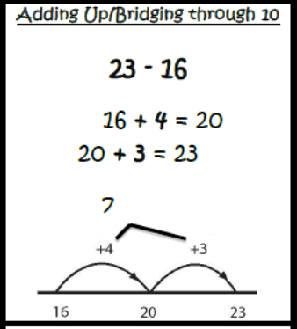
DAY 1 and 2 Number Strings - Encourage the use of this strategy.
Removal – If students tend to view subtraction as ‘taking away’, they will gravitate towards this strategy. Starting with the whole, the second number is removed, in parts. The ability to decompose numbers into ‘easy-to-remove’ parts gives learners access to this strategy. It is important to encourage learners to keep the ‘whole’ intact to prevent them from losing sight of the whole and the part.
DAY 3 Number String - Encourages removing the second number in parts that are the same as the ones digit in the whole number

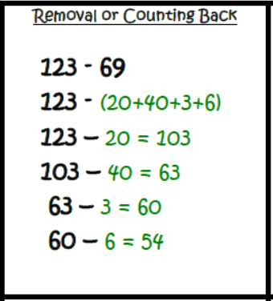
DAY 5 Number String - Encourages removal in place-value chunks and decomposing a single-digit number to remove it in parts.

DAY 4 Number String - Encourages removal in place-value chunks without regrouping

