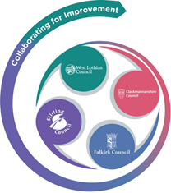 

**FVWL RIC Numeracy Academy**

**Blended Learning Support**

Number Talks – FIRST Level

**Remember** – Number Talks are all about how you solve a task, mentally.

For this activity, don’t use anything to help you, just use your brain!

**Once you have an answer, write down the way you worked it out, take a picture and send it back so that we can see how you solved it.**

Look at each number sentence and share the strategy you used to get each answer.

Did you use the same strategy each time?

You can also share your strategies with someone at home. Did they work it out the same way as you?

**87 – 40**

**87 – 44**

**87 – 50**

**87 – 53**