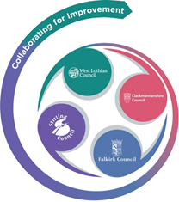 

**FVWL RIC Numeracy Academy**

**Blended Learning Support**

Number Talks – EARLY Level

**Remember** – Number Talks are all about how you solve a task, mentally.

For this activity, don’t use anything to help you, just use your brain!

**Once you have an answer, draw and/or write down the way you worked it out, take a picture and send it back so that we can see how you solved it.**

Look at each picture, in order, and answer these questions for each –

**How many beads do you see?**

**How do you see them?**

Draw the Rekenrek pattern and show your thinking.

For example –

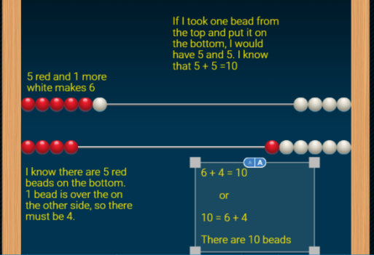

*Remember that we make the numbers on the left hand side of the Rekenrek

 A

 B

 C