Number Talks - 2nd Level
(Teacher Information)

Subtraction (5 different strategies)

63 – 28 = 35
Minuend – Subtrahend = Difference

1 Round The Subtrahend to a Multiple of Ten and Adjust

I rounded 28 to 30. Then I subtracted 30 from 63 and got 33. Then I added 2 back because I had taken away 2 too many
63 - 28
63 - 30 = 33
+ 2 = 35
2 Decompose the Subtrahend (Jump Strategy)

First I took 20 from 63 and that was 43. Then, I saw the 8 in 28 as a 3 and a 5; I took away the 3 from 43 first and that was 40, then I took away the 5 and that was 35
63 – 28
63 - 20 = 43
-3 = 40
-5 = 35

3 Add instead:
I started with 28 and added 2 to get 30; then I added 30 and got 60. So I added 3 more and got 63.
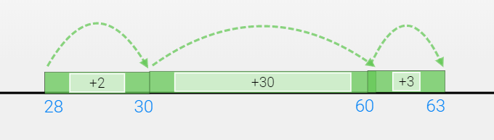
63 - 28
28 + 2 = 30
+ 30
60 + 3 = 63
2 + 30 + 3 = 35

I started at 28 and added 30 to get to 58. Then I jumped 2 more to get to 60 and 3 more to get to 63.
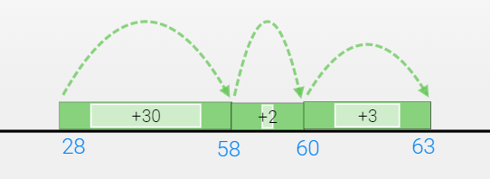
63 – 28
28 + 30 = 58
+2
60 + 3 = 63
30 + 2 + 3 = 35

4 Same Difference

I added 2 to 28 and got 30, then I added 2 to 63 and got 65. 65 minus 30 is 35.
+ 2 63 – 28 +2
65 – 30

63-28
65 -30 = 35

5 Break Apart by Place

60 minus 20 is 40; 3 minus 8 is negative 5, 40 minus 5 is 35

63 – 28
60 – 20 = 40
3 - 8 = -5
40 – 5 = 35

