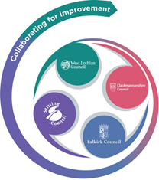 

**FVWL RIC Numeracy Academy**

**Blended Learning** **Support**

**Number Talks – EARLY Level**

**Remember** – Number Talks are all about how you solve a task, mentally.

For this activity, don’t use anything to help you, just use your brain!

**Once you have an answer, draw and/or write down the way you worked it out, take a picture and send it back so that we can see how you solved it.**

Look at each picture, in order, and answer these questions for each –

**How many butterflies do you see?**

**How many more to make 10?**

**How do you know?**

Draw the pattern, explain how you know and write the sum.

For example -

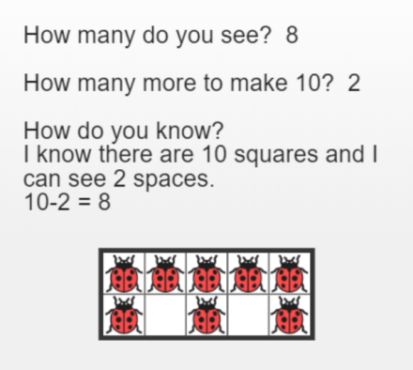

Today’s questions –

C

A

B

