Number Talks - 2nd Level
(Teacher Information)

Addition (5 different strategies)

63 + 28

1 Round and Adjust

I rounded 28 to 30. Then I added 30 and 63. The I took away the extra 2 and got 91

63 + 28
63 + 30 = 93
93 - 2 = 91

2 Take and give (compensation)

I took 2 from 63 and gave it to the 28, so I made the problem 61 + 30, then I added 61 and 30 and got 91

63 + 28
+2
63 + 28
61 + 30 = 91

3 Start from the left (Split strategy; add tens, then add ones)

I added 60 and 20 and got 80; then I added 3 and 8 and got 11; then I added 80 and 11 and got 91

63 + 28
60 + 20 = 80
3 + 8 = 11
80 + 11 = 91

4 Break One Addend Apart

I added 63 and 20 and got 83; then I added 8 and got 91
I added 60 and 28 and got 88; I added 3 more and got 91

63 + 28 or 63 + 28
63 + 20 = 83 60 + 28 = 88
83 + 8 = 91 88 + 3 = 91

5 Add Up

I started with 63, then I added 20 to get to 83, then I added 7 more to get to 90 and then I add the 1 that was left to get to 91 (jump strategy)

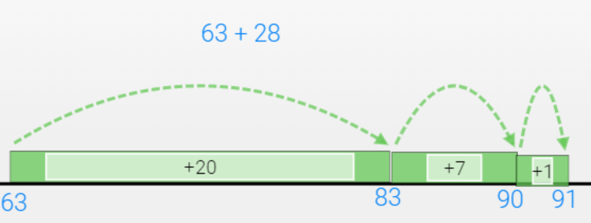

I started with 28 and added 2 to get 30; then I added 61 and got to 91

