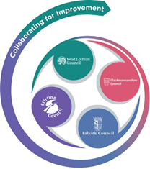 

FVWL RIC Numeracy Academy –

Blended Learning Support

Number Talks – Second Level

Day 1

**Remember** – Number Talks are all about how you solve a task, mentally.

For this activity, don’t use anything to help you, just use your brain!

**Once you have an answer, draw and/or write down the way you worked it out, take a picture and send it back so that we can see how you solved it.**

Look at the addition sentences. What mental strategy did you use to work out the answer?

Did you use the same strategy?

Was it an efficient strategy?

**48 + 9**

**71 + 39**

**247 + 98**

Remember to share with someone at home. Did they work it out the same way or a different way? Which way was the most efficient?