Maths Through Stories
Title - Dinosaur Deals
Author: Stuart J. Murphy
Mathematical Story Series - Mathstart
Mathematical focus – equivalent value
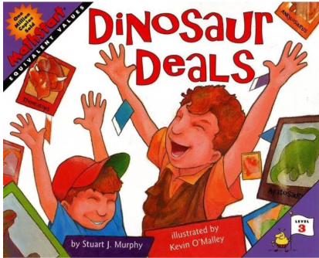

https://www.youtube.com/watch?v=s8ovPUkRQ50

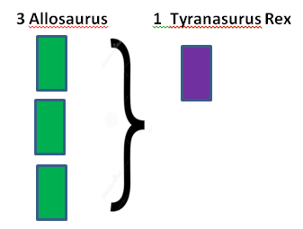
Day 1 Reading the story
As you read the story, use the diagrams to discuss each of the trades
that are made.
Ask questions like ‘How many Allosaurus does it take to equal a
Tyrannosaurus rex?

Day 2 Activity 1
How many of each type of cards did Mike have when he went to the Trading Fair? How many of each type did Mike and Andy have at the end of the story – can you name/draw them.

Day 3 Activity 2
Maths Through Stories

Look at all the Dinosaur Cards (on p28 and p29) and decide on a value for each one
e.g. 5 Allosaurus equal 1 Tyrannosaurus rex card because the Tyrannosaurus rex weighs about 5 times as much as the Allosaurus

=
5 Allosaurus 1 Tyrannosaurus rex
e.g. 2 Tricerotops equal 3 Stegosaurus as they are one and a half times longer in length.

=
2 Tricerotops 3 Stegosaurus
Looking at the length, height, weight, diet decide on a value for all of the dinosaurs in the story. Record this as above or draw it.

Day 4 Activity 3
Race for the Red Card game
Resources required – a dice, white cards, blue cards and red cards (If you don’t have paper you could use coloured counters) NB Any three colours can be chosen
Players take turns rolling a dice. For each roll, the player receives that number of white cards equal to the dots on the dice. When a player has 10 white cards, they can be traded for a blue card. 5 Blue cards can then be traded for 1 red card. The first player to earn a red cards wins.
Day 5 Extension Activities
1 If you have a collection of cards e.g. cartoon characters, football cards, Pokemon, Star Wars etc – make up a story about the trading of these cards. Write it down or act it out.
2 Conversion 10 feet = 3m 5cm Corythosaurus (length 30 feet) = 15 m 15cm
What is the length of the Tyrannosaurus in m/cm?
What is the height of the Triceratops in m/cm?
What other questions could you ask?

