

FVWL RIC Numeracy Academy

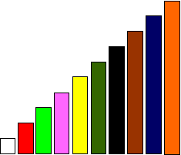

**Cuisenaire Lesson 4 – Fraction Wall Investigation**

When we have one rod or more, equivalent to a train of others rods made of one colour, we can use this to investigate fractions.

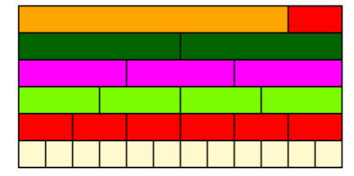

Look at the fraction wall. Build it. **Record as many facts as you can**

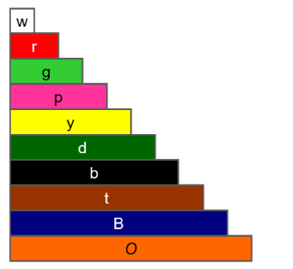e.g.

2 dark green = orange + red

so **2d = o + r**

½ (orange + red) = dark green

so **½ (o + r) = d**

Codes for recording names of rods

**Extension**

Build a different fraction wall and record as many facts as you can. Share your wall with a partner and ask them to record as many facts as they can. Then compare findings.