

FVWL RIC Numeracy Academy

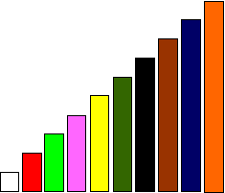

**Cuisenaire Lesson 3 – Fraction Wall**

When we have one rod or more, equivalent to a train of others rods made of one colour, we can use this to investigate fractions.

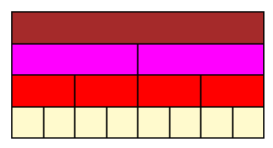

Look at the fraction wall. If the tan rod (t) is 1 – what fraction of the tan rod is:

* one pink rod (p)
* one red rod (r)
* one white rod (w)

**Are the following statements true (T) or false (F)**

t = 2p

3w = r

2r = ½ t

r = ½ p

r = ¼ t

4w = ¼ t

**Extension**

Make up some more true/false questions and test a partner