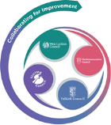

FVWL RIC Numeracy Academy

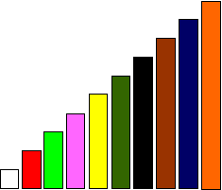

**Cuisenaire Lesson - thirds, ninths**

When we have one rod or more, equivalent to a train of others rods made of one colour, we can use this to investigate fractions.

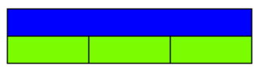

*Blue = 3 light green*

The blue rod cannot be halved but can be divided into 3 equal parts using the light green rod

$1$ Light green = $\frac{1}{3}$ Blue

1

$\frac{1}{3}$ $\frac{1}{3}$ $\frac{1}{3}$

Three light green rods are equal to the length of the Blue rod so

we can also refer to each of the light green rods as **one third**

Add white rods below the light greens. 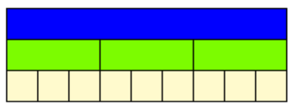

**How many do you have? What fraction of the blue rod is each white rod?**

What other facts can you find? e.g. **one white = 1/3 light green**

**Extension**

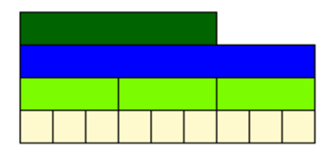Add the dark green rod to the Fraction Wall – what fraction is this to the Blue rod? How do you know?