

FVWL RIC Numeracy Academy

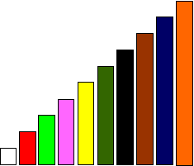

**Cuisenaire Lesson - Halves**

When we have one rod or more, equivalent to a train of others rods made of one colour, we can use this to investigate fractions.

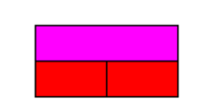

*pink = 2 red*

Two red rods are equal to the pink rod so

We can also refer to the red rods as **halves**

One red rod is half of the pink rod

1

$\frac{1}{2}$ $\frac{1}{2}$

**Can you find some other rods to make halves? Record** e.g. red = ½ pink

**Extension**

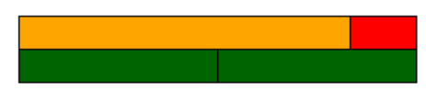

*orange + red = 2 dark green*

Here the dark green rod is half of the orange and red rod.

*dark green = ½ (orange + red)*

**Using the orange rod and one more, of a different colour – can you find some more halves?**