Maths Through Stories
Title – Less than Zero
Author: Stuart J. Murphy
Mathematical Story Series - Mathstart
Mathematical focus – negative numbers
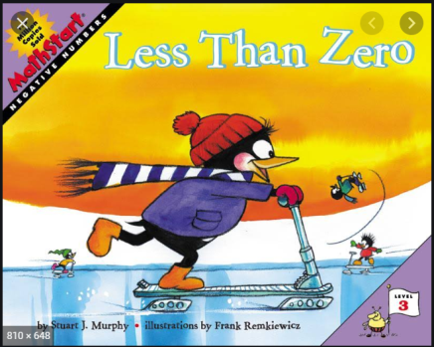
https://www.youtube.com/watch?v=trrHaFCFOCs

Synopsis of Story
Perry the Penguin needs 9 clams to buy an ice scooter - but he's not very good at saving. As Perry earns, spends, finds, loses, and borrows clams, a simple line graph demonstrates the concept of negative numbers

Day 1 Activity 1
Read the story. After reading the story, return to the graphs. Ask the child to retell the story by looking at the graphs to see what happened to Perry’s clams.

Day 2 Activity 2
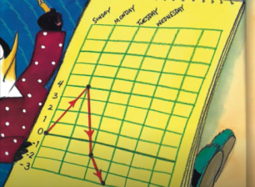
Drama – get the child to act out the situation. They act in role as Perry who is saving for an ice scooter. Use buttons/stones etc to represent the clams. As the act out the story change the objects to mirror the clams in the story. Get the child to make a graph similar to that in the story

Maths Through Stories

Day 3 Activity 3
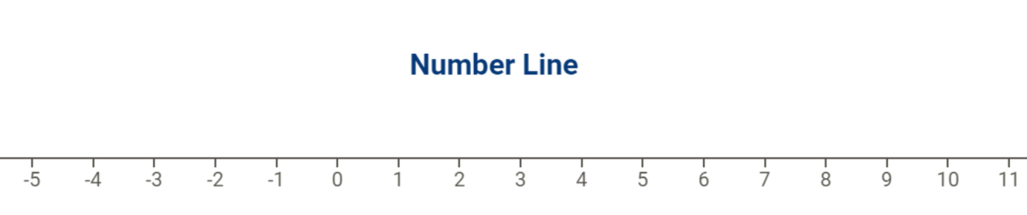
Create a Number Line (see below). As you re-read the story, keep track of Perry’s clams by using a marker (counter, penny etc) on the number line. Start with the marker on zero. When Perry gains some clams – move the marker to the right to reach the correct number. When Perry spends or loses his clams, move the marker to the left. After each move ask ‘How many clams does Perry have now?’

Day 4 - Activity 4
Pocket Money Tracker. Ask the child to record their pocket money over the coming weeks/months. Keep a running total of funds and purchases made. Discuss what could happen when allowance is spent and a purchase is required by the child.

