Maths Through Stories
Title – Ten in the Bed
Author: Penny Dale
Mathematical focus –counting, forward and backward number sequences.
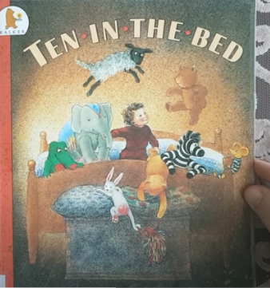
https://www.youtube.com/watch?v=ZnhP9P7Obfc
Day 1 Reading the story
As you read the story ask the children to count how many toys are on the floor as well as on the bed? Can the children count on from the number on the previous page rather than starting from one each time?
Day 2 Activity 1 - counting
Short recap of story from yesterday. How many were in the bed at the beginning? Turn to this page to check.

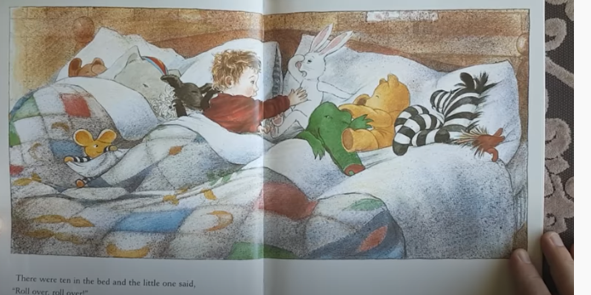
Count forwards to 10. I am going to count how many there are on the bed from 1 to 10 (point as you count) and I want you to say it after me. Ready? This time say it by yourself. Do it a few times together (you can point to each one as they count). Try different voices e.g. quiet, loud, slow, fast…
Turn to page below. How many were in the bed at the end of the story?
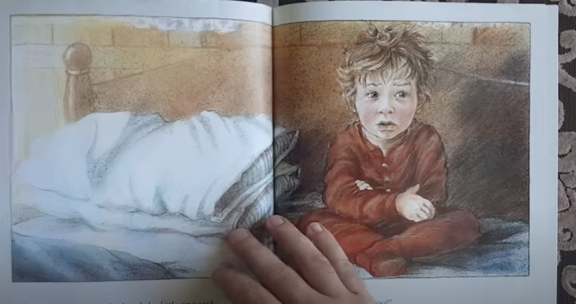
Count backwards from 10 to demonstrate each toy leaving the bed. I am going to count backwards from 10 and I want you to say it after me. Ready? This time say it by yourself. Do it a few times together (you can use your fingers to count down as they count). Try different voices e.g. quiet, loud, slow, fast…
Differentiation - Some learners may need to focus on counting forwards before they attempt backwards. Others may be secure within 10 so go beyond 10. How far can they count up to? How far can they count backwards? Can they do it from 20?
Follow up activities
Sing Ten in a Bed as a song using the children themselves, props or their fingers to perform the actions. Give plenty of opportunities to count forwards and backwards and starting from numbers other than 1 and 10 as you sing.
Day 3 Activity 2 – forward and backward number word sequences
Recap - count forwards and backward together. Say alternate number words around the group forwards and backwards. Let’s take turns to say the numbers. I will say one and you say two and we will keep going like that. Ready? This time you start. Let’s try it backwards now. This activity supports the learner to reflect on the last number spoken to generate the number word after or the number word before.
Open to the page below and say the line “There were four in the bed and the little one said Rollover. Rollover”
How many will be left in the bed. Count 1, 2, 3, that’s right 3. The number 3 comes before the number 4.
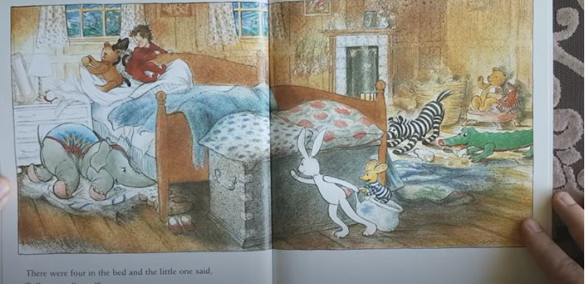
How many were on the floor? Count together. 1, 2, 3,4,5,6 and the elephant 7. How many were there when elephant joined them? 7.
Before and after game - I’m going to count and I want you to say the number after I stop. Ready? Don’t’ always start at 1 and then try backwards.
Differentiation – some children may not need a run up others will may need a longer run up i.e. always from 1 or 10. Providing children with ‘run up’ strategy to help child to produce number word after and before which is the focus for tomorrow.
Follow up activities
http://www.ictgames.com/mobilePage/flipCounter/index.html
Play this game to give children the opportunity to count forwards and backwards now seeing the numeral. Set the speed and the range of numbers appropriate to stage of children. Stop at numbers and ask them what comes before and after.
Day 4 Activity 3
Show book and sing song again, acting out the actions either with props, children or fingers.
Before and after with no run up - I’m going to say a number and I want you to say the number just after the one I say. Ready?
Use the props, screened numeral tracks, number lines or numeral rolls to support learning if needed.
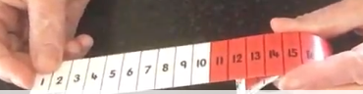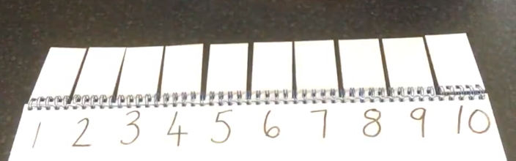
numeral roll click photo for a video screened numeral tracks click photo (you need to be logged into Glow to watch clips)
Differentiation - In future learning, being able to generate the number word after is necessary for learners in order for them to be able to develop counting on strategies to solve addition and missing addend tasks. Some learners may confuse ‘number word after’ with ‘number word before’. Some learners will use their FNWS run up strategy (ie. Start at 1 to get to the number they are looking for). The goal here is for them to generate the NWA without using a ‘run up strategy’.
Follow up activities
Enjoy singing other number songs together e.g. 1, 2,3,4,5 once I caught a fish alive. For more ideas on BBC website click below.
https://www.bbc.co.uk/programmes/b03g64rd
Day 5 Activity 4
Enjoy the story together. Then using props or children, tell the children you are going to make mistakes when you are counting and they have to spot the mistake. For example 1, 2, 4, 5. Ask children which number you have missed. Point to the children or props as you count. Do this with forward and backward number sequences and start from various starting points. Invite a child to do this and to make a mistake for everyone to spot.
Counting Stick- strip of wood divided into ten sections, unnumbered. Choose any number within your FNWS range. Point to the beginning end of the stick and tell the pupils that the first number is ‘x’. Then point to each division in turn, asking what number will go there. Miss out a number as you can count. Can children say the missing number? Repeat for your BNWS backwards numbers.
Follow up activities
Make puppets for the song. You can use socks, sticks, wooden spoons, lollipops etc. Use a block/brick/box/piece of material for the bed and children can then use the props to sing the song and retell story.
Digital Learning
When playing these games focus on reciting numbers in order
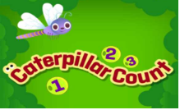
https://www.tvokids.com/preschool/games/caterpillar-count
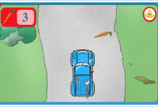
https://pbskids.org/curiousgeorge/busyday/drive/

