The Doorbell Rang
People at the table | 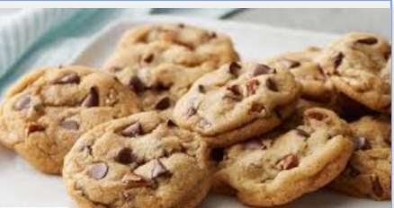  How many cookies does each person get? | Any cookies left over
2

3

4

5

6

7

8

9

10

11

12

People at the table | How many cookies does each person get? | Any cookies left over | Remember remainders!  (12÷ 5 = 2 r2)  Record
2 |  |  | 12 ÷ 2 =
3

4

5

6

7

8

9

10

11

12

