Maths Through Stories
Title – The Doorbell Rang
Author: Pat Hutchins

Mathematical focus – Division
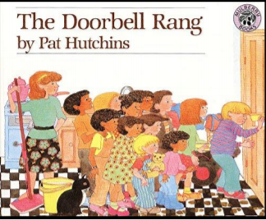
https://www.youtube.com/watch?v=HZpXuc735pg

Key mathematical vocabulary: divide, share, remainder

Day 1 – Reading the Story - Activity 1
Read the story to the children stopping at key points to ask them questions, including:
If Victoria and Sam share the cookies between them, how many cookies will each person get? If one more person comes, how many will there be now? How do you think they will share all the cookies?

Day 2 - Activity 2
Resources required – cookie cut outs, paper plates, recording sheet

Investigate how many cookies each person would get if there were two people at the table, three people at the table, four people at the table, etc.
Encourage the children to come up with the solution by dividing the cookie cut outs out onto the paper plates. Children can record their results on the Record Sheet. We have included two formats to allow differentiation for children who are able to record. (see Figures 1 and 2)

Maths Through Stories

Day 3 - Activity 3
Division tower
Resources – card 10-50, dice, bricks/cubes
Shuffle cards, put face down – reveal a card e.g. 25. If you roll dice and get 4 you have 25 divided by 4. Find the answer by building towers of 4 bricks/cubes to see how many groups make 25. Record answer i.e. 25 ÷ 4 = 6 r1. Take turns with partner.

Day 4 – Activity 4
Money Game
Resources – A bag of 2p, 5p, 10p coins a mug
Practice counting e.g. in 5s - 5, 10, 15…
Player 1 – grab some of the 5p coins – count them –e.g. 45p – put in mug
‘I have 45p. Counting in 5s - how many 5p coins do I have?’
Player 2 –works out and replies 5 x 9 = 45 and 45 ÷ 5 = 9 (this can also be notated)
To play game with remainders - add a 2p – ‘I have 47p - counting in 5s, how many 5p coins do I have? How much money is left over? Children will eventually realise that 4p is the biggest remainder when counting in 5ps.
Figure 1 Figure 2
