Maths Through Stories
Title – A Fair Bear Share
Author: Stuart J. Murphy
Mathematical Story Series - Mathstart
Mathematical focus – Addition and subtraction
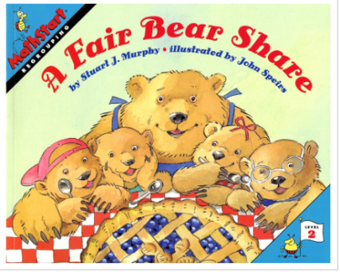
https://www.youtube.com/watch?v=jfLU01EVdAs

Day 1 – Reading the Story - Activity 1
As you read the story, ask the child/children – ‘How many tens can you make from 14? How many are left over? Or how many groups of ten can be made from 49? How many are left over?

Day 2 - Activity 2
Get the child to retell the story. Use ticks ✔ to record the nuts, berries and seeds that the cubs collected. Ask the child to circle the groups of ten. Again question how many groups of ten? Let’s count that out 10, 20, 30… How many left over?

Maths Through Stories

Day 3 - Activity 3
Let’s look at real situations e.g. leaves, acorns, stones etc. Sort items into their correct groups. How many tens and ones left over for each group? Then add all the groups together – How many groups of ten? Let’s count them 10 ,20, 30….. How many left over?

Day 4 - Activity 4
Now time to check out your kitchen cabinets. Choose 3 types of items e.g. boxes, cans, bottles.
Again use a tick ✔ to count and keep track of items. Circle the tens. How many items are there altogether?

Boxes | Bottles | Cans
✔✔✔✔✔ ✔✔✔  ✔✔✔✔✔ | ✔✔✔✔✔ ✔✔✔  ✔✔✔✔✔ ✔✔✔ | ✔✔✔✔✔ ✔✔  ✔✔✔✔✔

Alternatively check out the bedroom – e.g. books, toys and games – or choose your own categories!

Extension Activity
When out for a walk, keep a track of how many trees, dogs, cyclists etc. that you see. Make sure to take a paper and pen to record. Circle the tens and then add up the ten and ones.

