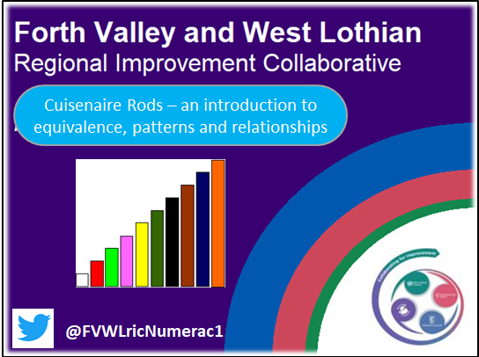
Cuisenaire Lessons – guidance
Please watch the video to develop your understanding of working with the rods as colours, to develop equivalence, discuss patterns and relationships.
We have provided lessons to support this tutorial through Twitter, Our Blog and You Tube Channel.
Cuisenaire Rods are a hands on manipulative but they can be accessed digitally and free on Mathbot.com.
An important element of each Cuisenaire lesson will be the questioning and discussion around the learners’ responses. How can this been done successfully when working remotely?
- Firstly, provide the Cuisenaire lesson for the learner through Microsoft Teams or Google Classroom for example.
- Ask the leaners to respond digitally to challenge using Mathsbot.com. ‘What do you notice’?
- On receiving their replies you can then add a comment and ask e.g. What do you wonder? Do you see a pattern? What mathematical words/phrases did you use?
- Then pass it back again.
- This provide a stimulus for rich discussion back and forwards particularly when everyone’s thoughts and ideas are shared between all learners.

Please following the FVWL ric Numeracy Academy, and share your learners’ journey using the handle @FVWLricNumerac1

