** **

FVWL RIC Numeracy Academy –

Home Learning Support

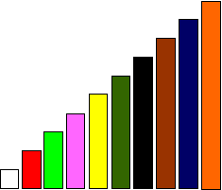

**Cuisenaire Lesson – equivalence**



Can you make some more trains equivalent to the orange rod using 2 different coloured rods?



Can you make some more trains equivalent to the orange rod using 3 different coloured rods?

**Extension**

Could you make a train of 4 rods equal to the orange rod?