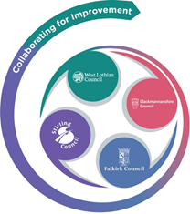 

FVWL RIC Numeracy Academy –

Home Learning Support

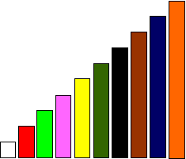

**Cuisenaire Lesson – Trains/patterns**

Make up your own trains and ask a friend to guess the rod or rods, which when put end to end, are equivalent to them

**Which are the rod/rods whose pattern includes one of these trains?**

White, red, pink C:\Users\Rendle.mary\Desktop\white red pink.png

White, white, yellow C:\Users\Rendle.mary\Desktop\white white yellow.png

Pink, light green C:\Users\Rendle.mary\Desktop\pink l green.png

Experiment with different sizes of trains.