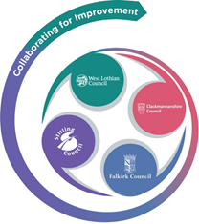 

FVWL RIC Numeracy Academy –

Home Learning Support



**Cuisenaire Lesson – Trains - complete patterns**

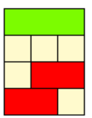This is a **complete pattern** for the red rod and the light green rod.

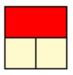



Can you make a complete pattern for the pink rod?



Now try with the yellow rod?

**What do you notice?**

**What do you wonder?**