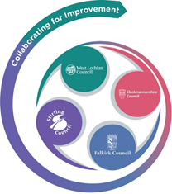 

FVWL RIC Numeracy Academy –

Home Learning Support



**Cuisenaire – ‘Build what I have’**

Choose 6 to 10 rods, each a different colour or a combination of colours (1 yellow, 1 pink, 1 red and 3 white). One learner arranges rods in a particular way, keeping them hidden (or keeping digital screen private) and then gives verbal instructions so that the other learner/s reproduce the arrangement.

**Example**

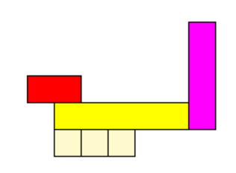

Place a yellow rod horizontally. Now put the pink rod to the right of it, in the opposite direction so that the rods are perpendicular. Make them touch so that it looks like the letter L on its side ….

After all the directions have been given, remove barriers (share digital screen) and compare structures. Were there any differences? Which mathematical words were helpful/confusing?