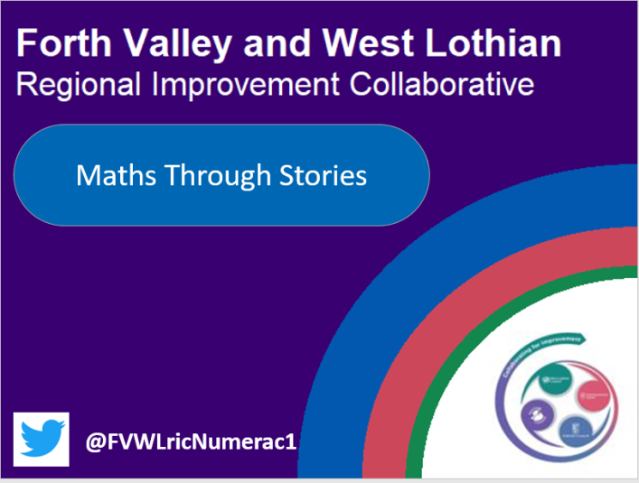

We are excited to be launching Maths Through Stories periodically throughout this term. Maths Through Stories is an engaging and creative way to teach and learn mathematical concepts.
We will be sharing Picture Books with lesson ideas initially at First Level with Early Level and Second Level to follow. Maths through Stories which is research based, is a fantastic way to show how mathematical concepts in story books can be used to develop numeracy skills.
In addition Maths Through Stories can be:-
1. Used to generate mathematical problems and context for mathematical problem solving
2. Used for introducing new mathematical topics and skills
3. Used to generate discussions about mathematics
4. Used in collaboration with role play and games
5. Used in collaboration with hands-on investigative activities
6. Used for formative assessment
7. Used for reviewing / recapping mathematical topics and skills
8. Used to consolidate knowledge at the end of the lesson
9. Used in collaboration with manipulatives
10. Used to integrate mathematics indoor and outdoor learning

We will provide a video link for each book and a digital set of lesson activities which can be completed over a week. If you do have any of the books that we will be sharing you may want to read via a video link with your learners. Please refer to this week’s Dinosaur Deals’ and a recommendation of how the lessons may be carried out throughout the week.

