|  |  |  |
| --- | --- | --- |
| **Appendix 2**  **Forth Valley & West Lothian**  **regional improvement collaborative**  **LITERACY Programme**  **2020**  cid:image001.png@01D59EC6.2AE8C9F0   |  | | --- | | We are delighted to present the very first Forth Valley and West Lothian RIC Literacy Programme for 2020. Outlined in this programme is the range of research-based professional learning opportunities which will be made available across the Regional Improvement Collaborative to build staff capacity and ensure that all our learners have access to meaningful learning experiences which enable them to progress their Literacy skills. The RIC Literacy Academy is situated in Abercromby Primary School on the new Tullibody South Campus and will be fully operational from January 2020. This recently opened state of the art campus is home to Abercromby Primary School, St Bernadette’s RC Primary School, Tulach Nursery and a new library. | | C:\Users\duncan.lindsey\AppData\Local\Microsoft\Windows\INetCache\Content.Outlook\94SH2DN2\IMG_7227.JPG  **Aims**   * Develop a positive attitude to Literacy and English across the Regional Improvement Collaborative, fostering high aspirations and an ethos of achievement. * Build staff capacity to develop appropriate skills, knowledge and understanding of reading comprehension across all sectors and subjects. * Ensure all our learners have access to meaningful learning experiences which enable them to progress their skills in Literacy and English .   An important part of our vision is to provide a range of pedagogical approaches to professional learning that will support improvements in teaching and learning: core elements in the process of building better outcomes for learners across FVWL. | |

**Lesson Study Model**

The FVWL Literacy Academy Team will advocate and implement the **Lesson Study Model** in several the programmes offered. This powerful, professional learning approach is known to dramatically improve learning and teaching and the practice and subject knowledge of teachers. It will follow the general model outlined here.

|  |  |
| --- | --- |
| **Word Aware**  Word Aware is a structured, whole school approach to enhance the vocabulary development of all children. This approach was selected following RIC workstream  engagement visits  in 2018 to schools using the approach successfully. The training will offer practical ideas to develop both spoken and written vocabulary.  "Vocabulary level at age five has been found to be the single best predictor of whether a child brought up in poverty will escape poverty in adult life. Without a good vocabulary, children struggle to understand what they are taught, to express how they feel, to manage social situations and resolve conflicts" (Jean Gross, CBE).  **Programme Overview** | **Aims**   * Explore word learning theory. * Learn a structured approach to teaching vocabulary in all subject areas. * Plan how to support vocabulary development in your school. * Ensure improved attainment in reading and writing over time.   **Who will be involved?**  **Early Level practitioners identified by their Local Authorities** |

|  |  |  |  |
| --- | --- | --- | --- |
| **Reciprocal Reading**  Reading comprehension strategies, which focus on the learners’ understanding of written text, are rated as high impact on the EEF Toolkit. Reciprocal reading is a structured approach to teaching strategies (questioning, clarifying, summarising and predicting) that students can use to improve their reading comprehension. The strategy is based on robust research examining what effective teaching and learning in literacy looks like. There is evidence of promise from evaluations which showed an average impact equivalent to around +4 months’ additional progress. Through collaborative enquiry, participants will engage with a programme of planning, teaching and dialogue sessions based on the Lesson Study Model. Practitioners will develop a deeper understanding of pedagogical approaches that engage learners and lead to improved outcomes. | | | Aims   * Development of a deep understanding of the pedagogical approaches that engage learners and lead to desirable outcomes. * Sharing and application of the strategy across the school. * Improved attainment in reading over time. * Establishment of practitioner network |
|  | | |  |
| Programme Overview | | | To support the practitioners who will be engaging in the programme high quality professional learning will be provided.  Led by our RIC Literacy Academy Team, this comprehensive and collaborative training ensures practitioners are equipped with the knowledge, understanding and skills to develop highly effective pedagogies in their classroom and across their schools. |
| Who will be involved?  In year one, 16 /32 schools across the FVWL Regional Improvement Collaborative will participate in the Reciprocal Reading Programme. Each Authority will identify practitioners teaching at Second/Third Level to take part. |  | *Extract from SIFs (HMI)*  *Focus on challenge and the development of advanced literacy skills to develop ability to be more analytical and evaluative when engaging with texts* | |

**Scotland Reads**

This paired reading initiative was based on sound academic research, with the expertise of Professor Keith Topping from Dundee University being utilised to evaluate the pilot and provide volunteer training materials.

Teachers observed that pupil motivation, in terms of being more inclined to choose books and read independently, has been heightened, alongside self-esteem and belief in abilities to read with understanding and for pleasure.

Parents were most appreciative of the one-to-one input that their children received during the paired reading sessions. Working closely with pupils had been a worthwhile and inspiring experience for the volunteers, who had found the schools to be welcoming places.

Scotland Reads Paired Reading Partners model gives authorities the opportunity to provide Classroom assistants, pupils and parents with comprehensive training in paired reading. Pupils reap the benefit in terms of increased engagement and self-esteem.

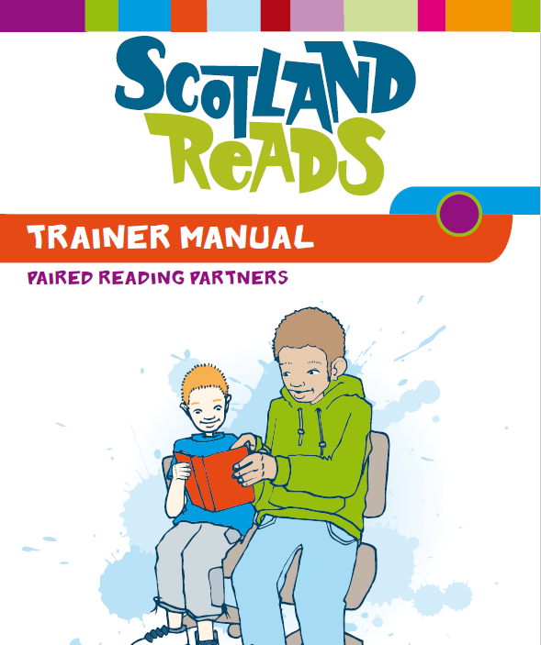

**Who will be involved?**

In year one, support staff and parents in up to 16 schools across the FVWL Regional Improvement Collaborative will have the opportunity to participate in programme. Each local authority will identify a Learning Assistant/Pupil Support Worker/parent/carer to take part.

|  |  |
| --- | --- |
| **Programme Structure**  “We know that in Scotland, reading for enjoyment has a significant impact on children’s and young people’s performance in reading. Children who choose to read for enjoyment and regularly engage with texts make better progress in reading.  The link between reading for enjoyment and deprivation levels is stronger in Scotland than almost every other country. It is, therefore, vital that children and families are encouraged to engage regularly with books and texts from the earliest age. This was highlighted in the National Literacy Action Plan which identified the need to develop a strong reading culture in Scotland”. (3-18 impact review) | This training is intended for parent groups, classroom assistants and school partner groups. It focuses specifically on building reading confidence and text comprehension. Attendees are introduced to techniques for developing reading confidence and meeting the needs of individual learners and through a rigorous and proven intervention.  Having completed the training, attendees will be able to carry out the Scotland Reads Intervention Programme.  The RIC will support attendees as they carry out live training in their setting. |

|  |  |  |
| --- | --- | --- |
| **Disciplinary Literacy**  Disciplinary Literacy will be led initially by Professor Sue Ellis of Strathclyde University and her colleague, Clare McAllister. This pedagogical approach is subject-specific and is designed to raise attainment and promote social justice. It is an approach that will support raising attainment and closing the gap via enriched literacy practices across the curriculum.    The literacy demands of the National 5 examinations and curricula mean that secondary schools must think carefully about ensuring that all pupils are taught how to read and write in subject-specific ways. A clear and early introduction is especially important for pupils from middling and low-literacy backgrounds if they are not to be disadvantaged by subject-specific literacy expectations.  Participants will develop knowledge of the common text-types and syntax pupils must learn to recognise and use. They will also explore the research on what works in vocabulary and comprehension teaching for subject disciplines, the research evidence on inclusive teaching techniques, ways to use text structure as a rubric to help pupils recall subject content knowledge and to help them read, write and think in subject-appropriate ways. | | [*Improving Literacy in Secondary Schools*](http://educationendowmentfoundation.org.uk/tools/guidance-reports/improving-literacy-in-secondary-schools/)argues for a change in tack. It emphasises that literacy in secondary school should not simply be seen as a basket of general skills. Instead, it must be grounded in the specifics of each subject  In particular, the report emphasises the importance of ‘disciplinary literacy’, an approach to improving literacy across the curriculum. It recognises that literacy skills are both general and subject specific, underlining the value of supporting teachers in every subject to teach students how to read, write and communicate effectively in their subjects.  **(Education Endowment Foundation, July 2019)** |
| **Programme Structure**  Secondary practitioners in subjects other than English receive a half day training session. Participants will be supported throughout by the literacy academy. An online support network will also be created and developed.  **Who will be involved?**  In year one, up to 16 schools across the FVWL Regional Improvement Collaborative will have the opportunity to participate in the Disciplinary Literacy programme. Each local authority will identify participating practitioners. |  | |

|  |  |
| --- | --- |
| **Reading Recovery** | *“Teachers in Reading Recovery are trained to make effective decisions on the evidence of a child’s responses during the individual teaching sessions. They decide where to direct the child’s attention next to further his particular cluster of abilities. They initiate and design the lessons and there is no package of teaching materials.”*  Clay, M. (2009) |
| Our aim is to close the gap and raise attainment in Literacy. Data shows uneven achievement in Reading and a need for increased achievement in writing: focusing on reading and vocabulary supports improvement in achievement.  Tools for Reading is the third element of Building A Reading Culture (one is building the will/reading for pleasure; two is the evaluation and accreditation of reading environment).    Closing the gap requires focus on reading and writing skills. RR addresses the gap in both at age 5-6, providing one to one support provided by an experienced teacher who applies the research-based interventions tailored to individual learners shared via training at the RR centre. RR teachers become expert in diagnostic assessment of literacy and in supporting parents/carers as they develop understanding of their child’s literacy development. | |

|  |  |  |  |
| --- | --- | --- | --- |
| **Programme Structure** | | | |
| **Who will be involved?**  In year one, up to 4 schools across the FVWL Regional Improvement Collaborative will have the opportunity to participate in the Reading Recovery programme. This training programme will enable teachers to become specialists in children's early literacy development and equip them to support colleagues within the school community. |  | Two independent research reports commissioned by the KPMG Foundation into the long-term benefits of Reading Recovery, reveal that the intervention helps close the GCSE attainment gap between these children and their peers. The research shows that Reading Recovery has the potential to deliver up to £1.2 billion to the economy in the form of increased lifetime earnings and reduced costs for special educational needs and disabilities (SEND) services.  (Hurry, J. and Fridkin, L., 2018)  Reading Recovery participants are more than twice as likely as similar children to achieve five or more good GCSEs 10 years later.  ([TES,](https://www.tes.com/news/reading-scheme-age-5-helps-gcse-success) December 2018.) |

**Toe by Toe**

|  |  |  |  |
| --- | --- | --- | --- |
| Toe by Toe is a highly systematic page-by-page and step-by-step series of activities in one book, delivered one-to-one, with instructions for the ‘coach’ provided for each activity. It deliberately takes learners right back to the beginning of phonics and works up from there, based on the observation that many learners with difficulties seem never to have got the hang of phonics. Unusually, many of the stimuli are non-words, in order to focus learners’ attention solely on decoding and avoid guessing based on any other ‘cue’. It is suitable for any child (or adult) with reading difficulties, especially those who have been diagnosed as having specific learning difficulties. Parents, special needs teachers, and support, teaching and classroom assistants can all use the scheme effectively. It is intended that learner and coach should work through the entire scheme, however long that takes, and then graduate to simple reading books. | | | |
|  |  |  | |
| **Evaluation**  Within the West Dunbartonshire Literacy Initiative, which ran for 10 years from about 1995, Toe by Toe was used as the catch-up scheme, yielding a fairly large amount of quantitative data on the scheme’s effectiveness in Scottish Primary 5-7 (equivalent to England and Wales Y5-7, hence partly KS2 and partly KS3 but treated here as primary). The results suggest that, when delivered meticulously, this programme can achieve useful gains.  References  MacKay (2006, 2007)  The RIC Literacy Academy team will travel to train Authority - identified PSWs/LAs/parents to deliver the programme through one full-day workshop. They will train staff and will provide guidance on how the intervention should fit within the school day. The RIC Literacy Academy team will provide support to schools as well as performing fidelity checks throughout the course of the intervention. |  | ***Overview***  *The sessions are led by teachers and administered by trained PSWs/LAs. Both teacher and PSWs/LAs are provided training in how to deliver the sessions.*  *A small test of change intervention using the* ***Toe by Toe*** *materials will take place over 6 weeks with 4 groups across the RIC using improvement methodology to measure learner engagement, practitioner confidence in delivering the sessions and on learner attainment.*    Who will be involved?  Parents and Classroom assistants identified by Local Authorities. | |

**Work Stream Opportunities**

The RIC Literacy Academy team aims to seek expertise from a range of professionals across Forth Valley and West Lothian – and beyond. There will be opportunities for school and university practitioners to share good practice to raise attainment and close the poverty related attainment gap with a focus on reading comprehension skills.

Future plans include a professional reading group (Literacy) and good practice sharing sessions designed to share effective practice in the teaching of BGE close reading.

Updates will be provided on Twitter: **@FVWLricLit**