Feedback
What is one word you use to describe NAME?


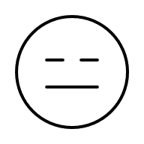

Please choose a smiley face to describe how you feel with your time with NAME or draw your own?

Do you understand why NAME is here?

Yes No Maybe Not sure

On a scale of 1- 10 how helpful has NAME been?

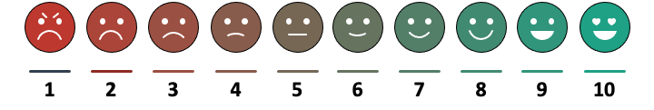

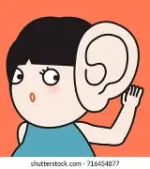
Does NAME listen to you?

Can you draw NAME



