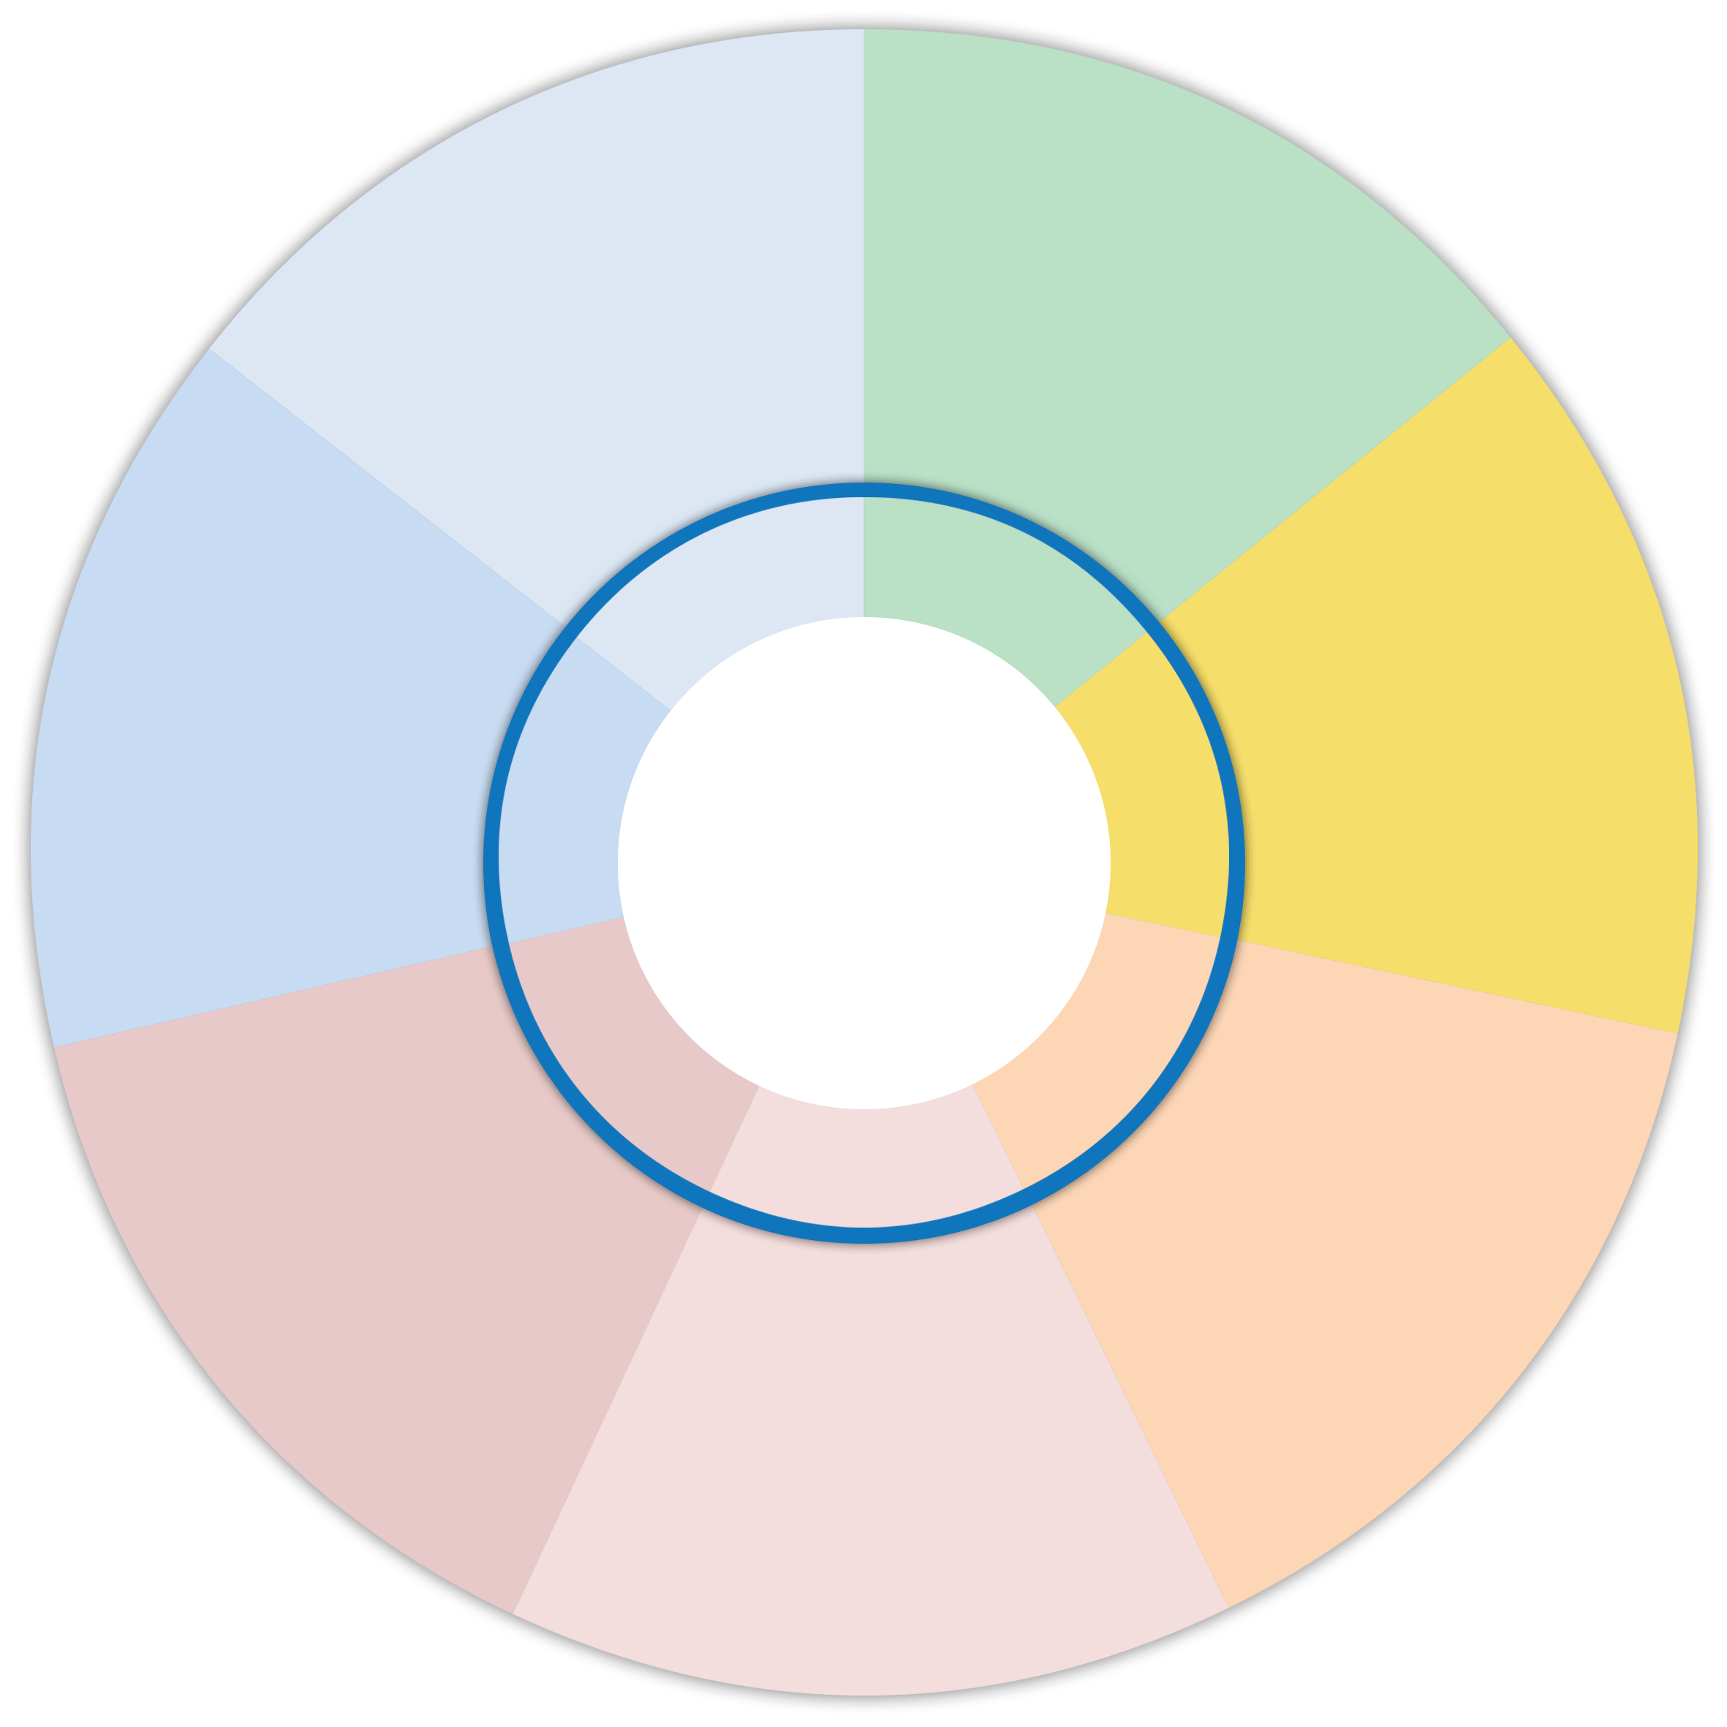

What is the scrapbook or magazine? They were designed by Our Hearings Our Voice and are resources that will help support children and young people to prepare for their hearing. A speech and language therapist supported the work and all the material is ASN friendly.

www.ohov.co.uk

Project aims: to increase the meaningful participation of children and young people in their hearings, offering them choice about the date and time of their hearing, how they attend and sending them a tool to help them prepare for the hearing.
What are we asking of partners? To promote and gather children and young people’s views prior to a hearing, support them to attend a pre-hearing visit and use the scrapbook or magazine to support preparation.

Next steps: We are about to launch this project and sharing our plans with our partners will ensure that we can work across the partnership to ensure success of this project. Phase 1 pilots were completed with positive evaluations.

How will we do this? Ask children via a trusted professional when and how they would prefer their hearing to take place; pro-actively invite them to pre-hearing visits; and send out a scrapbook (for ages 5-11) or magazine (ages 12-18) to help them prepare.
Which children are involved? The views of children aged 8 and older, attending grounds or annual review hearings should be sought and will be pro-actively invited to a pre hearing visit.

Why? We want to make hearing times more flexible to fit around children’s lives whilst supporting them to feel prepared, listened to and more in control during hearings.

Child Friendly Scheduling – 7 Minute Briefing
4
3
5
6
7
12
2

