Pre-Employment Checklist & Induction Template
Arrange | Notes | Complete
Falkirk Council ID Badge | Email access.control@falkirk.gov.uk with:  - Employee Name  - Employee Number (NI Number)  - Work Location  - Service  - Suitable passport style photograph  - Start Date  Collect from Foundry or posted via internal mail. Badges will be actioned within 10 working days.
Laptop & Mobile | Use existing equipment where possible - Request via Service Desk
IT Systems | System Access Request, Liquid Logic, Teams Channels & Mailboxes - Request via Service Desk
Olle | Email technicallearning@falkirk.gov.uk to generate an account. They’ll need an email address and start date.  Olle - Login (tessello.co.uk)
CPD Manager | Email socialservices.training@falkirk.gov.uk with:  - Employee No:  - Name:  - Job Title:  - E-mail:  - Dept:  - Based:  - Line Manager:  Falkirk Social Work Services CPD (cpdservice.net)
Pool Cars | New system for accessing pool cars - Intranet (falkirk.gov.uk)
Individual Learning Plan | NQSWs should share this to their Supervisor prior to beginning their post. If they do not have one they should discuss with their University and produce one as soon as possible.

Induction
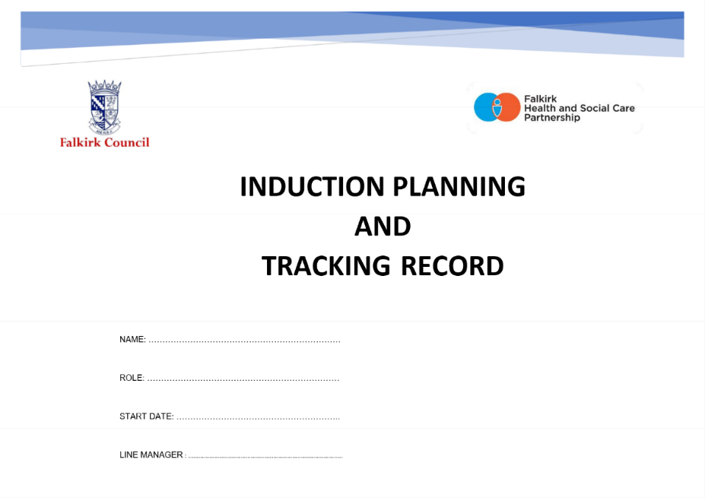
Falkirk Council’s Induction Process can be found on the Practitioner’s Pages under the Recruitment, Induction and Retention tab. The Induction Planning and Tracking Record should be used as a baseline for new workers to ensure they can access key policy and timescales related to their placements with Falkirk Council. There are key timescales related to their employment with Falkirk that need to be completed within a specific time.

NQSW Supported Year
All Newly Qualified Social Workers should familiarise themselves with the guidance for the NQSW Supported Year in Falkirk available on the Practitioner’s Pages.

Shadowing
All NQSWs should be encouraged to shadow across services (Children & Families, Justice and Adults) throughout their Supported Year. NQSWs should also complete a Shadowing Request and reflect on how this integrates with the learning needed from the Supported Year.

Please amend as needed!

Week 1
Date |  | Morning | Lunch | Afternoon | Notes
Monday |  | Arriving for 9am.  Show layout of offices, workspaces, breakout areas, fire safety arrangements, toilets and changing areas, identify personal spaces |  | Arrange worker safety arrangements with Admin, including personal contact information, access to sites, first aid, introduction to management team and colleagues.  Spend time with colleagues.
Tuesday |  | Setting up on laptop and encourage to begin familiarising themselves with the workplace and systems.  Completing Induction Planning and Training Record from Practitioners Pages. |  | Shadowing / Policies / Olle Learning / Visiting services.  Spend time reviewing Supported Year guidance to know what is expected.
Wednesday |  | Shadowing / Policies / Olle Learning / Visiting services  Access CPD Manager and explore core learning and training. |  | Shadowing / Policies / Olle Learning / Visiting services
Thursday |  | Shadowing / Policies / Olle Learning / Visiting services |  | Shadowing / Policies / Olle Learning / Visiting services
Friday |  | Shadowing / Policies / Olle Learning / Visiting services |  | Shadowing / Policies / Olle Learning / Visiting services

Week 2
Date |  | Morning | Lunch | Afternoon | Notes
Monday |  | Shadowing / Policies / Olle Learning / Visiting services  Review Supported Year documentation and begin to plan out how NQSW will approach their Supported Year. |  | Shadowing / Policies / Olle Learning / Visiting services  Populate NQSW & Supervisor diaries with protected learning time, supervision and development discussion meetings.
Tuesday |  | Shadowing / Policies / Olle Learning / Visiting services |  | Shadowing / Policies / Olle Learning / Visiting services
Wednesday |  | Shadowing / Policies / Olle Learning / Visiting services |  | Shadowing / Policies / Olle Learning / Visiting services
Thursday |  | Shadowing / Policies / Olle Learning / Visiting services |  | Shadowing / Policies / Olle Learning / Visiting services
Friday |  | Shadowing / Policies / Olle Learning / Visiting services |  | Shadowing / Policies / Olle Learning / Visiting services

