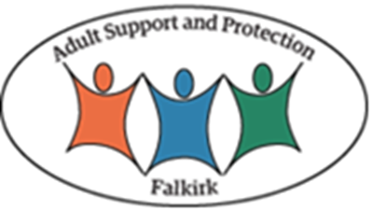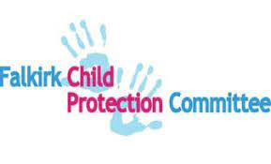

Request for Information

FALKIRK CHILD PROTECTION COMMITTEE /
FALKIRK ADULT PROTECTION COMMITTEE

OFFICIAL – SENSITIVE – PERSONAL

REQUEST FOR INFORMATION TO CONDUCT A LEARNING REVIEW

You have been identified to participate in a Learning Review and are asked to complete this request for information.

This report is required to be completed within 10 working days and sent electronically to (insert)

This report is required to contain information outlining your agency/service contact/ interaction with the adult/child and/or family whose details are below.

Please include a brief account of agency involvement prior to the event which triggered the notification and some very initial reflection regarding practice and decision-making within that agency. If you have historical information, please give a brief summary of the themes and issues you have identified in the background history section.
Learning Review identifier:
Date of the request for information:

Child/Adult’s Name and Identifier number:
Date of birth:
Date of death (if applicable):
Date of significant incident:
Gender:
*If more than one adult/child for whom the Learning Review is considered, repeat the second column. Please provide the following information (complete/delete as appropriate).

Details – Child
Names of child’s parents/carers and dates of birth:
Names of siblings and dates of birth:
Child’s home address:
Child’s current address, if different from above:

Education establishment details:

Details – Adult
Adult’s home address:

Adult’s current address, if different from above:

If more than one child for whom the Learning Review is considered, please amend or repeat the table above

Summary of involvement with the Adult/child(ren) and/or family:
Background history:
Relevant Chronology: please insert any additional rows

Date of Event | Brief Detail of Event | Agencies/People Involved | Outcome/Consequences for child/adult

Key practice issues:
Please provide information on:
- recognition and assessment of risk and need in relation to the Adult(s) /child(ren)/family
- information sharing in this case
- strategies and actions to minimise harm
- timely and effective action taken
- multi-agency responses
- evidence of planning and reviewing
- quality of record keeping
- appropriate use of legal measures
- evidence of child/person-centred practice
- any good practice identified
- any areas identified for practice improvement
Parallel processes
Are you aware of any current or planned reviews being undertaken for this case? If yes, please give details.
Are you aware of any criminal proceedings associated with this case?
If yes, please give details.

Report completed by:
Name:
Title:
Agency:
Email address:
Date:

