Draft
April 2024

Children’s Services
Childcare Allocation, Review & Evaluation Group (CARE Group)
Early Identification and Intervention Support
Children Under 3 Years Old

Important information:
- Consideration will be given to whether Education could add further and specific support to the child’s existing plan.
Possible outcomes are:
- Signposting to local community support and local groups.
- Third Sector support.
- Support at home from Education; Early intervention team/ASN Service.
- Coordination of support from multi agencies.
- Enhanced transition planning.
- Allocation of early learning and childcare discretionary sessions – up to 2 sessions per week.
- Before submitting, please refer to appendices below particularly Appendix 1 – ELC Eligibility pathway for 2-year-olds.
- Please complete the form and submit by email to ELCCare@falkirk.gov.uk.
- All information must be submitted no later than 15th of each month.

FOR ELC INTERVENTION TEAM USE ONLY
Date form received: | Date of panel:

Section 1: Consent

Referrers details and confirmation
The Parent/Carer agrees to the gathering and sharing of information contained in this form with the CARE Group,
Falkirk Council Education Services and partner agencies so they can help to provide the right services for their child and family.
Referrer Name |  |  | Date
Job title and Service
Contact Telephone Number
Email address

Consent from Parent/Carer
I agree to the gathering and sharing of information contained in this form with the CARE Group, Falkirk Council Education Services, and partner agencies so they can help to provide the right services for my child and family. I agree that any personal information provided on this form will be treated in accordance with the Data Protection Act 2018.
Parent/Carer Name(s) |  |  | Date
Contact Telephone Number
Email address
Child’s Details:

Forename(s) |  |  | Known As
Surname
Date of Birth |  |  | Gender M F  (to select, double click on check box)
Home Address (This must be where the child is ordinarily resident)
Address
Postcode

Section 2: Child meets criteria for early identification and support:
(See appendix 2 for further information)
CRITERIA
Please consider the criteria below. To select check boxes, please double click on box.

Applications are considered only for children whose needs are “enhanced” or “intensive” as defined by the Staged Intervention Framework in respect of stage 3 and 4, “enhanced” and “intensive”.

Complex Medical conditions – child may have serious health conditions or health diagnosis.

Significant development delays – child may exhibit significant delays in cognitive, communication, motor or social development.
Multiple areas of need – the child requires a comprehensive and multidisciplinary approach due to behavioural, social, emotional difficulties.
Lack of progress with previous interventions – despite earlier interventions at lower stages, the child has shown limited progress, indicating the need for further support and interventions.

RELEVANT INFORMATION AND DETAILS IN REFERENCE TO CRITERIA ABOVE
Please give further details of child’s needs and diagnosis if this is known.

EXISTING SUPPORT
Please outline the specific support and interventions which are working well for the child and family.

Please remember to include any relevant attachments if available e.g., initial agency assessments (include information from ASQ if this has been completed), Childs plan.

Please save this form and send to elccare@falkirk.gov.uk.

WE ARE UNABLE TO ACCEPT PAPER COPIES OF THE REQUEST FORM AT PRESENT

FOR ANY FURTHER INFORMATION OR ENQUIRIES PLEASE CONTACT

ELC EARLY INTERVENTION
ELCCare@falkirk.gov.uk
Appendix 1
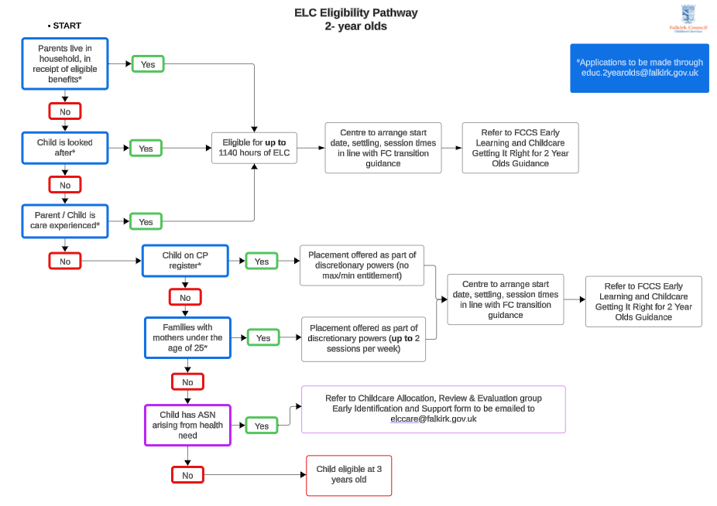

Appendix 2 – Child meets criteria for early identification and support
Please consider criteria and why the child’s needs are of an exceptional nature (defined as Stage 3 or 4/HV equivalent of Intervention)

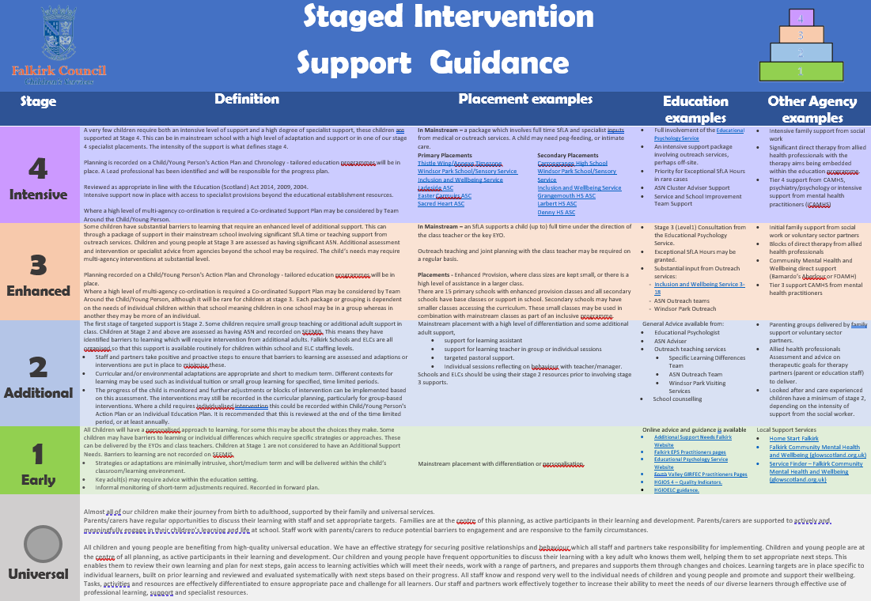

Relevant information/Details:
Information that may be contained in this section, for example, would be:
- Birth history
- Child’s developmental assessment, e.g., scoring from ASQ, language and communication skills, social and emotional wellbeing, motor skills, independence, cognitive development?
- Long term health needs/diagnosis
- Current medical needs

Please outline the existing support this child and family are receiving and the outcomes. What is working well?
You may wish to include:
- The early intervention support that has been provided – previous or ongoing.
- Multi-agency referrals made, stage of process e.g. on neurodevelopmental assessment pathway from …. expected waiting time for assessment, levels of involvement, Impacts being made, what is working well? – i.e., Pediatrics, Speech and Language, Health Services, Children with Disabilities Team
- professionals involved with the child and levels of involvement.
- the impact that the support is having on the child and family.

