FORTH VALLEY
CHILDREN AND YOUNG PERSON’S
WELLBEING ASSESSMENT

PLEASE NOTE:
- There is an expectation that Named Persons (and Lead Professionals where applicable) will be able to contribute fully to the information requested below.
- There is a requirement when submitting this form to ensure that the family, child and young person are aware of the information that has been shared and with whom.
- Additional Guidance : getting-right-child-statutory-guidance-assessment-wellbeing-2022-part-18-section-96-children-young-people-scotland-act-2014.pdf
- Please share details of supports currently in place and what you think social work could add.

CORE DETAILS of the child/young person (of whom you have made an assessment)
- Child/Young Person’s Details
Name
Date of Birth
Age
CHI Number
Address
Family’s Contact Telephone Number
Nursery/School (if relevant)

Is this Child/Young Person
known to Services?
If YES, do you know which Services?
When was the child last seen, and by who?

- Members of Household (if known)
Please complete date of birth for all members of the household if known
Name | Relationship to Child/ Young Person | Date of Birth/Age/CHI number (if known)

3. Additional Family Members who could help with any plan to improve the child’s wellbeing (if known)
Name | Relationship to Child / Young Person | Address/Phone Number

4. Reason for Completing this assessment.
Click ‘Please Select’ for options list Please Select...
Provide details why you are completing this form:

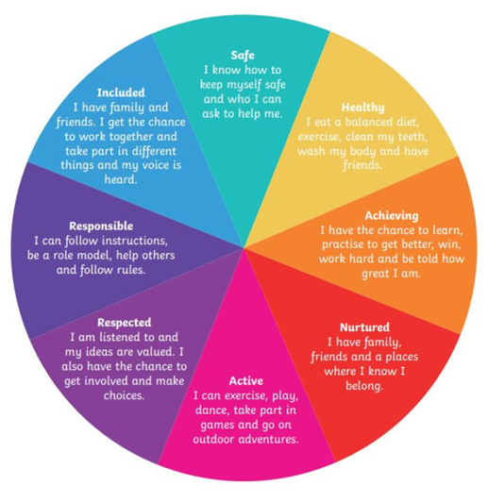
5. Description of Child/Young Person’s Wellbeing

Let’s talk about SHANARRI.

We use SHANARRI to:

- Check how the child/young person is doing
- See what’s going well
- Find out what help is needed

This helps make a plan that’s right for the child/young person and their family/carer.

Is there anything getting in the way of this child/young person’s wellbeing?
Include evidence of strengths and concerns within each relevant domain.
We don’t need to fill in all the sections, only the ones that are most important just now.

Safe
Healthy
Achieving
Nurtured
Active
Respected
Responsible
Included

6. Risk Factors, Protective Factors and Analysis (use Resilience Matrix and Toolkit)
Resilience matrix - GIRFEC wellbeing resources (SHANARRI) - gov.scot

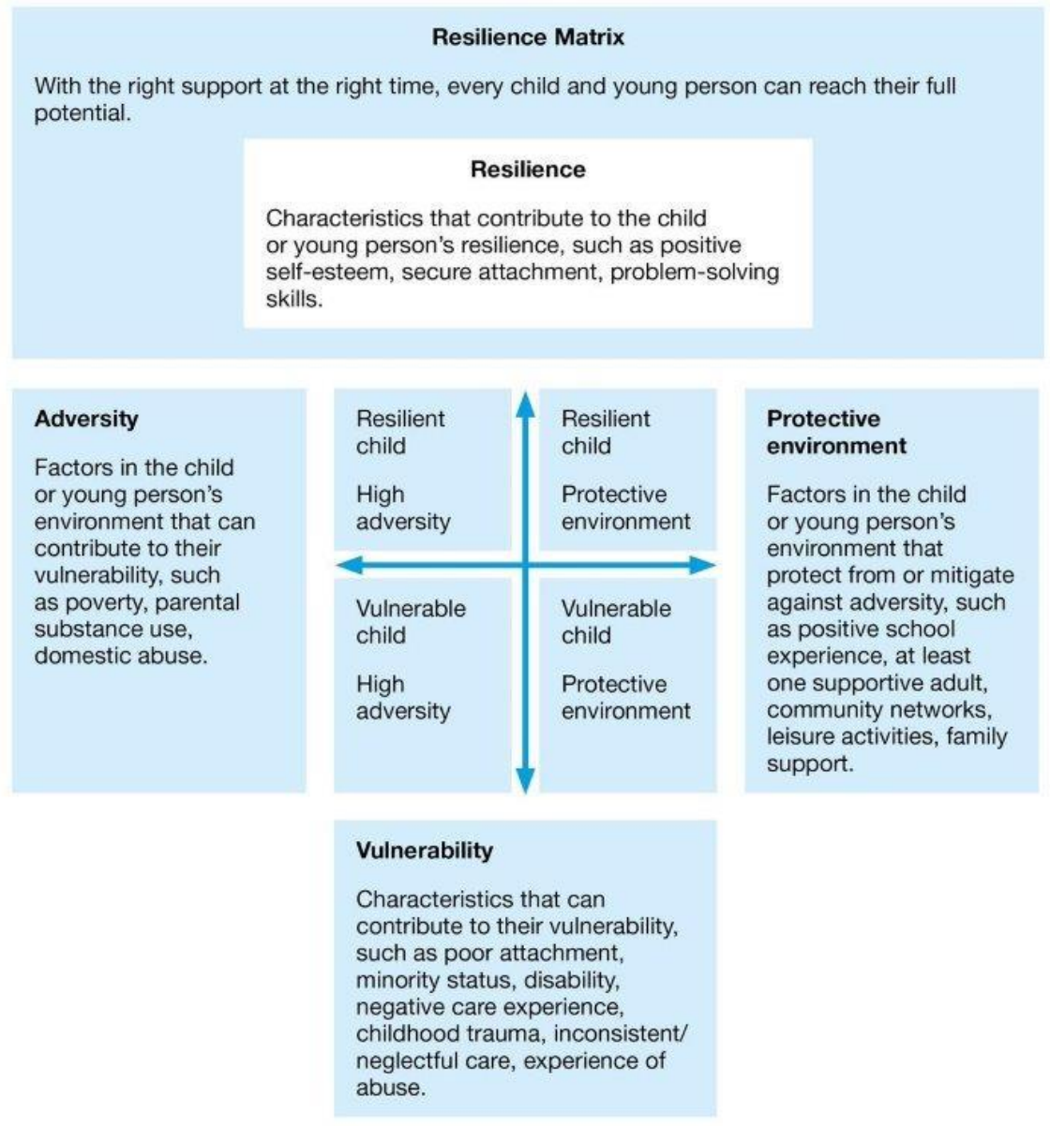

What are the strengths?
What is working well for the child/young person, family or carer?
What would we like to change to make things better?

7. The following discussions/actions have taken place to date
What has your agency already done to help the child/young person?
What additional help may be needed from others?

8. Is the child/young person aware of this assessment being made? | Yes | ☐ | No | ☐
Please share child/young person’s views
If child/young person is not aware you are sharing this information, briefly explain why.

9. Are the parents/carers aware of this assessment being made? | Yes | ☐ | No | ☐
Please share parents/carers’ views
If parents/carers are not aware you are sharing this information, briefly explain why.

10. Desired outcomes identified with the family

11. Next Steps, Recommendations and any Actions Agreed and by Whom

12. Contributors to Assessment
Name | Designation | Contact Details

13. This form will be forwarded to:
Name | Designation | Organisation / Agency | Email & Telephone Number | Date

14. Name and contact details of person(s) completing the well-being assessment

Name | Designation | Organisation / Agency | Email & Telephone Number | Date

