

Team Around the Child (TAC) Meeting
Forth Valley Guidance

GIRFEC in Forth Valley
Getting it right for every child (GIRFEC) is the National approach in Scotland designed to improve outcomes and supporting the wellbeing of our children and young people by offering the right help, at the right time, from the right people. The Child’s Plan should be used by all practitioners in children’s and adult’s services to identify strengths and needs, and then what supports are required to improve outcomes for children and young people. Links to helpful resources and information about GIRFEC can be found via this link to the Forth Valley Practitioners Pages.
The national practice model (below) is at the heart of GIRFEC and our Forth Valley Child’s Plan’s. To help make sure everyone; children, young people, parents, carers and the services that support them, has a common understanding of what wellbeing means, we describe it in terms of these eight indicators.

Wellbeing Indicators

Safe: Protected from abuse, neglect or harm at home, at school and in the community.
Healthy: Having the highest attainable standards of physical and mental health; access to
suitable healthcare and support in learning to make healthy, safe choices.
Achieving: Being supported and guided in learning and in the development of skills, confidence and self-esteem, at home, in the school and in the community.
Nurtured: Having a nurturing place to live in a family setting, with additional help if needed, or where possible, a suitable care setting.
Active: Having opportunities to take part in activities such as play, recreation and sport, which contribute to healthy growth and development, at home, in school and in the community.
Responsible: Having opportunities and encouragement to play active and responsible roles at home, at school and in the community, and where necessary, having the appropriate guidance and supervision and being involved in decisions that affect them.
Respected: Having the opportunity, along with carers, to be heard and involved in decisions that affect them.
Included: Having help to overcome social, educational, physical and economic inequalities; and being accepted as part of the community in which they live and learn.

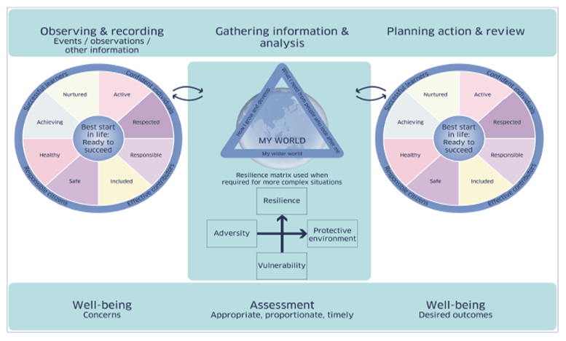

How to use the Wellbeing Indicators?
The wellbeing indicators make up the wellbeing wheel which is used in the National Practice Model above. This helps us to identify concerns and then, following assessment decide if a Team Around the Child (TAC) meeting would help to inform the planning, action and create/review a child’s plan, if required.

What is a TAC Meeting?
A TAC meeting brings everyone who is supporting a child together, involving the child/young person and parents/carers. This can include school staff, social workers, family support, health professionals, third sector and others.
The purpose of the meeting is to:
- Discuss how we can offer support for the child and to determine whether targeted intervention (therefore leading to a Child’s Plan) is needed to meet the identified needs of the child/young person. It is also important to acknowledge and build on strengths too.
  - Address the child’s needs, and sometimes also the family’s needs, if they impact the child’s wellbeing.
  - Place the child and their family are at the centre of the process, and their input is essential in developing and reviewing the plan.

There are some helpful visual guides at the end of this document that professionals can refer to as a reminder of the Team Around the Child (TAC) process and who is most appropriate to invite along to meetings at various stages. There are also leaflets that explain the process at the end of this document that can be shared with children, young people and their parents/carers.

Voice of the child, young person and their parent(s)/carer(s).
In line with the UNCRC, the child, young person and their parents/carers involvement is crucial. They should be an active part of the TAC process, as we know engagement of children, young people and their parents/carers has a direct impact on how we achieve positive outcomes. Where possible the child or young person should be encouraged and supported to attend all, or some of their TAC meeting, unless it is in their best interest not to. However, attending a TAC meeting can be a daunting experience and we should seek to support participation to the best of our abilities if attending in person is not an option. If they do not attend their views and wishes should still be sought and shared by someone (professional, family/carer, advocate etc). A parent/carer can also bring a support person or advocate to the meeting if that would help their participation.
The NSPCC have published some useful guidance to help us hear and facilitate the voice of the child and a podcast that discusses the voice of the child in practice.

Key considerations for how to best include the child:
  - Age and Maturity: Ensure the child/young person’s age and developmental stage are appropriate for participation and consider how best to support this.
  - Willingness: The child/young person should be able to attend if the want to and have the option to decline.
  - Support: Provide necessary support to help the child express their views meaningfully and effectively.
  - Confidentiality: Maintain appropriate confidentiality, sharing information with the child as proportionate and suitable to their age and development.

What is the role of the Named Person?
Every child and young person in Forth Valley will have a Named Person in Health or, if they are in school, in Education who will be responsible for making sure that child/young person has the right help in place to support his or her development and wellbeing.
Children, young people, parents and carers should have clear information about who is the child/young person’s Named Person and the Named Person should be accessible to the parent, child or young person and be seen as someone they can talk to about any worries or problems affecting the child or young person.
It is the responsibility of any other professional who becomes involved with the child/young person to notify the Named Person of their involvement.

What is the Lead Professional and what do they do?
When two or more agencies need to work together to provide help to a child or young person and family those involved will agree who is to act as Lead Professional to co-ordinate that help. Sometimes this will be the Named Person but not always. Guidance on the Named Person and Lead Professional can be found on the Forth Valley Practitioner’s Pages via this link Named Person & Lead Professional Guidance .

The Lead Professional is responsible for:
- Coordinating the team, managing the Child’s plan, and ensuring everyone is working together.
- Organising meetings, keeping track of the progress, and communicating the child’s plan to everyone involved, including the child and family/carer.
- Ensuring that all information about the child’s or young person’s needs is shared between the professionals, in line the information-sharing guidelines.

Lead Professional Assessment & Child's Plan template can be found on the Forth Valley Practitioner’s pages.

Who can ask for and arrange a TAC?
Whoever identifies a concern generally has the responsibility to arrange and chair the TAC, or liaise with the other relevant professionals to agree who is best placed to do this.
It is important to remember that if at any point an agency considers that referral to the Children’s Reporter may be required. This must be discussed at a TAC meeting and only when the team around the child are satisfied that all voluntary supports have been exhausted would referral to the Reporter be made. The referral will be made by one agency on behalf of the team around the child.

How the Process Works:
- Initial Meeting:
  - The first step in the process is to organise a meeting with all relevant professionals and the child, young person and their parents/carers. The named person, or trusted adult helps prepare the child, young person and parents/carers for this meeting, making sure they understand who will be there, the purpose of the meeting, and what to expect.
  - It’s important to set up the meeting so that the child, young person and family feel comfortable and informed. The child, young person and family should have input on the meeting’s time, place, and format. The meeting can be in person, online or a mix of both.
  - Everyone will introduce himself or herself. The Chair should state the reason for the meeting so that all members are clear, and everyone understands why they are there.
  - The child or young person and their parents/carers person should be supported to share their views. Everyone else should then provide an updated chronology (i.e. what has led to the meeting/happened since the last meeting).
- Creating the Plan:
  - During the meeting, the team discusses the child or young person’s strengths, needs, any issues the family is facing, and what actions can be taken to support the child or young person.
  - A clear child’s plan is created, outlining who will do what and by when. Everyone involved should agree on these actions and responsibilities.
  - A Lead Professional should be identified, if not already.
  - The plan should be based on an up-to-date assessment of the child or young person’s needs, and it may change as the child or young person’s situation evolves.
  - The child or young person’s well-being and development are always considered, and the professionals should focus on building a plan that supports the child or young person’s strengths.
- Regular Reviews:
  - After the Child’s Plan is agreed, the team will regularly review the child or young person’s progress to see if the plan is working.
  - The family should be part of these reviews, and the team should consider whether any changes to the plan are needed.
  - The team should also reflect on what’s going well and what might need improvement.
- Communication and Involvement:
  - The child or young person and their parents/carers should always be kept informed about the progress of the plan and any changes that happen along the way.
  - The Lead Professional ensures that communication is clear and that everyone involved is on the same page.
  - Parents/carers and the child or young person should be encouraged to express their views, concerns, and suggestions during the process.
- Working Together:
  - Professionals from different services (e.g., social services, schools, health services) work together to create a plan that meets the child’s needs in all areas.
  - This could include services for the child or young person and parents/carers, such as healthcare, education support, family support or mental health services.
  - When needed, professionals from adult services (e.g., for the parents or carers) may be involved to ensure a comprehensive approach.
- Dealing with Disagreements:
  - Sometimes, disagreements may arise between professionals or between the family and professionals. If this happens, the Lead Professional should help mediate and resolve the issue.
  - In most circumstances any difficulties can be resolved via the previous step. However, if difficulties persist support can be sought via Forth Valley Escalation Guide.
- Exit Planning:
  - If the situation improves and the child or young person no longer needs the level of support previously provided, the team will help the family transition out of the process.
  - This might include helping the family access other services or ensuring the child or young person has continued support if needed.
Key Principles for Success:
- Single Plan: The team works on one agreed-upon plan, focusing on meeting the child or young person’s needs.
- Family Entitlement: The Team Around the Child approach should be seen as a positive and valuable service for the family, not an imposition.
- Strength-Based: The plan should focus on the strengths of the child or young person and their family, helping them build on these strengths while addressing challenges.
- Inclusive: All professionals involved should contribute and value each other’s opinions. If there’s disagreement, it should be addressed constructively.
- Clear Communication: The language used should be simple and clear, so everyone understands the plan and their roles.
In summary, the Team Around the Child approach is designed to bring together a group of professionals who work collaboratively with a family to support the child or young person’s needs and builds on strengths. The family is at the centre of this process, ensuring that their voice is heard, and the professionals coordinate their efforts to achieve the best outcomes for the child or young person and family. Regular reviews and clear communication are key to the success of this approach.

Do we need to invite Social Work to a TAC?
Not always, a social worker should only be invited if there is an identified role. As detailed in the following intervention map, most children and young people can be supported by a single agency plan. If you are unsure, you can contact the relevant Social Work Intake Team to have a conversation, and they can confirm if social work input is required at that stage.

Consent
GIRFEC relies on professionals sharing information about children and young people to identify areas of need and how best to support and keep them safe. Organisations and people working with children and young people have access to sensitive, personal information and as a result are duty bound to handle, store, process and share this information in line with existing laws and guidance e.g data protection, UNCRC, GDPR, common law duties and professional codes of practice. In most circumstances, professionals supporting children, young people and families/carers will seek their consent before sharing information with another professional. Practitioners should be careful to only share information that is necessary and proportionate to the purpose they are seeking to achieve.
However, Data Protection rules DO NOT prevent the sharing of information necessary to protect the welfare of a child or young person. If in doubt refer to your agencies Child Protection Lead.
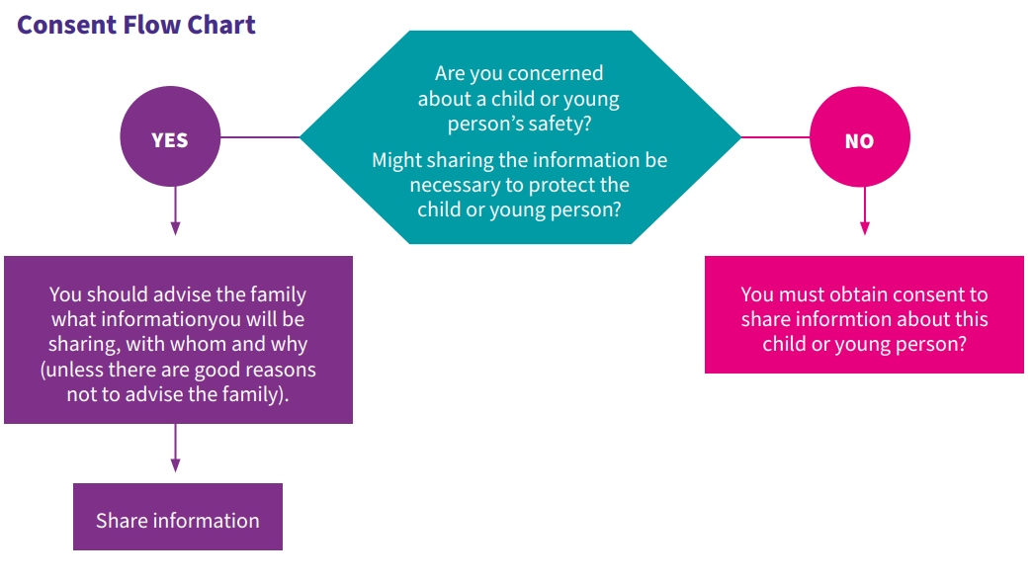
Further information about information sharing can be found on the Forth Valley Practitioner pages via these links GIRFEC Information Sharing Agreement, Information sharing guidance and Information Sharing Principles for GIRFEC.

How to chair a TAC.
A TAC meeting should last approximately 1 hour and should include the relevant professionals, parents/carers and when appropriate, the child/young person. If the child/young person is not attending, it is important that their views are sought and shared at the meeting. Guidance on how to facilitate and chair a TAC can be found on the Forth Valley Practitioners Pages via these links, Chair’s introduction to the TAC &TAC Chair Agenda.

How to record a minute of a TAC.
This TAC Minute template should be used to record that a TAC meeting has taken place and who contributed. Each professional has a responsibility to record their attendance and agreed actions within their own relevant systems. However, a minute of the meeting should be taken by the agreed person and shared with everyone.
The minute should clearly evidence the reason for the meeting and provide a concise summary of the discussions and agreed actions. The Child's Plan should be used as a working document to help structure the discussion and be updated to reflect this.
If it is decided by the TAC that a referral to another service is required to help the family e.g family support, educational psychology, social work then additional supporting evidence using the Wellbeing Observations and Assessment tool should be submitted to the relevant agency along with the minute and Childs Plan.
When should there be a professionals meeting instead of/in addition to a TAC meeting?
In the GIRFEC approach, the choice between holding a TAC meeting or professionals meeting depends on the circumstances and needs of the child/young person and/or their family/carers.
Professional meetings are only appropriate when:
- Disagreement or uncertainty among professionals exist and need to be resolved before presenting a clear, collaborative plan to the family.
- There is a need to share confidential information that is not yet allowed to be shared with the child/young person and/or family/carer.
- To plan an intervention or referral to social work (immediate child protection concerns should be shared ASAP via existing processes).
Sometimes a professional meeting is useful in advance or after a TAC to follow up on in-depth dialogue or to further develop a more detailed Child’s Plan. The parent/carer and child/young person should be made aware a professional meeting has or is being arranged and who will be in attendance. A professional meeting should not be used as a mechanism to talk about things that workers are not prepared to say to the family. A brief minute and the key actions must be recorded in the child/young person’s file and shared with the relevant people. Someone should also provide feedback to child/young person and their parent/carer unless it is agreed that it’s not safe to do so for Child Protection/welfare reasons.

Here are some links to supports that are in your area, locally and nationally that may be helpful.

https://www.aliss.org/

Here is a visual representation as a helpful reminder of the TAC process.

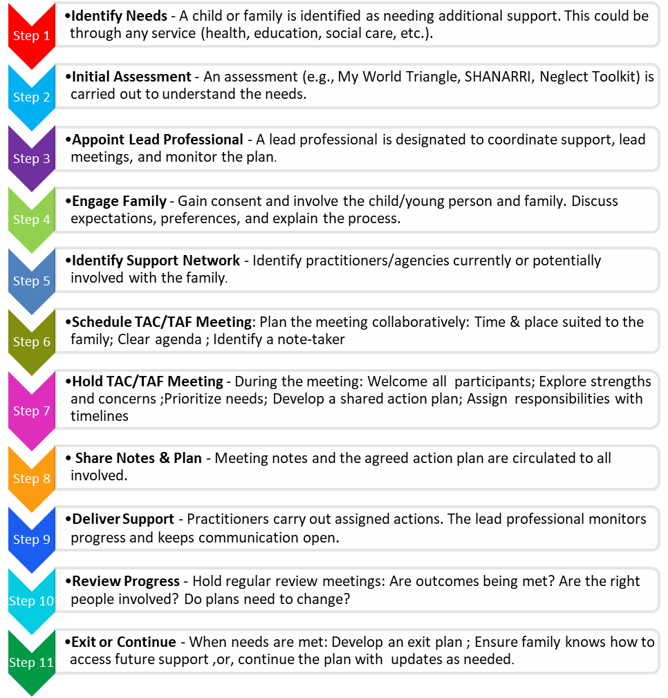

Here is a helpful visual representation of Who should be involved in a TAC and when?
*Please note that terminology to describe the various stages may vary within education between authorities. However, the processes and guiding principles under GIRFEC remain the same.

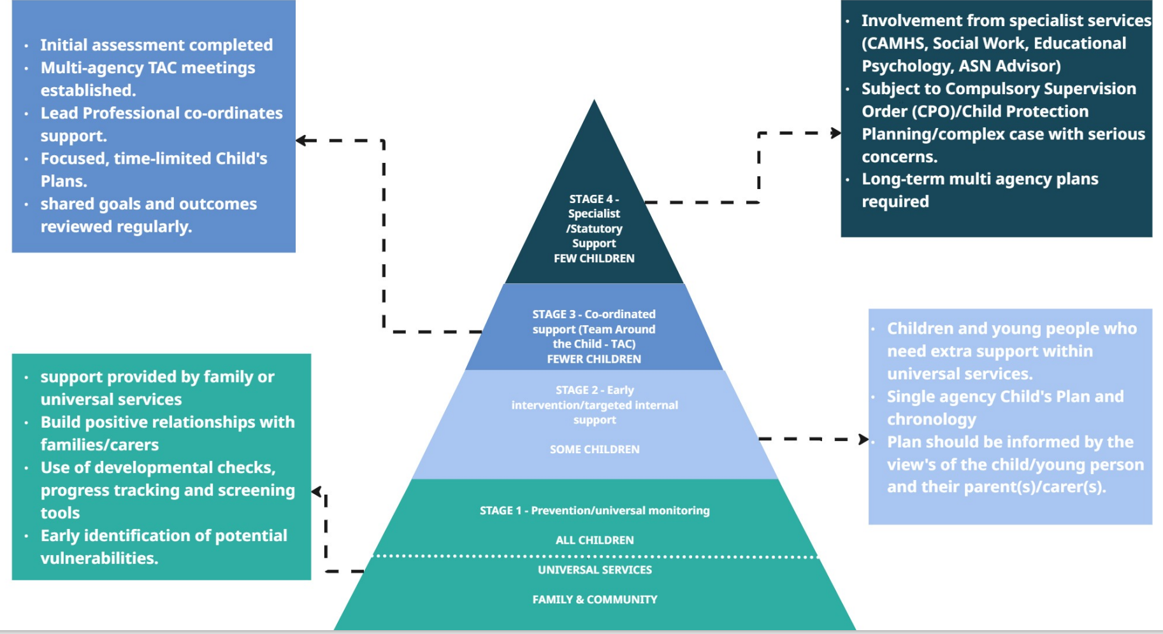

At every stage we should ask ourselves the 6 GIRFEC Questions to support the assessment process.

- What is getting in the way of this child’s wellbeing?
- Do I have all the information I need to help this child?
- What can I do now to help this child?
- What can my agency do to help this child?
- What additional help, if any, may be needed from others?
- Are this child’s human rights being met?

Stage 1
At the level of universal services, education and health work to support children, young people and their families/carers, intervening early and only when necessary to prevent unmet need escalating. This includes an element of personalised support but is provided within the service. The agency will co-ordinate and monitor support to overcome the barrier and support the child or young person to flourish.

Stage 2
Sometimes children and young people need extra support within universal services. This additional support should be determined by a wellbeing assessment and informed by the views and wishes of the child, young person and their parent/carer. The universal service lead professional will initiate a single agency Child’s Plan and chronology and will be responsible for ensuring these are updated.

Stage 3
Stage 3 supports are not needed for most children and young people. Targeted supports at this level go beyond what is available via universal provision and involve as least one other agency. With the consent of the child, young person and their parent/carer, a wellbeing assessment will be undertaken to identify strengths, but also needs and what additional supports are required to overcome these needs. A multi-agency Child’s Plan is necessary at stage 3 to co-ordinate supports and clarify professional roles and responsibilities. A Team Around the Child (TAC) meeting will be convened involving the parents/carers, and hopefully the child or young person (or someone present to represent their views). The universal service and partner agencies will agree who should be the “Lead Professional” for the child (does not need to be social work).
In some circumstances the TAC will identify a need for statutory measures to support the child or young person.

Stage 4
For some children and young people highly specialist support is required from two or more agencies to address well being needs. At stage 4 the Lead Professional will almost always be a social worker. If the child or young person in involved in child protection process and/or is Care Experienced (Looked after at home or away from home) or subject to a Compulsory Supervision Order, the Lead Professional will always be a Social Worker.
Stage 4 support is intensive and in place because the child or young person has significant and complex support and protection needs. For these reasons it is hoped and expected that support at this stage will time limited to affect positive change. The Child’s Plan must be reviewed and updated regularly where necessary to maximise the opportunity for positive outcomes for the child or young person. At stage 4 the ultimate aim of the Child’s Plan is to intervene as appropriate to reduce/remove barriers to the child or young person’s happy, healthy and safe development and strengthen family capacity

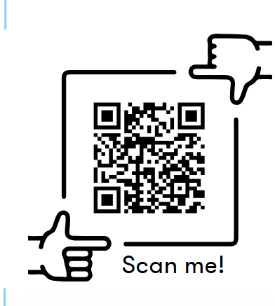
Leaflet for a younger child

Leaflet for a young person
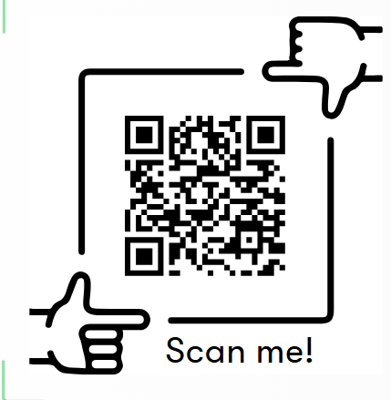


Leaflet for a parent/carer

